Relationships and Sex Education Policy
Cribden House School

Introduction
The Relationships Education, RSE, and Health Education (England) Regulations 2019 made Relationships Education compulsory in all primary schools since September 2020. Health Education is statutory from September 2020 and covers the key facts about puberty and the changing adolescent body. As a maintained primary school, from the 2020 academic school year, we must provide Relationships and Health Education to all pupils as per section 34 of the Children and Social work act 2017.
Sex education is not compulsory in primary schools (we are not required to provide sex education apart from the elements included in the primary science curriculum). However, we are encouraged to deliver Sex Education that ensures both boys and girls are prepared for the changes adolescence brings and drawing on knowledge of the human life cycle as set out in the National Curriculum for science. Following consultation with parents and carers, pupils in Year 6 will receive sex education lessons if parents/carers do not withdraw their children from this.
This policy has been written to ensure we are meeting the legal requirements of the statutory Relationships Education and the government guidance with regards to Sex Education.
How this Policy was developed

The policy was written by the PSHRE subject leader (Sherryl Wright) in consultation with parents/carers, staff, governors and School Council (during the 2019-2020 academic year and has since been reviewed). A consultation of parents/carers took place in June 2020 to seek and gain the views of parents/carers with regards to Relationships Education and Sex Education. Any enquiries were directed to Sherryl Wright (subject leader).
This policy is intended to be used as an outline to the guiding principles by which the staff of this school will teach Relationships (and Sex) Education, learning about the emotional, social and physical aspects of growing up, relationships, human reproduction, and human sexuality. Some aspects are taught in Science, and others are taught as part of personal, social, health, relationships and economic education (PSHRE). As a school, we use the PSHE Association’s Thematic Model to support teaching and learning of this subject.
Aims and Objectives
At Cribden House School, the aims of Relationships and Sex Education are:
- To ensure Relationships Education is part of a child’s broad, balanced curriculum at Cribden House, integral to PSHRE and the basic curriculum of the school and part of the child’s all-round development.
- Creating a positive, respectful culture around relationships.
- For children to understand the features of positive, healthy relationships, family relationships and other relationships; they will understand what friendship is, what family means and who the people are who can support them.
- To raise pupils’ self-esteem and confidence, especially in their relationships with others, enabling them to have safe and stable relationships which promote respect, love and care.
- To prepare children for healthy relationships in an online world.
- For pupils to recognise how to take turns, how to treat each other with kindness, consideration and respect, understand the importance of boundaries, honesty and truthfulness, permission seeking and giving, and the concept of personal privacy.
- Help pupils develop a positive and secure personal identity, a sense of their own values and feelings of confidence and empathy.
- To ensure that all understand the importance of respecting others and accepting those who differ, yet challenging those behaviours and attitudes which exploit others and do not reflect our values (teamwork, respect, inclusion and positivity).
- To understand how to stay safe and report things that make them feel unsafe, including have the knowledge they need to recognise and to report abuse (including emotional, physical and sexual abuse).
- To respect and care for their bodies ensuring they are cognitively prepared for puberty and adulthood
- To respond to the needs of pupils and parents/carers by providing accurate knowledge of sex education at a level suitable to children’s age, learning needs and academic understanding (cognitive ability level).

How will Relationships Education be taught:
At Cribden House School, many aspects of Relationships Education are taught throughout the year for each year group. We will ensure Relationships Education is taught within PSHRE (Personal, Social, Relationship, Health and Economic) education which is regarded as a core subject at our school. PSHRE lessons take place weekly with a key theme for each half term (see Appendix 1 for long term PSHRE curriculum plan). Relationships Education will also be delivered through a number of different forms including:
- Social and emotional interventions – a specific programmed sequence of adult led sessions (e.g. Feelings through Art, Thrive, therapy crews).
- Circle Time sessions where children will have the opportunity to talk, listen and share opinions in a safe and secure environment led by the teacher (including daily Newsround sessions).
- Educational visits or visitors that enhance teaching and learning
- Links through other curriculum subjects such as Science and RE.

We ensure that pupils are given information appropriate to their age, cognitive ability, learning needs and stage of development; all content is adapted to suit the needs of each child. The PSHRE subject leader and headteacher are responsible for the organisation of Sex Education at Cribden House School. It is the responsibility of class teachers/HLTAs to ensure PSHRE lessons are delivered weekly and adapted to suit the needs of their cohort.
How will Sex Education be taught:
Sex Education lessons are delivered at a pre-planned point during the year (currently during the Summer term), in order that parents/carers are informed and can be involved in supporting their child. Sex Education is delivered by the class teacher or HLTA and within a single gender group. An ‘Ask it basket’ question box or bag will be used in each room to encourage pupils to ask questions with anonymity and without embarrassment.
Puberty for Years 4, 5 and 5:
We have a PSHRE programme tailored to the age and maturity of children, ensuring that boys and girls know about puberty before they experience it (Years 4, 5 and Year 6). This statutory content is delivered to children in single sex groups; some sessions may take place on a 1:1 basis. Sometimes there may be a need/request to deliver it to children from additional year groups; this request may come from home or staff (e.g. early onset of puberty). Class leads inform parents/carers ahead of puberty lessons being taught to their child to ensure that they understand what learning their child is accessing. Puberty lessons are adapted to allow children with a range of special educational needs (e.g. ASC, SLD, GLD) to access them. For these children, work is completed with children that is appropriate to their processing level, e.g. this could be on identifying body parts (as part of the Science curriculum) or recognising potential changes to their body through puberty. We believe in working in partnership with parents, carers and understand the importance of sharing our RSE programme with families; so that they are able to support their children’s physical, moral, mental wellbeing and emotional development at home.
Learning outcomes of the Year 4, 5 and 6 programme are to:
• Identify some products that they may need during puberty and why;
• Know what menstruation is and why it happens.

Sex Education programme for Year 6
We have a Year 6 Sex Education programme tailored to the age and maturity of children ensuring that boys and girls know how babies are conceived and born (Year 6). Sex Education (how babies are conceived and born) is delivered to Year 6 children following their parents/carers being informed ahead of the lesson taking place and them being given the right to withdraw. Sessions are delivered in single sex groups by teachers and the content of the session may be adapted according to maturity levels and other relevant factors (e.g. learning need). Class teachers/HLTAs work with parents, carers and the PSHRE subject leader to assess whether a child’s cognitive understanding/Special Educational Need would allow them to take part in the SRE sessions (e.g. for children with ASC, SLD, GLD). For these children, work is completed with them that is appropriate to their processing level, e.g. this could be on identifying body parts (as part of the Science curriculum) or recognising potential changes to their body through puberty. We believe in working in partnership with parents, carers and understand the importance of sharing our RSE programme with families; so that they are able to support their children’s physical, moral, mental wellbeing and emotional development at home.
Learning outcomes of the Year 6 programme are to:
- Identify the changes that happen through puberty to allow sexual reproduction to occur;
- Understand how a baby is conceived and born.
- Know a variety of ways in which the sperm can fertilise the egg to create a baby;
- Know the legal age of consent and what it means.
Visiting speakers from the community, e.g. school nurse, may also make a valuable contribution to the Sex Education curriculum. Their input will be carefully planned and monitored to fit into and complement the curriculum. Teachers/HLTAs are always present during sessions delivered by visiting speakers and the teachers remain responsible for the delivery of the Sex Education curriculum.
Right of Withdrawal from SRE
Relationships Education is a statutory part of the school’s curriculum and, consequently, parents may not withdraw pupils from these lessons.
Parents have the right to withdraw their children from those aspects of sex education that are not included in the Science Curriculum; how a baby is conceived and born. Cribden House School will inform parents/carers ahead of when aspects of the Sex Education programme are taught via a letter with a right to withdraw slip and an appendix containing the main lesson resources being sent home; parents/carers are informed via DOJO, letter or phone call of when they have sent this letter home. The class teacher/HLTA will ensure parents/carers are informed prior to the Sex Education lessons and will provide an opportunity for parents/carers to discuss any concerns and view a sample of the resources used in lessons if they request to (e.g. the animated video as we send a paper copy home of the main lesson content). Parents/carers can withdraw their child from Sex Education by writing to their class teacher or our headteacher, Mrs Halligan. Alternative work will be set for children who have been withdrawn from these lessons.
Questions Raised by Pupils
Establishing a safe, open and positive learning environment, built on trusting relationships between all members of the class community is vital to successful and effective teaching and learning within this subject. A set of ground rules is established prior to the programme of work so that both teachers and pupils are working within a safe environment where they will not feel embarrassed or anxious during discussions. Questions raised by children should be answered honestly and with a degree of detail appropriate to the child’s age and stage of development. Teachers will use their professional skill and discretion before answering questions and if necessary will deal with questions on an individual basis after the lesson. Where pupils’ questions require a response that goes beyond the prescribed programme of study for the year group, the pupils’ parents/carers are informed and asked whether they would like school to answer the question on a 1:1 basis or whether they want to answer the questions at home. Where appropriate, teachers will discuss a child's concerns with the child’s parents/carers.
Teachers are aware that effective RSE, which brings an understanding of what is and is not acceptable in a relationship, can lead to the disclosure of a safeguarding issue. The usual standards of confidentiality between child and teacher will be observed, except where a child’s question might suggest the possibility of abuse. In these circumstances, the Designated Safeguarding Leads (DSLs), Mrs S Halligan, Miss J Ashworth, Mr Baker, Mrs Lowton and Miss Edmundson, should be informed. This should also be recorded on CPOMS. If the DSLs are not able be contacted, a member of the Senior Leadership Team should be consulted. No adult should ever promise confidentiality to a child, as per the school’s Safeguarding Policy. Review, Assessment and Evaluation Monitoring of the RSE Policy is the responsibility of the headteacher, governors, and the PSHRE leader.
Monitoring of Relationship Education:
Monitoring of lessons and standards will follow the same whole school approach as other subjects. PSHRE is monitored by the Subject Leader (Sherryl Wright) on a termly basis through book and planning scrutinies and learning walkthroughs. Children (who are cognitively able to) will complete pre and post half termly assessments for each half termly PSHRE unit covered. Teachers delivering Relationships Education should constantly evaluate their lessons to inform future planning.
Assessment of Relationships Education delivered outside the PSHRE curriculum is conducted through the monitoring and observation of pupils’ learning with reference to the following:
• Knowledge and understanding gained.
• Skills learnt and developed.
• Attitudes and values explored.
• Responses offered by pupils.

Equal Opportunities
The RSE programme will be delivered in accordance with the school’s Single Equality Policy, and the Equality Act (2010). Consequently, pupils will learn from an early age that there are many different types of ‘family’ (using stonewall and PSHE Association resources). In KS2, pupils will be taught that the term ‘relationship’ may refer to two people of the same or different: gender, ethnicity, religion/belief, or ability/disability. The promotion of any type of relationship shall not occur. Where appropriate, pupils will be given opportunities to discuss specific issues related to puberty in single sex groups. Resources and methods of teaching will be in line with the strategies set out in the policies.
Links with other Policies
Due to the nature of the subject, this policy should be read and implemented in conjunction with other policies.
Date of Policy: November 2020
Most recent review of Policy: April 2022
Next Review: April 2023

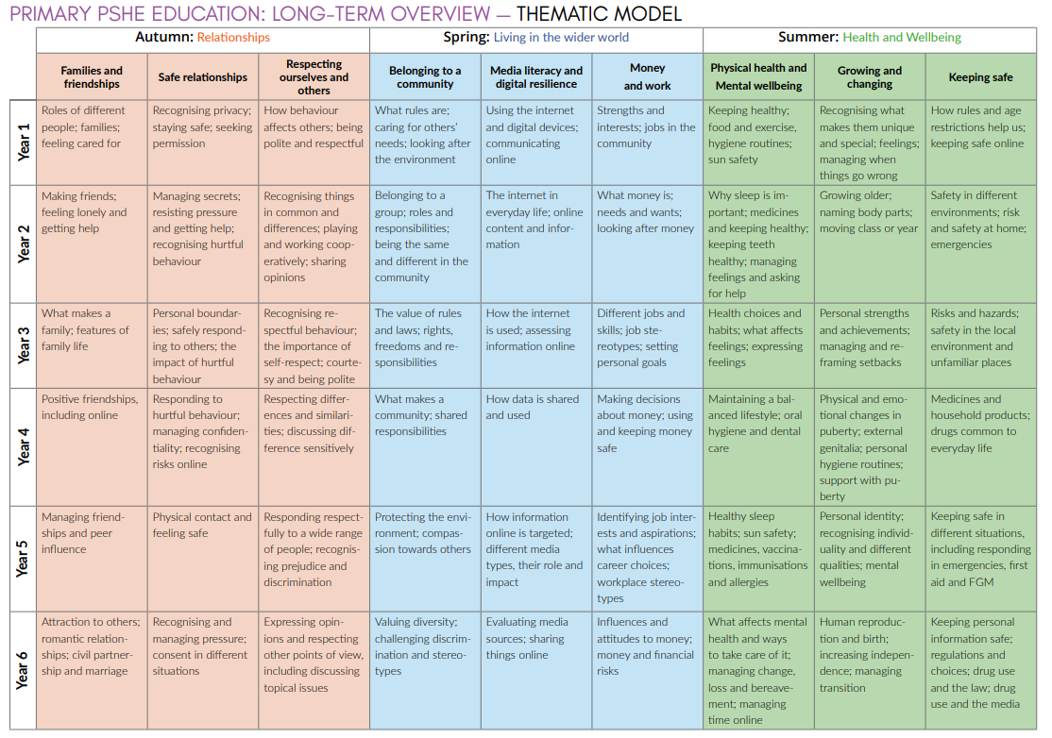
Appendix 1: PSHRE Long term curriculum plan (using the PSHE Association Thematic Model)

