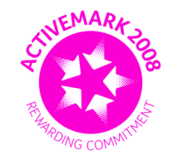
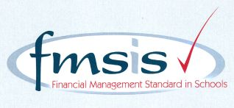

CROSSCANONBY ST JOHN'S CofE PRIMARY SCHOOL

Mrs Kelly Bowe
Headteacher
Garborough Close e-mail: head@crosscanonby.cumbria.sch.uk
Crosby www.crosscanonby.cumbria.sch.uk

MARYPORT Telephone: 01900 812326 Cumbria CA15 6RX

Dear Parents/Guardians,

For your information we have outlined below some of the topics that will be covered this term in Class 2. We have already made a good start to our studies and we feel sure that you will make every effort to assist and encourage your child as this term progresses.

Our Christian values for this half-term are WISDOM and HOPE.

ENGLISH:
KEY TEXTS:
- ‘Escape From Pompeii’ by Christina Balit
- ‘Gregory Cool’ by Caroline Binch
- Explanation texts

- Expanded noun and prepositional phrases
- Fronted adverbials
- Sentence openers
- Possessive apostrophes
- Diary writing
- Formal and informal language
- Using a thesaurus
- Writing powerful descriptions
- Figurative language
- Retrieving and recording information
- Editing writing
- Non-chronological reports
- Conjunctions
- Persuasive language
- Writing a blog
- Similes and metaphors
- Direct speech
- Explanation texts
- Alliteration and rhyme
- Advertisements

SCIENCE:

- How do some solids, liquids and gases change state?
- Scientists and inventors

MATHEMATICS
YEAR 3:
- Fractions
- Money
- Time
- Shape
- Statistics
YEAR 4:
- Decimals
- Money
- Time
- Shape
- Statistics
- Position and Direction

HISTORY:

- How did Britain change between the end of the end of the iron age and the end of the Roman occupation?
Local History.

GEOGRAPHY:

Mountains, Volcanoes and Tsunamis

ART/DESIGN AND TECHNOLOGY

- ARCHITECTURE – Famous Buildings
- How can we design and make a small jewellery container? - MOULDABLE MATERIALS

RE:
- The Church – are all churches the same?
Are all places of worship the same?
Do people worship God in the same way?
Hinduism, Islam, Judaism, Sikhism.

PE:
- ABC’s in isolation and combination.
- Dance, movement through music and gymnastics
- Evaluating recognising success through team games
- Football bench ball

COMPUTING:

- Effective Searching – DIGITAL LITERACY
- Branching Databases – INFORMATION TECHNOLOGY

MUSIC
- Composing songs
- Using and writing musical notation

PSHE

- Relationships
- Changing Me

FRENCH
- Food
- ‘The Very Hungry Caterpillar’
- At the farm
- Bastille Day
- PHONICS & GRAMMAR: É en; Un/ une; simple plurals

If you have any questions regarding your child’s learning for this term, please do not hesitate to contact me.

Kind regards,

Kelly Bowe

