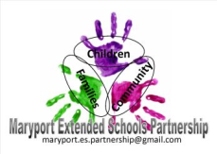
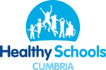
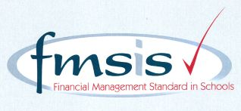

CROSSCANONBY ST JOHN'S CofE PRIMARY SCHOOL

Mrs Kelly Bowe
Headteacher
Garborough Close e-mail: head@crosscanonby.cumbria.sch.uk
Crosby www.crosscanonby.cumbria.sch.uk

MARYPORT Telephone: 01900 812326 Cumbria CA15 6RX

Dear Parents/Guardians,

For your information we have outlined below some of the topics that will be covered this term in Class 3. We have already made a good start to our studies and we feel sure that you will make every effort to assist and encourage your child as this term progresses.

Our Christian values for this half-term are WISDOM and HOPE.

ENGLISH:
KEY TEXTS:
- ‘Coraline’ by Neil Gaiman
- Persuasive writing

Y6 – SATS REVISION

READING COMPREHENSION SKILLS:
Vocabulary:
Give/explain the meaning of words in context.
Infer:
Make inference from the text/explain and justify using evidence from the text.
Predict:
Predict what might happen from the details stated and implied.
Explain:
Identify/explain how information/narrative content is related and contributes to the meaning as a whole. Identify/explain how meaning is enhanced through choice of words and phrases.
Make comparisons within the text
Retrieve:
Retrieve and record key information/key details from fiction and non-fiction.
Summarise:
Summarise main ideas from more than one paragraph.

- Using inference to write character descriptions
- Making comparisons through use of contrasting language
- Understanding symbolism as a method of figurative language
- Building tension and suspense
- Using emotive language through dialogue to convey characters’ feelings
- Writing recounts
- Using descriptive language
- Diary writing
- Drafting, editing and improving own writing

SCIENCE:

- How does the heart work and why is it so important?
- Scientists and inventors

MATHEMATICS
YEAR 5:
- Perimeter and Area
- Statistics
- Shape
- Position and Direction
- Decimals
- Negative numbers
- Converting units
- Volume
YEAR 6:
- SATs Revision
- Area, Perimeter and Volume
- Statistics
- Shape
- Position and Direction
- Practical application of Maths

HISTORY:

- What do we understand by the term ‘slavery’?

GEOGRAPHY:

- Why is Britain an attractive place to live for many who were not born there?
Immigration. European Union.

ART/DESIGN AND TECHNOLOGY

- TEXTILES – ‘Talking Textiles’ – learning about the fascinating Bayeux Tapestry and how other artists have told stories visually throughout the ages,
- ‘Making African Instruments?’ – MOULDABLE MATERIALS

RE:
- Paul. How did the news of Jesus’ resurrection spread around the world?
People of faith. How does having faith affect people’s lives?
Buddhism,Islam,Hindi Dharma.
- What does it mean to be a Muslim in British society today?

PE:
- ABC’s in isolation and combination.
- Dance, movement through music and gymnastics
- Evaluating recognising success through team games
- Football bench ball

COMPUTING:

- Databases – INFORMATION TECHNOLOGY
- Networks – COMPUTER SCIENCE

MUSIC
- Composing songs

PSHE

- Relationships
- Changing Me

FRENCH
- Numbers 50 – 100
- Emotions
- Euros
- At the supermarket
- PHONICS & GRAMMAR: Using ‘tu/vous’
Using ‘de la/du/des’

If you have any questions regarding your child’s learning for this term, please do not hesitate to contact me.

Kind regards,

Kelly Bowe

