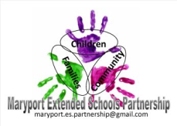
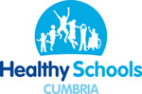
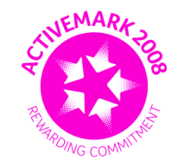
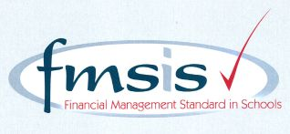
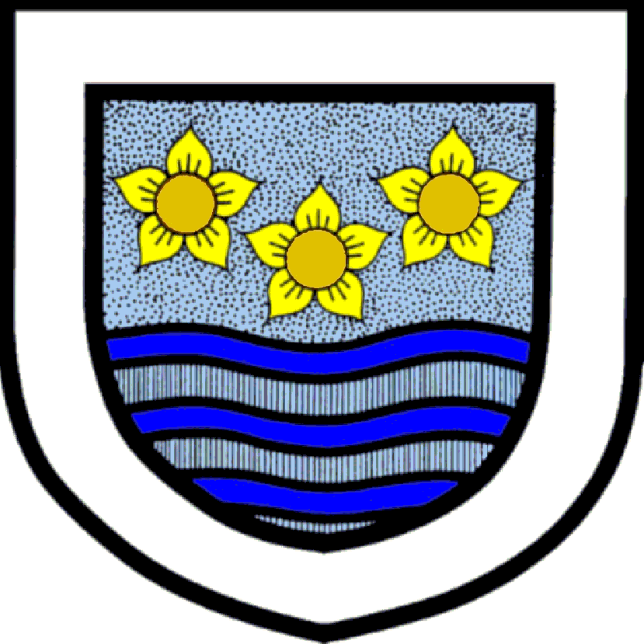
Big enough for opportunity
Small enough to care
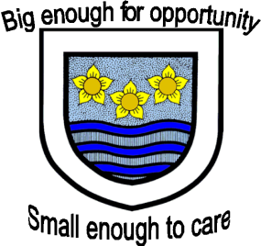

CROSSCANONBY ST JOHN'S CofE PRIMARY SCHOOL

Mrs A Pitcher Telephone: 01900 812326
Executive Headteacher Fax: 01900 816420
Garborough Close e-mail: head@crosscanonby.cumbria.sch.uk
Crosby www.crosscanonby.cumbria.sch.uk

MARYPORT

Cumbria CA15 6RX

Dear Parents/Guardians,

For your information we have outlined below some of the topics that will be covered this term in Year 4. We have already made a good start to our studies and we feel sure that you will make every effort to assist and encourage your child as this term progresses.

ENGLISH:
- Descriptive writing
- Recount
- Composing a song
- Persuasive writing
- Narrative – writing a story from another culture
- Instructions – writing spells
- Narrative – writing a spooky story

SPaG (Spelling, grammar and punctuation):
- Revision of basic word classes
- Expanded noun phrases
- Adverbs
- Fronted adverbials
- Inverted commas
- Direct speech
- Nouns and pronouns

SCIENCE:
- PHYSICS – Forces
- PHYSICS - Electricity

MATHEMATICS:
- Place value – including rounding and negative numbers
- Addition and subtraction
- Multiplication and Division
- Prime numbers

HISTORY:
- The Shang Dynasty - The children will learn about the Ancient Shang dynasty. They will learn who the Ancient Shang people were, where and when they lived, using maps and atlases to locate Shang cities.
They will also learn about the role of the king, the religious beliefs and rituals of the Shang people and how oracle bones were used in divination ceremonies.
The children will also examine a range of Shang artefacts and draw conclusions about what they can teach us.
At the end of the unit, we will take a close look at the remarkable discovery of the first intact Shang tomb, which belonged to the military general and high priestess Fu Hao.

GEOGRAPHY:
- Amazing Americas- Children will first find out about the continents of North and South America, and the countries that form them. They will also look in more detail at some of the contrasting regions of the Americas, finding out about the landscape, climate and locations of each area. There is the opportunity to carry out a detailed fieldwork study of the children’s local area to help them to identify the similarities and differences between a region of the Americas and where they live. Children will also develop their map and atlas skills and practise reading and writing coordinates. They will learn about the ancient and new wonders of the world, specifically those of the Americas, and they will research a natural wonder of the Americas and create their own presentations to teach others what they learn.

FRENCH:
- Revision
- My Family

ART and DESIGN AND TECHNOLOGY:
- Fabric/Silk Painting
- Design and build a lighthouse

RE:
- What do Christians and Muslims understand about the need for thankfulness in their lives?
- What do Christians believe about the Prince of Peace?

PE:
- Dynamic movement through modified games – tag rugby
- Modified games (attacking and defending) – hand ball and basket ball

COMPUTING:
- Online Safety
- Controlling Devices

MUSIC
- Exploring rhythm through drumming and Samba.

