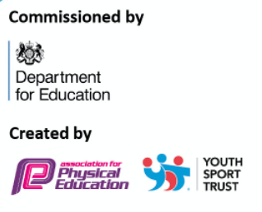
Evidencing the Impact of the Primary PE and Sport Premium

2022 - 2023

Our Aim

At Crowland, PE is an area of strength and we recognise and understand the importance of a robust curriculum. Our aim is to provide high quality, engaging Physical Education lessons and extra-curricular activities for all pupils, to improve children’s physical literacy and enable them to continue lifelong enjoyment and participation in sport.

Details with regard to funding
Please complete the table below.

Total amount carried over from 2021/2022 | £0
Total amount allocated for 2022/23 | £ 19,093
How much (if any) do you intend to carry over from this total fund into 2022/23? | £0
Total amount allocated for 2022/23 | £19,093
Total amount of funding for 2022/23. To be spent and reported on by 31st July 2023. | £
Swimming Data
Please report on your Swimming Data below.

Meeting national curriculum requirements for swimming and water safety.  N.B. Complete this section to your best ability. For example you might have practised safe self-rescue techniques on dry land which you can then transfer to the pool when school swimming restarts.  Due to exceptional circumstances priority should be given to ensuring that pupils can perform safe self rescue even if they do not fully meet the first two requirements of the NC programme of study | 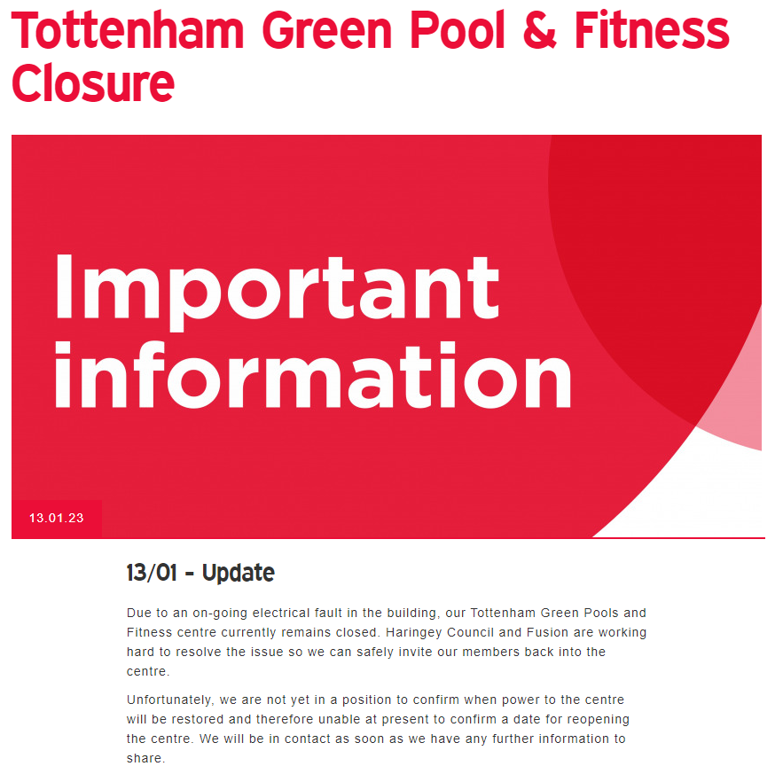  There has been major disruption to our swimming this year as our local centre has closed. We are keeping an eye on the situation and funding will be allocated to this next year.
What percentage of your current Year 6 cohort swim competently, confidently and proficiently over a distance of at least 25 metres?  N.B. Even though your pupils may swim in another year please report on their attainment on leaving primary school at the end of the summer term 2020.  Please see note above | %
What percentage of your current Year 6 cohort use a range of strokes effectively [for example, front crawl, backstroke and breaststroke]?  Please see note above | %
What percentage of your current Year 6 cohort perform safe self-rescue in different water-based situations? | %
Schools can choose to use the Primary PE and sport premium to provide additional provision for swimming but this must be for activity over and above the national curriculum requirements. Have you used it in this way? | Yes/No

Action Plan and Budget Tracking
Capture your intended annual spend against the 5 key indicators. Clarify the success criteria and evidence of impact that you intend to measure to evaluate for pupils today and for the future.

Academic Year: 2020/21 | Total fund allocated: | Date Updated:
Key indicator 1: The engagement of all pupils in regular physical activity – Chief Medical Officers guidelines recommend that primary school pupils undertake at least 30 minutes of physical activity a day in school |  |  |  | Percentage of total allocation:
 |  |  |  | %
Intent | Implementation |  | Impact
Your school focus should be clear what you want the pupils to know and be able to do and about  what they need to learn and to  consolidate through practice: | Make sure your actions to achieve are linked to your intentions: | Funding allocated: | Evidence of impact: what do pupils now know and what can they now do? What has changed?: | Sustainability and suggested next steps:
Implement daily physical activity.  Develop playground games so all children are involved in physical activity. | Go Noodle / Cosmic Yoga / BBC Supermovers to be done after each playtime.  Provide Sports Coach during playtimes to develop playground games.  Sports coach to provide CPD to lunchtime / playtime staff.  Mindfulness and mental wellness / yoga / focus activity to be done after lunchtime.  Teachers to provide extra 30 mins high intensity or running every 2 weeks. | In house
Key indicator 2: The profile of PESSPA being raised across the school as a tool for whole school improvement |  |  |  | Percentage of total allocation:
 |  |  |  | %
Intent | Implementation |  | Impact
Your school focus should be clear what you want the pupils to know and be able to do and about  what they need to learn and to  consolidate through practice: | Make sure your actions to achieve are linked to your intentions: | Funding allocated: | Evidence of impact: what do pupils now know and what can they now do? What has changed?: | Sustainability and suggested next steps:
To continue to embed to the positive ethos of Sport and Wellbeing at Crowland.  To further push and raise the profile of sport to parents and children.  Celebration assembly-celebrating sporting and PE achievements in star assembly. | To continue to provide a wide range of sports available to children.  Using GET SET 4 PE ‘Active Families’ as home tasks set by teachers. | In house

Key indicator 3: Increased confidence, knowledge and skills of all staff in teaching PE and sport |  |  |  | Percentage of total allocation:
 |  |  |  | %
Intent | Implementation |  | Impact
Your school focus should be clear | Make sure your actions to | Funding | Evidence of impact: what do | Sustainability and suggested
what you want the pupils to know | achieve are linked to your | allocated: | pupils now know and what | next steps:
and be able to do and about | intentions: |  | can they now do? What has
what they need to learn and to |  |  | changed?:
consolidate through practice:
To continue to develop staff confidence in teaching high quality PE.  To enable Sports Coach to partake in CPD to increase understanding of pedagogy when teaching PE.  To promote the use of high-level vocabulary in PE in line with school’s key drivers.  To continue building links with sports community (Tottenham Hotspur Foundation) for teacher CPD opportunities. | To continue to use GET SET 4 PE to provide teachers with easy-to-follow lesson plans.  Staff survey identify CPD requirements.  Staff meeting on PE, Haringey CPD and GET SET 4 PE.  Teacher CPD in 4 weekly sessions with sports coach.  Sports Coach to attend Haringey CPD courses and meetings.  Sports Coach to have timetabled PPA time.  To continue to communicate with the Foundation organisers for opportunities for staff and children. | £1,350 – Haringey CPD package  £5,581
Key indicator 4: Broader experience of a range of sports and activities offered to all pupils |  |  |  | Percentage of total allocation:
Intent | Implementation |  | Impact
Your school focus should be clear | Make sure your actions to | Funding | Evidence of impact: what do | Sustainability and suggested
what you want the pupils to know | achieve are linked to your | allocated: | pupils now know and what | next steps:
and be able to do and about | intentions: |  | can they now do? What has
what they need to learn and to |  |  | changed?:
consolidate through practice:
Purchase of high-quality equipment (including storage equipment).  To continue to provide a wide range of After School Club activities for children.  To push the numbers of PP chn attending extra-curricular clubs. | To purchase equipment when necessary.  To implement Sports Leaders to monitor and keep equipment in good order.  Offer free places | £7,000  In house  £2,000 | PP numbers attending clubs: | Moving forward, we aim to purchase larger range of SEND equipment to be used specifically for PE to meet the needs of all leaners.  Increase number of PP children who attend extra-curricular activities.

Key indicator 5: Increased participation in competitive sport |  |  |  | Percentage of total allocation:
 |  |  |  | %
Intent | Implementation |  | Impact
Your school focus should be clear | Make sure your actions to | Funding | Evidence of impact: what do | Sustainability and suggested
what you want the pupils to know | achieve are linked to your | allocated: | pupils now know and what | next steps:
and be able to do and about | intentions: |  | can they now do? What has
what they need to learn and to |  |  | changed?:
consolidate through practice:
All children to be given to opportunity to participate in competitive sport. | Sports coach to arrange friendly fixtures with local schools to enable more children to attend competitive sport.  Sports coach to arrange intra competitions between classes / year groups at the end of the term / half term. | In house

Signed off by
Head Teacher: | S.Stavrinou
Date: | February 2023
Subject Leader: | Nafisa Gilkes
Date: | February 2023
Governor: | TB approved by Rose Dowling
Date:

