Welcome to our first Newsletter. These newsletters will now come to you every half term, and will have information about the School community, our pupils and events. Firstly though, some introductions to the new Leadership Team at CAA: I am very much looking forward to leading the school community as your acting Head of School. Kris Williams, from the Eden Academy Trust, a school trust that works exclusively with specialist schools such as ours, will be supporting our school as Executive Head two days a week. In January, Kara Smallman will also start as Deputy Headteacher.
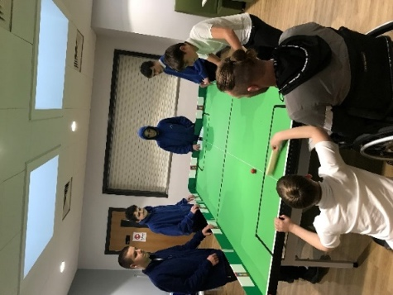
Table Cricket
Danny from Cumbria Cricket has been delivering fun Table Cricket sessions to pupils at CAA. It has been wonderful to see how much our pupils have enjoyed these sessions. Danny has been impressed by the standard, skill and attitude of our pupils and it is amazing to think that for many it will have been their first introduction to the game. We are revving up for our first inter- school competition in March at William Howard School.
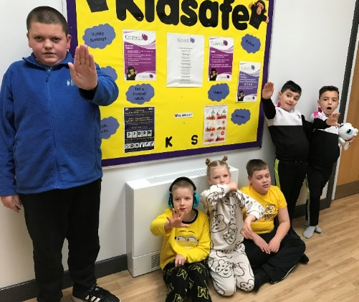
Anti-bullying Week at CAA
All over the country, schools come to focus every year on understanding what bullying means and how we can make sure this doesn’t happen in school. At CAA we had a week of workshops delivered for all of our classes, led by Lisa Wilson our Kidsafe Lead. There was a focus on understanding what bullying means, talking to people if you are worried and knowing who to talk to.

Dates for your diary
- Last Day of term Tuesday 20th December – School finishes at 1pm
- Spring term starts Wednesday 4th January
- Year 11/12 Mock Exams begin - Monday 23rd January

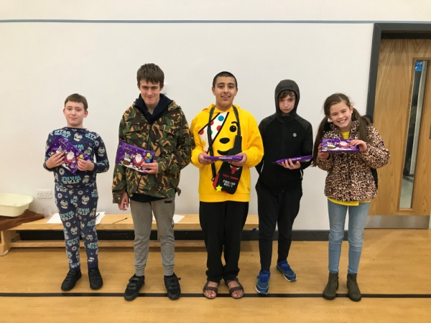
19th November - Children in Need
Our Owls’ Class were a massive help in the set up as well as the running of the games and activities. There were 5 activities for students to choose, including the very popular Scooter Board Challenge and the Teacher Pie Face.
As a school we raised £331.40 from sale of raffle tickets and the exciting games that the students loved taking part in.
Well done to everyone involved – it was a great afternoon.

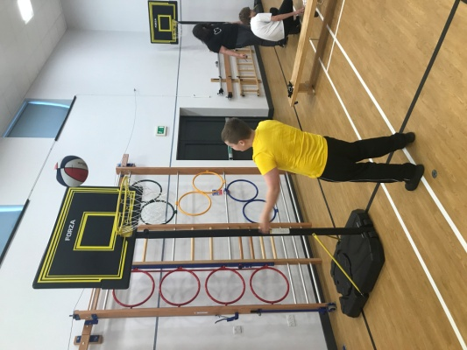
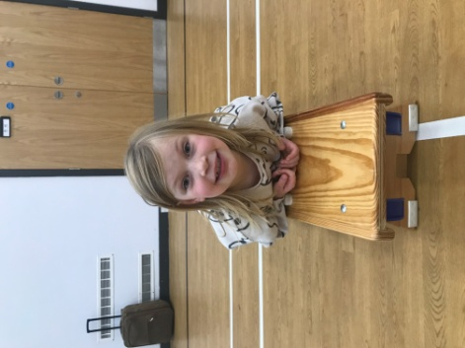
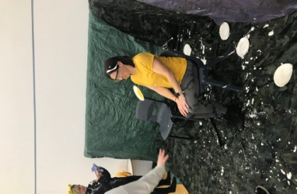
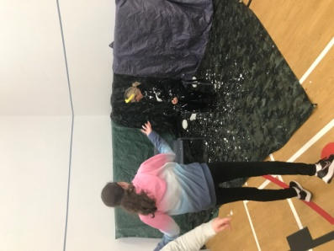
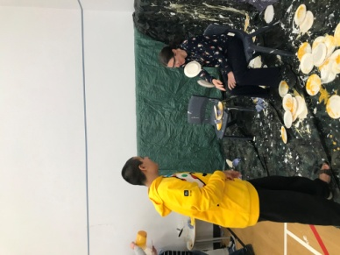

Christmas Crafts
Our Rivers enjoyed a great afternoon of Christmas crafts including decorating biscuits and making their own decorations. Students from across the classes worked together on the different activities.

