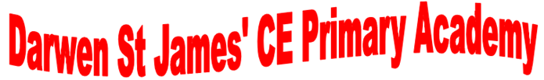

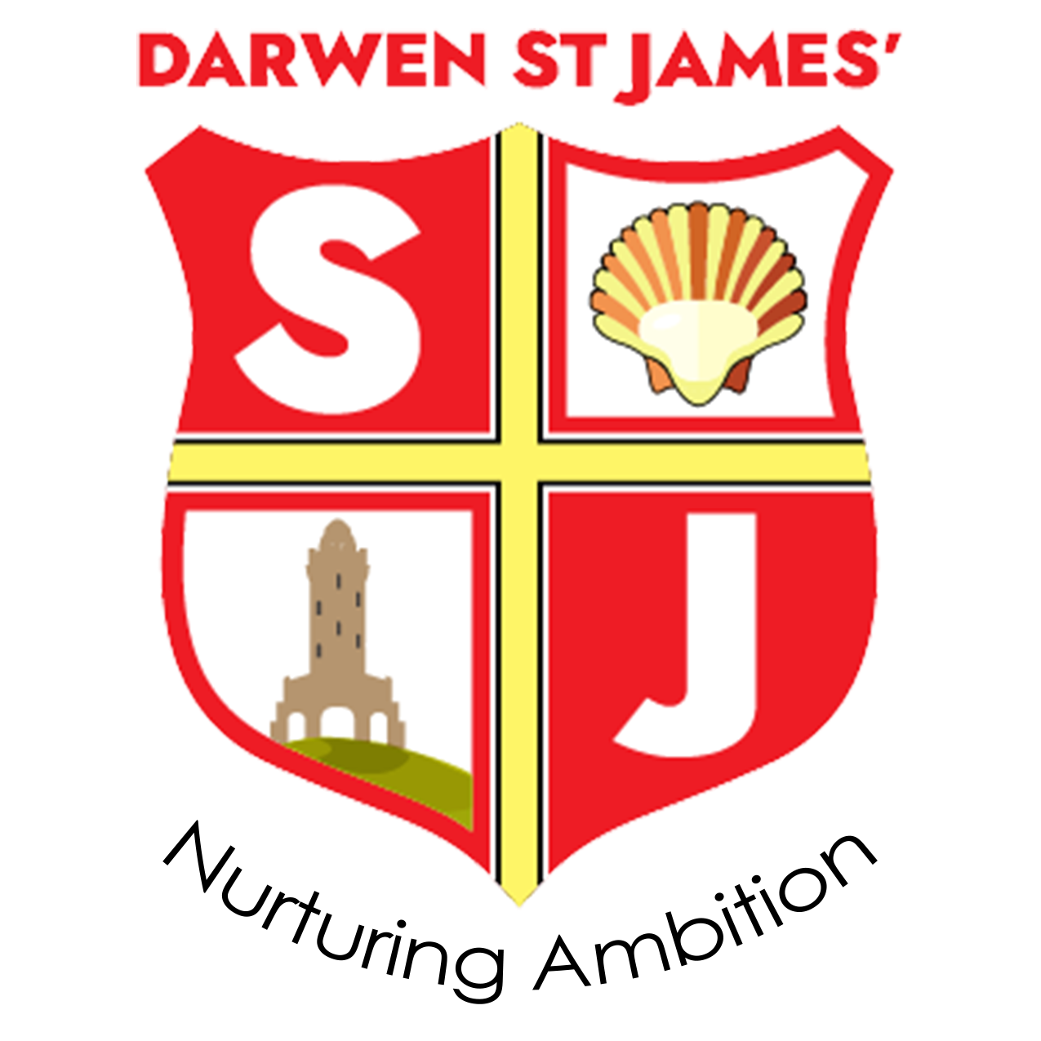

Art and Design Policy

Mission Statement
Nurturing ambition through a living faith
Vision
Our academy delivers a purposeful curriculum through its living Christian faith. We nurture ambition in all our learners in order for them to become positive citizens of tomorrow.
Bible
Let us not love with words or speech alone but with actions and truth. John 3:18
--------------------------------------------------------------------------------------
Definition
“Art, craft and design embody some of the highest forms of human creativity. A high quality art and design education should engage, inspire and challenge pupils, equipping them with the knowledge and skills to experiment, invent and create their own works of art, craft and design. As pupils progress they should be able to think critically and develop a more rigorous understanding of art and design. They should also know how art and design both reflect and shape our history, and contribute to the culture, creativity and wealth of our nation.”
National Curriculum 2014
Rational
Art and design activity enriches children’s learning and enables them to communicate their thoughts, ideas and observations in a practical and expressive way. In talking about art and evaluating their own and others’ work, children are encouraged to develop their visual language, ideas and feelings. Through experience of a variety of materials, tools and techniques children have the opportunity to record creatively the world around them.
Aims
The core curriculum for art and design aims to ensure that all pupils:
- Produce creative work, explore their ideas and record their experiences.

- Become proficient in drawing, painting, sculpture and other art, craft and design techniques.
- Evaluate and analyse creative works using the language of art, craft and design.

- Know about great artists, craft makers and designers, and understand the historical
and cultural development of their art form.

Teaching Objectives
National Curriculum subject content;
Key Stage 1
Pupils should be taught:
To use a range of materials creatively to design and make products.
- To use drawing, painting and sculpture to develop and share their ideas, experience and imagination.
- To develop a wide range of art and design techniques in using colour, pattern, texture, line, shape, form and space.
- About the range of artists, craft makers and designers, describing the differences and similarities between different practices and disciplines and making links to their own work.

Key Stage 2
Pupils should be taught to develop their techniques, including their control and use of
materials with creativity, experimentation and an increased awareness of different kinds of art, craft and design.
Pupils should be taught:
- To create sketch books to record their observations and use them to review and revisit ideas
- To improve their mastery of art and design techniques, including drawing, painting and sculpture with a range of materials (for example, pencil, charcoal, paint, clay)
- About great artists, architects and designers in history.

Planning
There is a programme of study for Art and Design in place from Year 1 to Year 6 that is taught through Access Art. Skills in the Foundation Stage are planned through the objectives within the EYFS.
Lesson plans from Access Art ensure full coverage of the skills relating to the Art and Design curriculum for each year group throughout the year. Lesson plans highlight the lesson objectives, skills to be covered in each lesson and appropriate artistic vocabulary.
Record Keeping, Assessment and Reporting
As with all areas of the curriculum, assessment is an integral part of the teaching process. Class teachers keep records of work in individual books.. Photographs are a useful tool to keep as a reminder and evidence of a pupil's achievement. Teachers assess children’s achievement on the SONAR system following each unit. Formative assessment is mostly carried out informally by the teachers in the course of their teaching and should be based on the identified assessment opportunities. Children’s progress in Art and Design is reported to parents through the pupil annual report and consultation meetings throughout the year.
Speaking and Listening
Pupils are encouraged to provide specific evaluation of each other’s work through verbal peer-assessment strategies.
Monitoring
The monitoring of coverage and progress across the school will be done by the subject coordinator in consultation with teachers and the SLT.
Inclusion
At Darwen St James’ we plan to provide for all pupils to achieve, including boys and girls, higher achieving pupils, gifted and talented pupils, those with SEND, pupils with disabilities, pupils from all social and cultural backgrounds, children who are in care and those subject to safeguarding, pupils from different ethnic groups and those from diverse linguistic backgrounds.
Equal Opportunity
Care should be taken to give each child the opportunity to learn about the global community, regardless of race, Religion, language or gender.

Health and Safety
Children should be working in a safe environment both inside and outside of the classroom. The relevant risk assessments must be completed when using any potentially dangerous equipment, such as scissors or craft knives. When conducting fieldwork, children should be properly supervised and should be made aware of any potential dangers, such as busy roads or water hazards.
Parental Involvement
As with all areas of children’s learning we need the support of parents and carers to help us to maximise the development of each child’s potential. This would include helping the child with any research or homework that may be set. Asking parents to come and share their skills and experiences. As well as joining in with the celebration of their children’s achievement and success.
Updated September 2024

