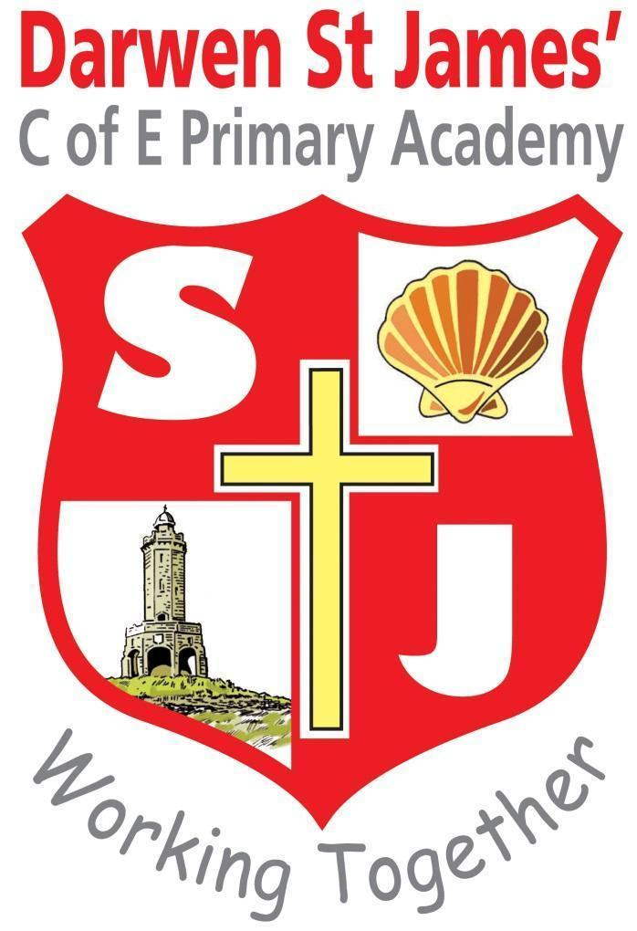

SCIENCE POLICY 2025-26

Mission

Nurturing ambition through a living faith.

Vision

Our academy delivers a purposeful curriculum through its living Christian faith. We nurture ambition in all our learners in order for them to become positive citizens of tomorrow.

Bible

Let us not love with words or speech alone but with actions or truth. John 3:18.

Introduction

At Darwen St James we teach Science to all EYFS, key stage 1 and key stage 2 children as part of the normal school curriculum. The school uses the Kapow Science Scheme as a framework for planning and the EYFS curriculum.

Aims and Objectives
Science teaches an understanding of natural phenomena. It aims to stimulate a child’s curiosity in finding out why things happen in the way they do. It teaches methods of enquiry and investigation to stimulate creative thought. Children learn to ask scientific questions and begin to appreciate the way science will affect their future on a personal, national, and global level.
.
The aims of science are to enable children at Darwen St James’ C of E Primary School to:
• Ask and answer scientific questions.
• Plan and carry out scientific investigations, using equipment, including computers, correctly.
• Know and understand the life processes of living things.
• Know and understand the physical processes of materials, electricity, light, sound and natural forces.
• Know about the nature of the solar system, including the earth.
• Evaluate evidence and present their conclusions clearly and accurately.

Achieving and maintaining high standards
At Darwen St James’ C of E Primary Academy we use a variety of teaching and learning styles in science lessons. Our principal aim is to develop children’s knowledge, skills, and understanding. Sometimes we do this through whole-class teaching, while at other times we engage the children in an enquiry-based research activity. We encourage the children to ask, as well as answer scientific questions. They have the opportunity to use a variety of data, such as statistics, graphs, pictures, and photographs. They use ICT in science lessons where it enhances their learning. They take part in role-play and discussions and they present reports to the rest of the class. They engage in a wide variety of problem-solving activities. Wherever possible, we involve the pupils in ‘real’ scientific activities, for example, researching a local environmental problem or carrying out a practical experiment and analysing the results.

Planning
At Darwen St James’ C of E Primary School we use the Kapow scheme of work for science as the basis of its curriculum planning. Each unit contains information and advice required for teachers to provide excellent learning opportunities for their children:
- Clear learning expectations
- Engaging activities to enable the learning to happen
- Advice for each activity as to the type of recording the children could do
- Resources required
- Preparation required
- Key vocabulary
- Background science knowledge for teachers
- Information on key scientists who have worked in the different areas of science
- Assessment tasks for each of the units.
- Explore, engage and extend activities to hook children into their learning
- Website links
- Very clear and plentiful examples of how children will be able to address ‘working scientifically’ through practical learning.

The class teacher is responsible for editing the daily lesson plans for each lesson to meet the needs of their pupils (short-term plans). These plans list the specific learning objectives of each lesson.
The topics in science build upon prior learning. We ensure that there are opportunities for children of all abilities to develop their skills and knowledge in each unit and we also build progression into the science scheme of work, so that the children are increasingly challenged as they move up through the school.

We teach science in EYFS classes as an integral part of the topic work covered during the year. As the EYFS classes are part of the Foundation Stage of the National Curriculum, we relate the scientific aspects of the children’s work to the objectives set out in the EYFS Framework which underpin the curriculum planning for children aged three to five. Science makes a significant contribution to the objective in the EYFS by developing a child’s knowledge and understanding of the world, e.g. through investigating what floats and what sinks when placed in water.

In KS 1 and 2, children record their learning in their own Science books..

Teaching Science to Children with Special Educational Needs
Where necessary, adaptations will be made to the curriculum, to equipment and resources to allow access to Science for pupils with SEND, including provision for pupils that are extremely able in Science.

Assessment, Recording and Reporting
At Darwen St James’ C of E Primary School we assess children’s work in science by making informal judgements as we observe them during lessons. On completion of a piece of work, the teacher marks the work and comments as necessary. Parents are also informed of their child’s progress in the reports throughout the year.

Tracking and Monitoring
It is the responsibility of the science subject leader to monitor the standards of children’s work and the quality of teaching in science. The science subject leader is also responsible for supporting colleagues in the teaching of science, for being informed about current developments in the subject and for providing a strategic lead and direction for the subject in the school. The science subject leader will write regular reports in which s/he evaluates strengths and weaknesses in the subject and indicates areas for further improvement.

Updated November 2025

Mrs Gonzalez

