Art and Design and Design Technology Whole School Overview 24 25
 | AUTUMN 1 | AUTUMN 2 | SPRING 1 | SPRING 2 | SUMMER 1 | SUMMER 2
N | MARK MAKING AND SOUND  Experiments with a range of media, tools,  materials, sound and whole body movement  through multi-sensory exploration. When holding  crayons, chalks, etc., makes connections between  their movement and the marks they make. |  | CREATING MATERIALS  Enjoys the sensory experience of making marks  in food, damp sand, water, mud, paste or paint.  Notice and becomes interested in the  transformative effects of their action on materials  and resources. |  | MOTOR SKILLS  Manipulates objects using hands singularly and  together. Shows increasing control in holding,  using and manipulating a range of tools and  objects. Holds mark making tool with thumb and  all fingers.
Pre | HOW CAN WE EXPLORE MATERIALS AND MARKS  Nursery night time collage  Transforming objects  Printing with string  Galaxy painting  Autumn floor textiles  Collage with wax crayon rubbing |  | HOW CAN WE US OUR BODIES TO MAKE ART  Dancing to art  Movement maps  Hands, feet and flowers  Repeat pattern printing roller  To colour (what does colour smell like and feel  like) |  | HOW CAN WE EXPLORE 3D MATERIALS  Insect hotels  Fruit and veg heads  Magic caring box  Clay pens  Marble hole punch sketch books
Rec | WHAT CAN WE SEE Finding circles Shells –  observational and imaginative drawing Collecting,  arranging and drawing Still life compositions inspired  by Cezane |  | HOW CAN WE EXPLORE COLOUR  Explorers books – collecting colour T-shirt paintings |  | HOW CAN WE BUILD WORLDS  World in a matchbox Prop making for toys Creating a  book world
YEAR 1 | FOOD  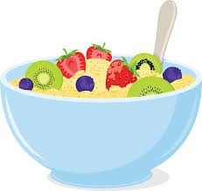  Develop a food vocabulary using taste, smell, texture and feel; Group familiar food products e.g. fruit and vegetables; Explain where food comes from; Cut, peel, grate, chop a range of ingredients; Work safely and hygienically; Understand the need for a variety of foods in a diet; Measure and weigh food items, non-statutory measures e.g. spoons, cups.  Outcome:  A modern, healthy, fruity porridge | DRAWING & SKETCHBOOKS  SPIRALS  Using drawing, collage and mark-making to explore spirals. Introducing sketchbooks.  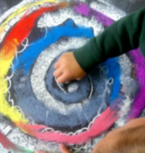  Outcome:  A range of spiral drawings | WORKING IN 3D  PLAYFUL MAKING  Exploring materials and intention through a playful approach.  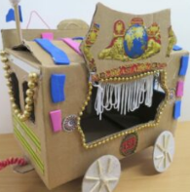  Outcome:  3D weather symbols | TEXTILES  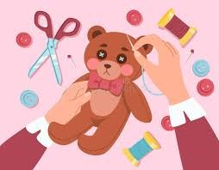  Cut out shapes which have been created by drawing round a template onto the fabric; Join fabrics by using e.g. running stitch, glue, staples, over sewing, tape; Decorate fabrics with attached items e.g. buttons, beads, sequins, braids, ribbons; Colour fabrics using a range of techniques e.g. fabric paints, printing, painting.  Outcome:  A stuffed teddy | SURFACE & COLOUR  INSPIRED BY FLORA & FAUNA  Explore how artists make art inspired by flora and fauna. Make collages of MiniBeasts and display as a shared artwork.  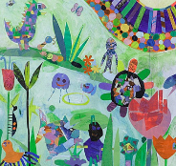  Outcome:  Make a collage of plants and minibeasts | MECHANISMS  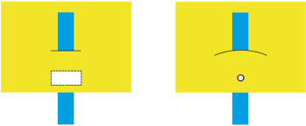  Join appropriately for different materials and situations e.g. glue, tape; Fold, tear and cut paper and card; Cut along lines, straight and curved; Use a hole punch; Insert paper fasteners for card; Experiment with levers and sliders to find different ways of making things move in a 2D plane.  Outcome:  A picture of an explorer moving across a scene
YEAR 2 | STRUCTURES  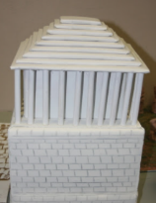  Explore how to make structures stronger; Investigate different techniques for stiffening a variety of materials; Test different methods of enabling structures to remain stable; Join appropriately for different materials and situations e.g. glue tape; Mark out materials to be cut using a template.  Use a glue gun with close supervision.  Outcome:  A new wonder of the world | DRAWING & SKETCHBOOKS  EXPLORE & DRAW  Introducing the idea that artists can be collectors & explorers as they develop drawing and composition skills.  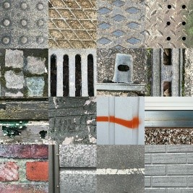  Outcome:  A composition using cut outs of own work and collage | WORKING IN 3D  BE AN ARCHITECT  Exploring architecture and creating architectural models.  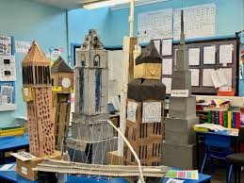  Outcome:  An architectural building that would fit in in Shanghai | MECHANISMS  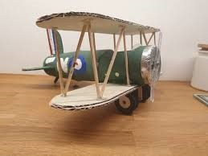  Try out different axle fixings and their strengths and weaknesses; Make vehicles with construction kits which contain free running wheels; Use a range of materials to create models with wheels and axles e.g. tubes, dowel, cotton reels; Roll paper to create tubes; Cut dowel using hacksaw and bench hook; Attach wheels to a chassis using an axle; Mark out materials to be cut using a template.  Outcome:  An old-fashioned aeroplane on wheels | SURFACE AND COLOUR  EXPLORING THE WORLD THROUGH MONO PRINT  Using a simple mono print technique to develop drawing skills, encourage experimentation and ownership.  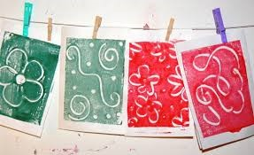  Outcome:  A simple crown using mono printing | FOOD  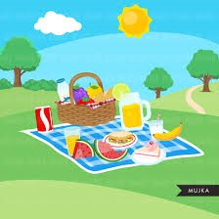  Develop a food vocabulary using taste, smell, texture and feel; Group familiar food products e.g. fruit and vegetables; Explain where food comes from; Cut, peel, grate, chop a range of ingredients; Work safely and hygienically; Understand the need for a variety of foods in a diet; Measure and weigh food items, non-statutory measures e.g. spoons, cups.  Outcome:  A picnic to take on a visit to the seaside

 | AUTUMN 1 | AUTUMN 2 | SPRING 1 | SPRING 2 | SUMMER 1 | SUMMER 2
YEAR 3 | FOOD  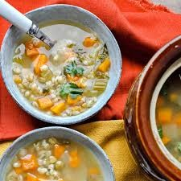  Develop sensory vocabulary / knowledge using, smell, taste, texture and feel; Analyse the taste, texture, smell and appearance of a range of foods (predominantly savoury); Follow instructions / recipes; Make healthy eating choices – use the Eatwell plate; Join and combine a range of ingredients; Explore seasonality of vegetables and fruit; Find out which fruit and vegetables are grown in countries/continents studied in Geography.  Outcome:  A warming broth for the Antarctic | SURFACE & COLOUR  Explore how artists combine media to create work in response to landscape. Use acrylic and thread to make a volcano.  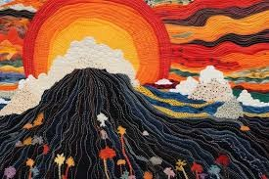  Outcome:  A volcanic picture with stitching to add detail | DRAWING & SKETCHBOOKS  Making loose, gestural drawings with charcoal, and exploring drama and performance.  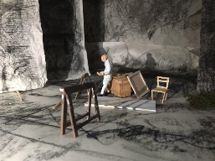  Outcome:  A cave drawn with charcoal and caveman project | MECHANICAL SYSTEMS  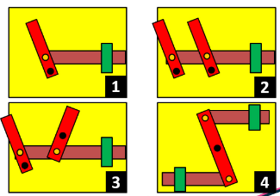  Develop vocabulary related to the project; Use lolly sticks/card to make levers and linkages; Use linkages to make movement larger or more varied.  Outcome:  A historical picture of a child working with levers and linkages to make it move – creating a collaborative class book | WORKING IN 3D  TELLING STORIES THROUGH DRAWING AND MAKING  Explore how artists are inspired by other art forms – in this case how we make sculpture inspired by literature and film.  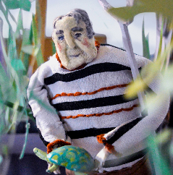  Outcome:  A 3D model of a character inspired by the play scripts read in English | STRUCTURES  Develop vocabulary related to the project; Create shell or frame structures; Strengthen frames with diagonal struts;  Make structures more stable by giving them a wide base; Measure and mark square section, strip and dowel accurately to 1cm. painted and stitched piece.  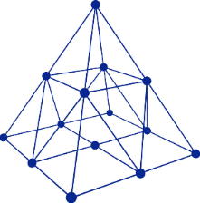  Outcome:  A pyramid structure made from doweling
YEAR 4 | DRAWING & SKETCHBOOKS  STORYTELLING THROUGH DRAWING  Explore how artists create sequenced drawings to share and tell stories. Create accordion books or comic strips to retell poetry or prose through drawing.  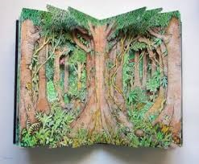  Outcome:  A zine book based on the rainforest | TEXTILES  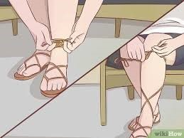  Develop vocabulary for tools materials and their properties.  Understand seam allowance.  Join fabrics using running stitch, over sewing, blanket stitch; Prototype a product using J cloths; Use prototype to make pattern; Explore strengthening and stiffening of fabrics; Explore fastenings (inventors?) and recreate some; Sew on buttons and make loops; Use appropriate decoration techniques.  Outcome:  A pair of Roman sandals (focus on sewing base and adding ribbon for ties) | FOOD  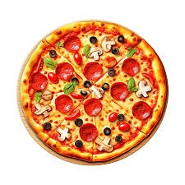  Develop sensory vocabulary / knowledge using, smell, taste, texture and feel; Analyse the taste, texture, smell and appearance of a range of foods (predominantly savoury); Follow instructions / recipes; Make healthy eating choices – use the Eatwell plate; Join and combine a range of ingredients; Explore seasonality of vegetables and fruit; Develop understanding of how meat / fish are reared/caught.  Outcome:  A pizza with locally sourced / seasonal food toppings | SURFACE & COLOUR  EXPLORING PATTERN  Exploring how we can use colour, line and shape to create patterns, including repeating patterns.  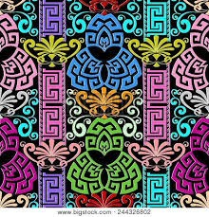  Outcome:  A pattern based on Greek design | ELECTRICAL SYSTEMS & ICT  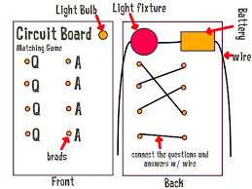  Incorporate a circuit into a model; Use electrical systems such as switches bulbs and buzzers; Use ICT to control products.  Outcome:  An electrical quiz game based on the water cycle | WORKING IN 3D  THE ART OF DISPLAY  Explore how the way we display our work can affect the way it is seen.  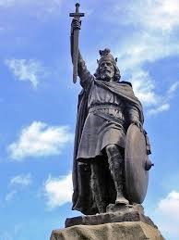  Outcome:  A statue positioned on a plinth based on a person from Anglo Saxon times

 | AUTUMN 1 | AUTUMN 2 | PRING 1 | SPRING 2 | SUMMER 1 | SUMMER 2
YEAR 5 | DRAWING & SKETCHBOOKS  TYPOGRAPHY & MAPS  Exploring how we can create typography through drawing and design, and use our skills to create personal and highly visual maps.  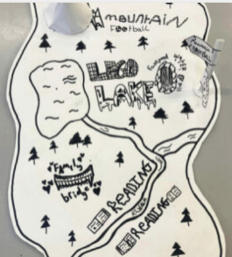  Outcome:  A 3D map inspired by the Tudors including typography | TEXTILES  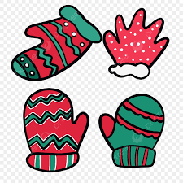  Use the correct vocabulary appropriate to the project; Create 3D products using patterns pieces and seam allowance; Understand pattern layout; Decorate textiles appropriately (often before joining components); Pin and tack fabric pieces together; Join fabrics using over sewing, back stitch, blanket stitch or machine stitching (closer supervision); Combine fabrics to create more useful properties; Make quality products.  Outcome:  A sewn pair of hand warmers suitable to wear in the Alps | FOOD  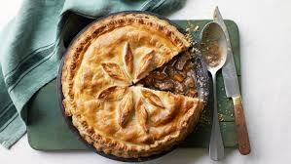  Prepare food products taking into account the properties of ingredients and sensory characteristics; Weigh and measure using scales; Select and prepare foods for a particular purpose; Work safely and hygienically; Show awareness of a healthy diet (using the eatwell plate); Use a range of cooking techniques; Know where and how ingredients are grown and processed; Consider influence of chefs e.g. Jamie Oliver and school meals.  Outcome:  A pie for the local cotton mill children | SURFACE & COLOUR  MAKING MONOTYPES  Combine the monotype process with painting and collage to make visual poetry zines.  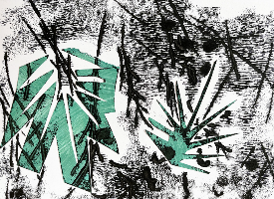  Outcome:  A visual poetry zine about the desert | MECHANICAL SYSTEMS  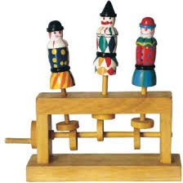  Develop a technical vocabulary appropriate to the project; Use mechanical systems such as cams, pulleys and gears.  Outcome:  A toy that could be used by a child in the early 1940s | WORKING IN 3D  SET DESIGN  Explore creating a model set for theatre or animation inspired by poetry, prose, film or music.  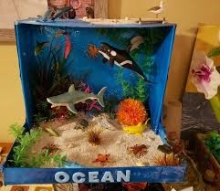  Outcome:  A set design of the ocean in a shoebox
YEAR 6 | ELECTRICAL SYSTEMS & ICT  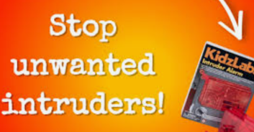  Use electrical systems such as motors; Program, monitor and control using ICT.  Outcome:  An alarm for a box of school playground equipment | DRAWING & SKETCHBOOKS  2D DRAWING TO 3D MAKING  Explore how 2D drawings can be transformed to 3D objects. Work towards a sculptural outcome or a graphic design outcome.  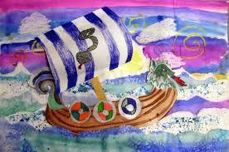  Outcome:  A Viking longboat / home 2D to 3D structure | STRUCTURES  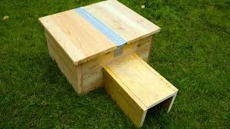  Use the correct terminology for tools materials and processes; Use bradawl to mark hole positions; Use hand drill to drill tight and loose fit holes; Cut strip wood, dowel, square section wood accurately to 1mm; Join materials using appropriate methods; Build frameworks to support mechanisms; Stiffen and reinforce complex structures.  Outcome:  A home for an wild animal in the local area – hedgehog / bird / insect | FOOD  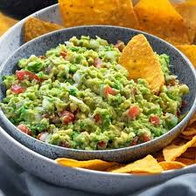  Prepare food products taking into account the properties of ingredients and sensory characteristics; Weigh and measure using scales; Select and prepare foods for a particular purpose; Work safely and hygienically; Show awareness of a healthy diet (using the eatwell plate); Use a range of cooking techniques; Know where and how ingredients are grown and processed; Consider influence of chefs e.g. Jamie Oliver and school meals.  Outcome:  A Maya inspired tortilla and dip | WORKING IN 3D  SHADOW PUPPETS  Explore how traditional and contemporary artists use cutouts and shadow puppets.  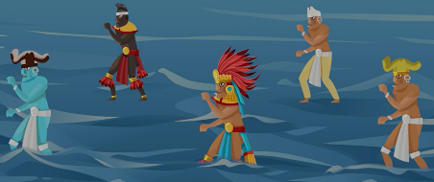  Outcome:  Shadow puppets for the Maya creation story | SURFACE & COLOUR  ACTIVISM  Explore how artists use their skills to speak on behalf of communities. Make art about things you care about.  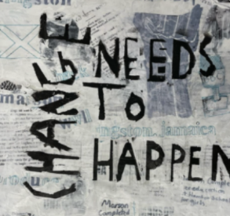  Outcome:  An activism style poster based on the effects of climate change / traffic / litter in the local area

