 | Year 1 | Year 2 | Year 3 | Year 4 | Year 5 | Year 6
National Curriculum  Objectives | Pupils should be taught:  - to use a range of materials creatively to design and make products  - to use drawing, painting and sculpture to develop and share their ideas, experiences and imagination  - to develop a wide range of art and design techniques in using colour, pattern, texture, line, shape, form and space  - about the work of a range of artists, craft makers and designers, describing the differences and similarities between different practices and disciplines, and making links to their own work. |  | Pupils should be taught to develop their techniques, including their control and their use of materials, with creativity, experimentation and an increasing awareness of different kinds of art, craft and design.  Pupils should be taught:  - to create sketch books to record their observations and use them to review and revisit ideas  - to improve their mastery of art and design techniques, including drawing, painting and sculpture with a range of materials [for example, pencil, charcoal, paint, clay]  - about great artists, architects and designers in history.
 | Year 1 Artists may cover: | Year 2 Artists may cover: | Year 3 Artists may cover: | Year 4 Artists may cover: | Year 5 Artists may cover: | Year 6 Artists may cover:
 | 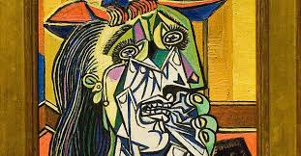  Drawing/Collage (Self Portraits) - Artist - Pablo Picasso  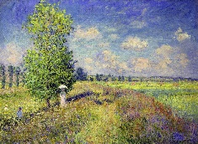  Drawing/Painting (Landscapes) - Artist - Claude Monet  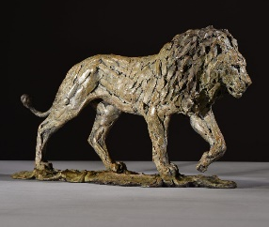  Drawing/Printing/3D Form – (Animals) Sculptor - Hamish Mackie | 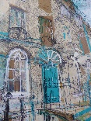  Drawing/Printing (Buildings)- Artists – Claire Caulfield & Lucy Jones  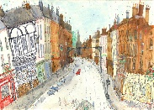  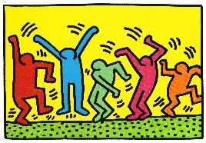  Drawing/Painting/3D Form – (Figures) Artist - Keith Haring  Drawing/Collage – (Textures) Artist - Carla Bosch  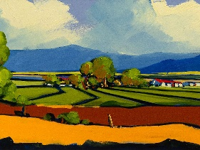 | Drawing/Printing – (Fossils) Artist - Christa Rijneveld  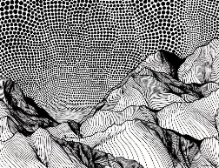  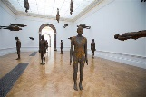  Drawing/3D Form – (Sculpture) Sculptor - Claes Oldenburg & Antony Gormley  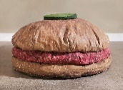  Drawing/Collage – (Greek Vases) Ceramicist - Grayson Perry  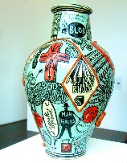  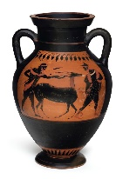 | Drawing/Collage 3D Form - Cardboard Artwork - Harry Thubron  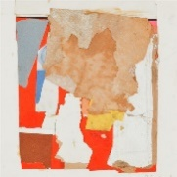  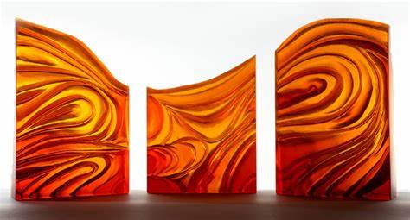  Drawing/Printing/Painting (Elements of Nature) - Artist - Adriana Brinsmead-Stockham  Book – How to Train your dragon – Cressida Cowell  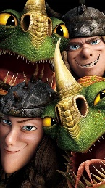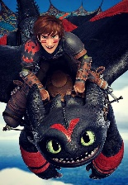 | Collage, 3D Form, Painting – (Packaging) – Artist – Ron Magnes  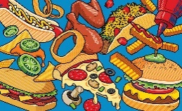  Drawing/Digital Media/Printing (Environment/Land Art) – Artist – Andy Goldsworthy  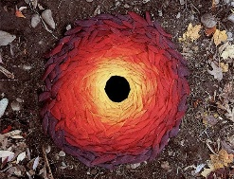  Drawing/Collage/Painting - Artist – Michael Lang & Jim Dine  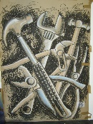  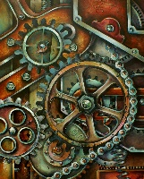 | Digital Media/Collage – (Photomontage) - Artist - David Hockney  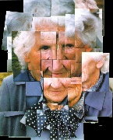  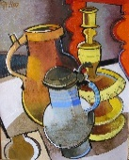  Drawing/Painting (Still Life) - Artist – George Braque & Geoffrey Key  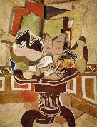  Drawing/Painting/3D Form – (Self Portrait) Artists – L.S Lowry & Frida Kahlo  