Our Values
‘At the heart of the community, we welcome and nurture, promoting resilience, growth and independence within our inspiring and transformative environment.’
ENJOY EMBRACE EVOLVE
At Delph Side, we intend for our pupils to acquire the skills and knowledge which will enable them to develop as individuals - to be emotionally literate, confident, caring, concerned and committed to their own development, yet aware of their responsibilities to others. We believe that positive and respectful behaviour is the responsibility of all ‘Delph Siders’, and should be modelled, supported and taught by parents, carers and Delph Side staff alike.
We believe that children behave positively when they ENJOY coming to school and being part of a wider community of friends and family who care about each other equally. Children should enjoy their learning and enjoy their time in class, which as a result, leads to much happier learners.
We believe that positive behaviour is supported when children and staff EMBRACE a high standard of expected behaviour, conduct, self-discipline and respect for themselves and others. Children should embrace reasonable challenges and overcome challenging milestones with the support of trusted adults.
We believe that behaviour expectations can be modelled by supportive adults, and that children can EVOLVE in their behavioural culture by observing high-quality examples throughout our school. Children who evolve their behaviour and learn from experience go on to become more resilient and help others to grow with them along their Delph Side journey.
Our values were created by staff, pupils and governors who collaborated to select ENJOY, EMBRACE and EVOLVE, along with key attributes which feed into our values:
- Positivity
- Resilience
- Empathy
- Belief
- Trust
- Nurture
- Community
- Respect
- Voice
- Responsibility
- Honesty

School Leadership
At Delph Side, we believe it is every person’s duty to uphold the expected standard of behaviour for our children to observe and follow, as high-quality role models. Our staff will lead by example by modelling the highest behavioural standards in their professional conduct, their interactions with each other and the relationships we form with our Delph Siders. We are committed to fairness, positivity and restoring justice; we listen to our children and demonstrate how to resolve conflict amicably with respect and dignity, but also with firmness.
Senior Leaders will support all staff members in promoting positive behaviour and lead on managing challenging behaviours across the school – being supportive coaches to teaching and learning staff. Senior Leaders will record, monitor and action behaviour which falls short of the high standards we set, and will report to the Governing Body on behavioural challenges, initiatives and development opportunities that arise. Leaders will also arrange for suitable training and development opportunities for staff to enable them to effectively deliver our behaviour policy.
Roles and Responsibilities
It is the responsibility of every staff member to encourage and model positive, respectful and socially acceptable behaviour at Delph Side, and to apply appropriate sanctions when negative, disrespectful or unsociable behaviours are observed in any setting within school.
We will involve parents when behaviour problems arise, at an early stage rather than as a last resort. This will be achieved through daily conversations at our classroom doors, through our Seesaw app and by promptly telephoning parents on the same day.
Our Pupils
Our pupils are active learners who engage with the activities set by their teachers. Through their enthusiasm for learning and the tasks at hand, our children will aim high with positivity in class and will strive to maintain their own high standards of behaviour, etiquette and interactions with others.
Through our Growth Mindset philosophy, our children are expected to positively impact on others’ well-being, by demonstrating positive attitudes to their learning and the learning of their peers. Pupils will be given responsibilities to help with managing everyday school life. Through their own contributions to wider school events, environments and procedures, the children will own and value their community and the people who make it a valued place.
Pupils will be encouraged:
- To respect each other’s right to speak and give opinions
- To help each other
- Not to put other people down or laugh at them
- Not to make personal comments
Our Parents
Parents are the first educators. They play a crucial part in shaping their children’s personalities and attitudes and continue to have a powerful influence over them throughout their school years. We believe that parents have a vital role in promoting good behaviour in school.
Delph Side expect to be supported by the parents of our pupils, in all matters involving negative behaviour, investigations into negative behaviour – including allegations of bullying - and in follow-up support opportunities.
Promoting Good Behaviour in All Areas of Our School
We believe that all behaviour is communication, and behaviour is most positive when children feel safe, secure and happy in their environment. At Delph Side, we strive to create this environment along with the engagement, stimulation and challenge that draws out the very best behaviours in all our Delph Siders.
We promote good behaviour using an array of strategies, which include the following:
- Our Delph Side Behaviour Steps (see appendices) which offer a systematic and scaled approach to managing behaviour, setting out appropriate and corresponding consequences and staff actions.
- Our Delph Side Behaviour Steps are visible in every learning area of school – for staff and children’s quick reference.
- EYFS-friendly Delph Side Behaviour Steps – with visual aid to support EYFS children
- Our Values – ENJOY, EMBRACE and EVOLVE – are woven into every lesson, visible in every room, and referenced in every weekly Gathering.
- Weekly Gathering – a virtual and in-person celebration of achievements, extra-curricular successes and weekly attendance.
- Values Badges – ENJOY, EMBRACE and EVOLVE badges awarded to children from each class in weekly Gathering.
- Trackit Lights behaviour management system to be used with ‘green’ behaviour points used in each class to reward positive behaviours. Green behaviour points will contribute towards ENJOY, EMBRACE and EVOLVE house teams.
- ‘Spotted’ badges awarded for positive behaviour, acts of kindness and supportive behaviour – noticed secretly by staff.
- ‘Making the Difference’ awards presented to children who have impressed with exceptional behaviour or contributions to school life or in the wider community.
- Attendance celebrated.
- Passport to Privilege – a reward system in each class which all children contribute towards. Rewards (chosen by each class teacher) are placed at various points milestones that classes achieve together.
- A restorative approach to resolving behavioural disputes and negative choices by ‘fixing’ situations between the victim and the aggressor.
- Visiting another class to share achievements, great work or share successes.
- Visiting SLT to share achievements, great work or share successes.
- Sharing achievements, great work or sharing successes via school social media.
- Sharing achievements, great work or sharing successes via the Seesaw app.
- Collective worship opportunities, SLT assemblies and subject leader assemblies to promote positive ethos and understanding of cultures, ideas, subject areas and lifestyles.
Classroom Management
In addition to ‘promoting good behaviour’ and the strategies outlined above, class teachers are given freedom to create and manage behaviour rewards which are suitable, appropriate and meaningful to their cohort of pupils – based on our knowledge and understanding of the pupils in their class. As outlined above, each class has its own Passport to Privilege which may include some of the following rewards:
- Extra break times
- Bring in a mascot day
- Non-uniform day
- Use of technology, such as Chrome books or iPads to enhance fun learning
- Extra PE opportunities
- Break a rule (such as bring in a treat for your snack)
- Pyjama day
All the above extrinsic opportunities come second to intrinsic, daily, ‘in the moment’ rewards of positive verbal feedback, celebration, acknowledgement of daily successes by all members of staff – in line with our Delph Side Behaviour Steps and our Values.
To effectively manage classroom behaviour for maximum teaching and learning, we will employ strategies such as, but not limited to:
- Differentiated learning tasks to provide suitable, engaging levels of challenge
- Well-constructed seating plans to limit disruption and maximise learning
- Provide hand-over meetings between teachers
- Offer quality-first teaching engage all learners and minimise opportunities for negative behaviours
- Utilise Teaching Assistants effectively to offer learning support
- Observe, review and feedback on classroom management through behaviour learning walks and audits
- Ensure lessons offer suitable pace, timings, challenges and enjoyment
- Use our Delph Side Behaviour Steps fairly, consistently and constructively

Preventing Bullying
The Department for Education states that no legal definition is outlined for what bullying constitutes, but provides the following guidance:
“There is no legal definition of bullying.
However, it’s usually defined as behaviour that is:
- repeated
- intended to hurt someone either physically or emotionally
- often aimed at certain groups, for example because of race, religion, gender or sexual orientation
It takes many forms and can include:
- physical assault
- teasing
- making threats
- name calling
- cyberbullying - bullying via mobile phone or online (for example email, social networks and instant messenger)”
- prejudice based bullying
- discriminatory bullying
Bullying, in all forms, will not be tolerated at Delph Side Primary School and is treated with urgency and is prioritised by all members of staff as part of our Safeguarding Policy, Anti-bullying Policy, Online Safety Policy and Social Media Policy.
We include all forms of bullying in our investigating of bullying incidents and concerns, and while we acknowledge that it is difficult to eliminate bullying in schools, we will act swiftly, decisively, fairly and justly to investigate bullying and ensure that our Delph Siders feel safe, secure and can fully meet our VALUES.
To prevent bullying and deal with any incidents of bullying, we employ a range of strategies:
- ‘Anti-Bullying Week’ is observed
- ‘Anti-Bullying Week’ materials are also used throughout the year
- Jigsaw PSHE curriculum
- Collective Worship
- Monitoring of communal areas at breaks and lunches
- Monitoring of playground by Senior Leaders and supervision by teaching staff
- Family Wellbeing Officer
- Educating around bullying and the impact it has
- Approachable staff who the children can have confidence in when disclosing bullying incidents and concerns
- Ongoing training and support given to Welfare and Support Staff
- Monitoring of playtimes by Behaviour Leader
- Computing curriculum which includes online safety, and our Online Safety Policy
- ‘Faith Week’ is observed to break down cultural barriers and educate children about diversity.
- Well-staffed break and lunch times on the playground.

Screening and Searching
There are two sets of legal provisions which enable our school staff to confiscate items from pupils:
- The general power to discipline enables a member of staff to confiscate, retain or dispose of a pupil’s property as a punishment. Staff are protected against liability for damage to, or loss of, any confiscated items provided they have acted lawfully and reasonably. Confiscated items that represent potential harm to pupils or staff will be secured in the school office before they can be disposed of/handed to the relevant authority.

- Power to search without consent for 'prohibited items' including:
- Knives and weapons
- Alcohol
- Illegal drugs
- Stolen items
- Tobacco and cigarette papers
- Pornographic images
- Any article that has been or is likely to be used to commit an offence, cause personal injury or damage to property
- Any item banned by the school rules which has been identified in the rules as an item which may be searched for
Weapons, knives, illegal substances and extreme or child pornography must be handed to the Police. Otherwise, it is for the teacher, and Senior Leaders, to decide if and when to return an item, or whether to dispose of it.
The school also reserves the right to follow DfE advice on Searching, Screening and Confiscation where there is a need to search a pupil for a mobile device relating to Online Safety (See Online Safety Policy and Social Media Policy).

Behaviour of Pupils with Additional Needs
To support the behaviour of pupils with additional needs, we will offer provision and flexibility which will enable pupils to regulate their own behaviour and give them the best opportunity to access mainstream teaching and learning, whilst respecting the rights of other pupils in our classrooms.
Our Behaviour Leader and SENDCO will meet to discuss the needs of pupils with SEND and with needs which may impact their ability to regulate their behaviour. We will assess, plan, deliver and review the support in place for pupils requiring additional support. As part of our consultation in planning effective SEND support, we will meet with parents to establish possible triggers for behaviours and understand remedial actions and effective strategies for de-escalating or pre-empting negative behaviour. In addition, we will make reasonable adjustments to classroom routines and classroom environments for pupils to maximise the likelihood for positive behaviour, such as: seating plans, planned breaks or sensory diet sessions, planned adult support and apdated learning.
Communication & Regulation Plans
To facilitate the tailored support that many of our pupils require, we will work in conjunction with parents to develop a Communication & Regulation Plan for any child who requires additional behavioural support.
We will meet with pupils, families and key staff in school to develop a plan of support, strategies and provision to promote the pupil’s wellbeing. A Communication & Regulation Plan will include possible triggers and will outline early anxiety behaviours, defensive behaviours and crisis behaviours -providing staff with useful strategies to help de-escalate behaviours and regulate the pupil safely and with dignity.
Plans will be reviewed regularly and will reflect the current provision and support required for the pupil as they progress through their time at Delph Side.
Child-on-child abuse
We are mindful that negative behaviours can occur between pupils and can take many forms and can also occur for a range of reasons. We are committed to investigating incidents which may present as bullying and those which may be abusive. We recognise the possibility of child-on-child abuse, and as part of our safeguarding and anti-bullying policies, Senior Leaders will investigate such incidents to their end – informing parents of findings and referring to relevant agencies where the circumstances permit.
As part of our investigation into child-on-child abuse, we will consider:
- The wishes of the victim in terms of how they want to proceed
- The nature of the alleged incident
- The ages of the children involved
- The development stages of the children involved
- Any power imbalance between the children
- Is the incident a one-off or a sustained pattern of abuse
- Are there ongoing risks to the victim, other children, school or college staff
- Contextualised safeguarding issues.
Suspensions, Off-site directions, Managed Moves and Exclusions
We are committed to ensuring that pupil negative behaviour is addressed, and pupils are offered timely, suitable support to enable them to restore their behaviour and make positive choices. Using our Delph Side Behaviour Steps and Playground Behaviour Steps, which are shared with pupils and parents and displayed in all public areas, we will endeavour to help children regulate their behaviour and work within the positive support systems provided.
For children whose behaviour has escalated, and continued negative behaviour has exhausted support options from step 1 to step 3 of our behaviour steps, an off-site direction may be utilised. This option is agreed upon by schools in our school cluster to allow the pupil to reflect on their more extreme behaviours and allow potential and proven victims to receive their own support through the aggressor’s absence. This is intended to be a short-term measure to help both the pupil and parents to address, reflect on and restore recent challenging behaviour. Parents and the pupil will be informed at every stage of our concerns, before and during a possible off-site direction.
In cases when off-site direction has been exhausted, we may use of a suspension as a way of addressing the severity and extremity of escalated behaviour. While this is unfortunate, we reserve the right to utilise a suspension – at the discretion of the head teacher and senior leaders. This is intended to be a short-term measure to help both the pupil and parents to address, reflect on and restore recent challenging behaviour. Parents and the pupil will be informed at every stage of our concerns, before and during a possible suspension.
When fixed term suspensions and off-site directions have been unsuccessful in restoring or remedying misbehaviour, we will ultimately utilise our right to a Managed Move. A Managed Move will only be actioned when all other support options have been exhausted, including the use of external support agencies and school cluster support – in conjunction with SEND support services – and has been sanctioned by the Headteacher and the Chair of Governors. We will engage with parents at every step of Managed Moves and consult with suitable primary settings to facilitate the transition and transfer of the pupil to their next primary setting.
In the most extreme circumstances, the headteacher may permanently exclude a pupil (in line with the DFE Suspension and permanent exclusion from maintained schools, academies and pupil referral units in England, including pupil movement August 2024).
Routines
We understand that clear, familiar routines offer structure, comfort and safety to our pupils, and to facilitate this, we provide daily routines which make life at Delph Side accessible and manageable for all pupils. Our breakfast club opens from 7.45am, and school gates open from 8.40am.
Adjustments to a typical timetable are available for pupils with additional needs, and can include structured support sessions in The Hub; with our Family Wellbeing Support Officer, sensory diet sessions, LEGO therapy, timetabled wellbeing sessions with our school therapy dog, and PE Plus sessions.
Physical intervention and support
At Delph Side, we recognise that on occasion, certain children may require physical support by our members of staff to ensure the safety of all children and staff. See our separate Use of Reasonable Force Policy.
Beyond the School Gate
We recognise that behaviour continues past our school gates and into the local community, and that our Delph Siders, whether in uniform or not, represent our school and our reputation. We also recognise that the emergence of social media, and its impact upon youngsters, can be a contributing factor to negative behaviour incidents outside of school. To address negative behaviours, including online behaviours, online hate, ‘trolling’ and even anti-social behaviour, we reserve the right to utilise our Delph Side Behaviour Steps, and the logical consequences set out in our steps to address behaviour effectively and appropriately beyond the school gate, if the behaviours:
- Bring Delph Side Primary School into disrepute
- Impact teaching and learning in school time
- Impact on staff school time by addressing ‘out of school’ behaviour
- Are being observed on numerous occasions without the child/children evolving their behaviour or outlook
This section should be read in conjunction with our Online Safety Policy, Computing Policy, Anti-Bullying Policy and Social Media Policy and with our Delph Side Behaviour Steps.

We are satisfied that the above Behaviour Policy is appropriate and to be adopted by the school. To be reviewed on an annual basis by the School Council, staff and Governing body.

This policy is referenced in:
- Staff Induction
- Child Protection & Safeguarding Policy
- Remote Learning Policy
- Acceptable Use Policy
- Online Safety Policy
- Cyber-Bullying Policy

Trackit Lights
Delph Side uses the Trackit Lights behaviour management system to uniformly reward positive behaviour and to regulate negative behaviours – which is based on a traffic light system of 4 colours.
KS2 GREEN Behaviours | KS1 GREEN Behaviours
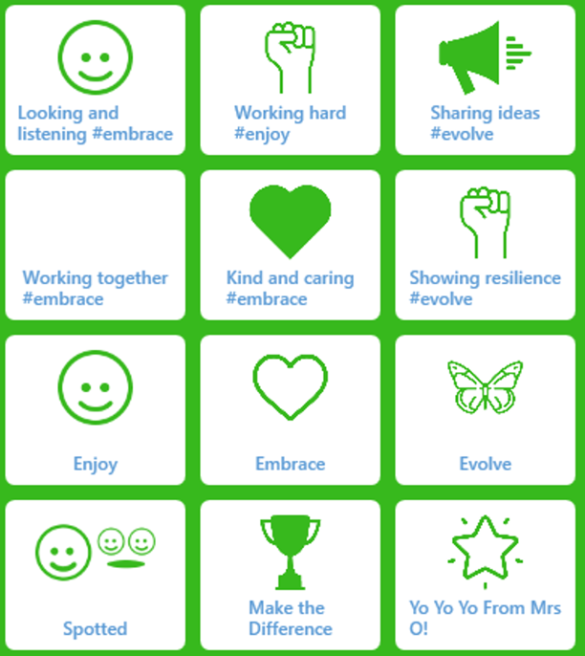 | 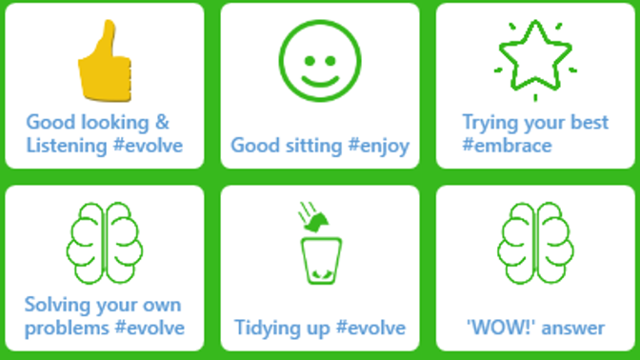

At Delph Side, to assist our day-to-day behaviour management and to enable our pupils to achieve their potential in each lesson, we will utilise the Trackit Lights behaviour management system.
We will refer to the Trackit Lights desktop app and iOS app to support children in making positive choices, which can be instantly recognised and rewarded. Trackit Lights is based around GREEN positive behaviours, where every child begins at GREEN and can receive GREEN POINTS for an agreed reason with the class teacher.
Spotting positive behaviours
When we spot positive behaviours, we will select GREEN and select a value which best represents the behaviour we have spotted. We will also clearly explain why the GREEN has been awarded – letting pupils know which positive attribute has been observed.
Each GREEN behaviour will award 1 point to the pupil and will award the point to the pupil’s Delph Side Values Team.
Mrs O reserves a special GREEN, which award the pupil and their team 10 points – to be used for an exceptional behaviour.

Amber behaviours
When a pupil’s behaviour choices don’t demonstrate positive attributes, or does not embody our Delph Side Values, we may use AMBER, which follows a verbal reminder of our expectations. An AMBER serves as a visual reminder to pupils, to encourage them to work on their current behaviour and earn GREEN points. This acts as an initial reminder. When a child demonstrates the positive attributes we love and expect, the pupil’s AMBER will be removed and will reset them back to ‘CLEAR’.
KS2 AMBER Behaviours | KS1 AMBER Behaviours
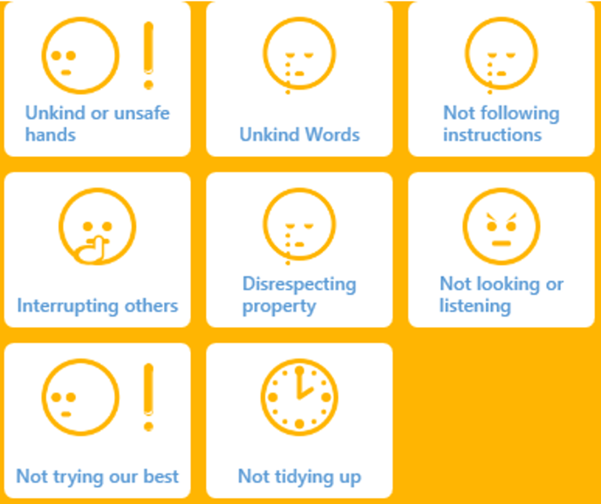 | 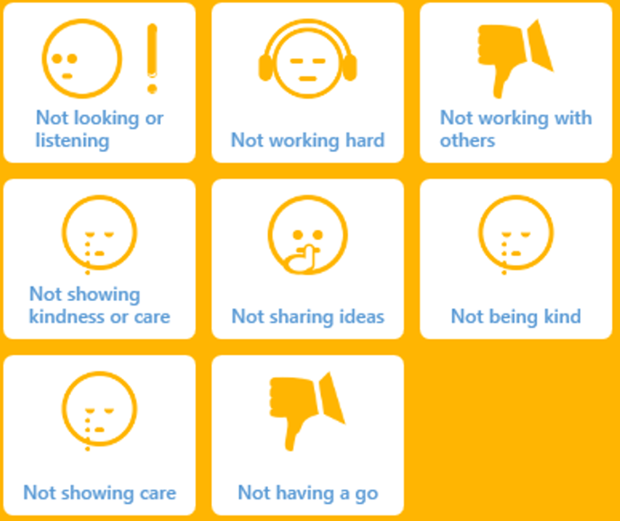

Yellow behaviours
On some occasions, following a verbal reminder, and an AMBER visual reminder, a pupil may continue to make negative choices. We will further remind pupils about the possibility of escalating to YELLOW or RED, but if attempts to support pupils in regulating their behaviour are unsuccessful (in line with our Behaviour Steps), we may convert a pupil’s AMBER – initial reminder – to a YELLOW final reminder. This will usually prompt pupils to self-regulate their behaviour and move towards more positive GREEN behaviours which embody our Delph Side Values.
We will make clear the reasons why a pupil has converted from AMBER to YELLOW – using similar phrasing to, ‘We must now use YELLOW, as you are not _____________. ‘

KS2 YELLOW Behaviours | KS1 YELLOW Behaviours
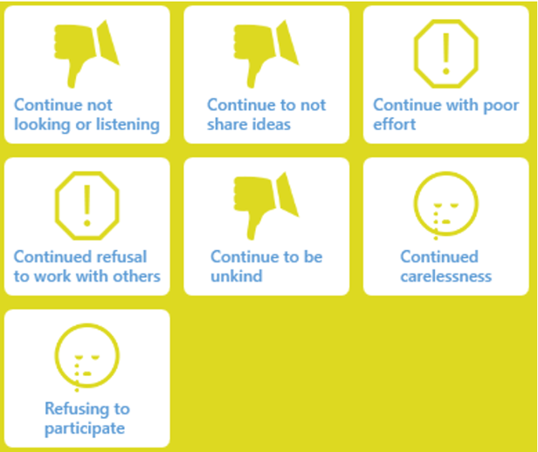 | 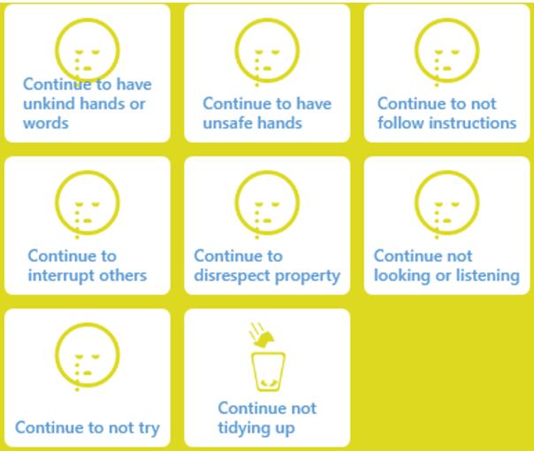

Red behaviours
On rare occasions, when attempts to support a pupil’s regulation towards positive behaviour has proven to be unsuccessful, we will convert a pupil from YELLOW to RED – selecting a specific reason from 7 possible scenarios which link to our Behaviour Steps.
KS2 RED Behaviours | KS1 RED Behaviours
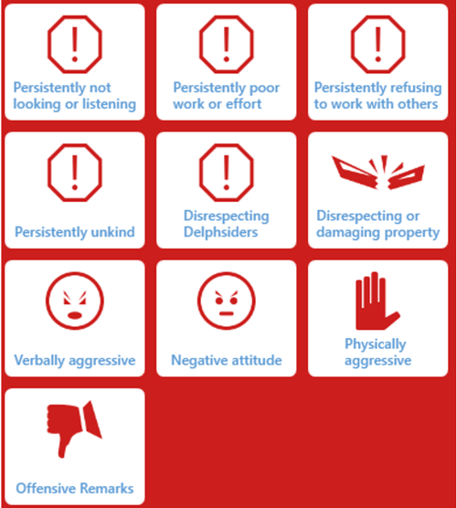 | 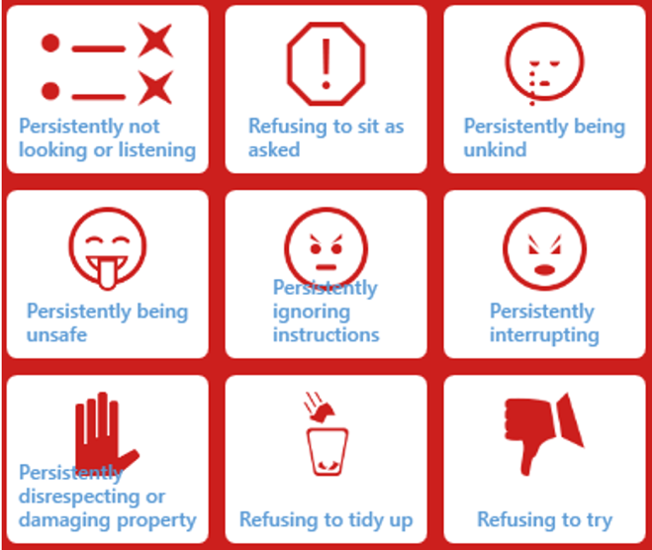

Sometimes, RED can be used when a pupil’s behaviour has not been progressively escalating, but when a single incident has been directly disrespectful, dangerous, verbally or physically offensive, property has been damaged or threatening and aggressive behaviours have been observed. This is in line with behaviours within Step 3, 4 and 5 of our Delph Side Behaviour Steps, which will typically be met with consequences from the Evolve section of Steps 3, 4 and 5.
Trackit Lights will be used in settings outside of the classroom, by all teaching and learning staff – on the playground, in the hall, during PE sessions, on residentials, on enrichment activities, during off-site learning, afterschool clubs and even when supporting behaviour standards ‘beyond the school gate’.
When RED behaviours are observed and recorded, resulting in agreed consequences, we will notify parents and carers to discuss incidents and how they were managed. Some pupils will find difficulty in regulating their behaviour and will already be identifying as requiring further support. Such pupils will have Communication and Regulation plans in place and may regularly use the Zones of Regulation system we utilise in our classrooms.
Delph Side Values Teams
Every child at Delph Side will be placed into one of 3 Values Teams: ENJOY, EMBRACE or EVOLVE. Each week, in our Gathering celebration assembly, we will reveal the number of GREEN behaviour points that each has – showing our pupils which team is in the lead.
Each half term, we will reward the winning team and will celebrate the team on our school social media. We will record the scores of each team, then reset GREEN points to zero to begin the next half term.
Cohorts and assigning points
Tracking data from Trackit Lights shows that adults should aim to award 6 GREEN points per lesson. We will award 6 GREEN points per adult, per lesson in order to promote our positive values and reward positive behaviour for learning. Our points will, as mentioned above, contribute to our Values Team points, which will be rewarded half-termly.
Within Trackit Lights, we have split our system into 2 cohorts (Rec and KS1, and KS2) in order to create a customized and bespoke series of GREEN behaviours, which have been designed by the teaching and learning team.
Zones of Regulation
At Delph Side, we recognise the importance of promoting positive mental health, recognising good emotional wellbeing and how we interact with and impact on each other’s general wellbeing. We aim to develop a culture of understanding around the discussion of mental health and the wellbeing of our peers, and to enable our pupils to regulate their emotions. By implementing the Zones of Regulation, we aim to teach our pupils to identify emotions in themselves and others and provide them with strategies to help regulate their emotions and improve their wellbeing.
The Zones of Regulation is a range of activities and visual strategies to help develop skills in self-regulation. We recognise that self-regulation, control and managing our feelings and emotional responses to events directly impacts our responses to situations and can determine how we perceive situations. To support our pupils in understanding their emotional state and how they may react as a result, we will display a Zones of Regulation Chart in each classroom, with pupils able to position their name into a zone that they feel reflects their current level of wellbeing or their current emotional state. This will be used by staff to gauge children’s needs and provide timely emotional and wellbeing support – allowing our pupils to feel heard and understood. This will enable staff and pupils to promptly discuss and regulate our pupils’ mental health and avoid negative situations from occurring or escalating.
The Zones of Regulation is a curriculum based around the use of four colours to help children self-identify how they’re feeling and categorise it based on colour. The curriculum also helps children better understand their emotions, sensory needs and thinking patterns. The children learn different strategies to cope and manage their emotions based on which colour zone they’re in. Additionally, the Zones of Regulation help children to recognise their own triggers, learn to read facial expressions, develop problem-solving skills, and become more attuned to how their actions affect other people.
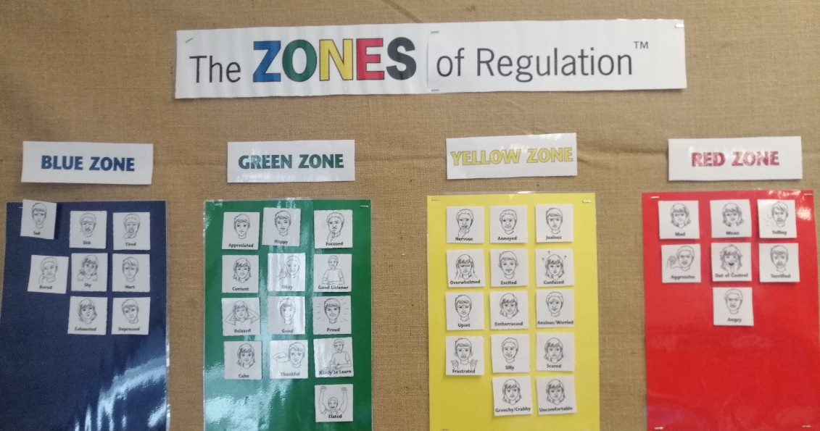

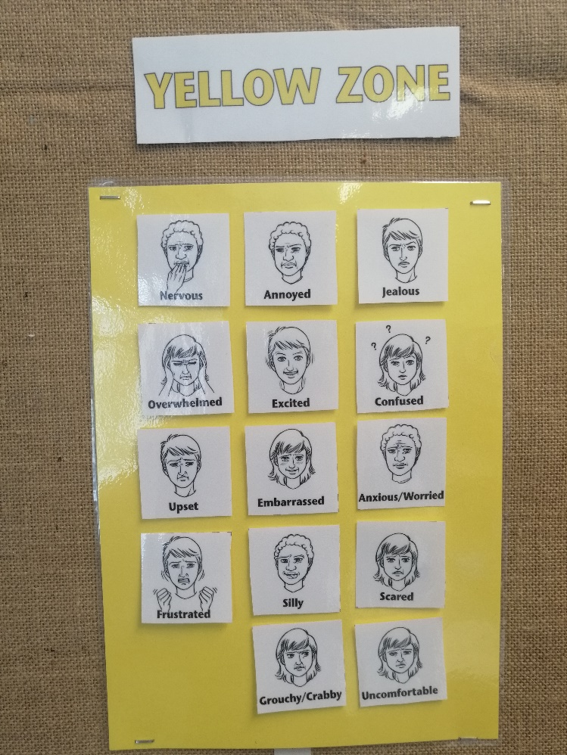
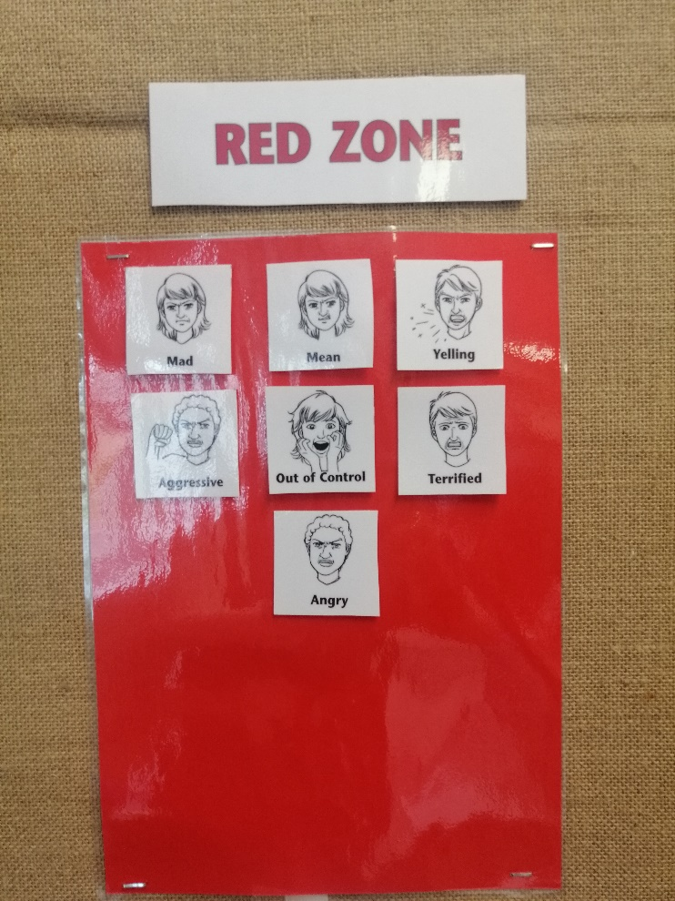
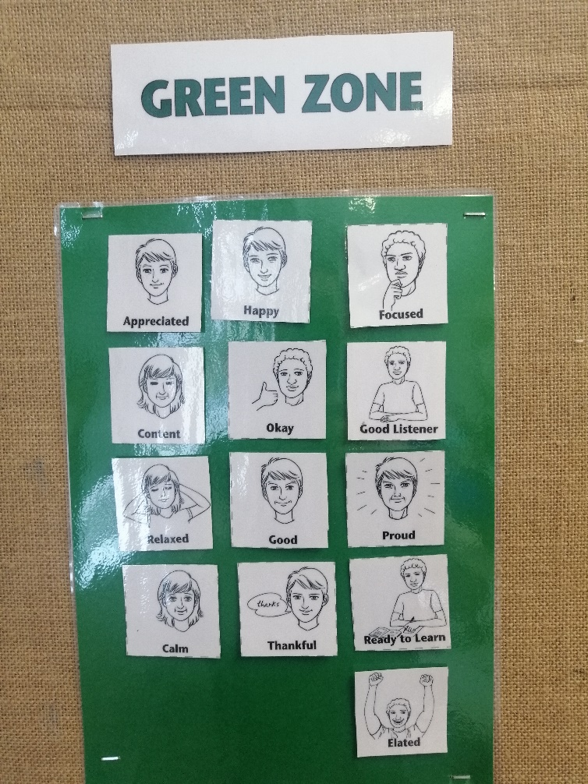
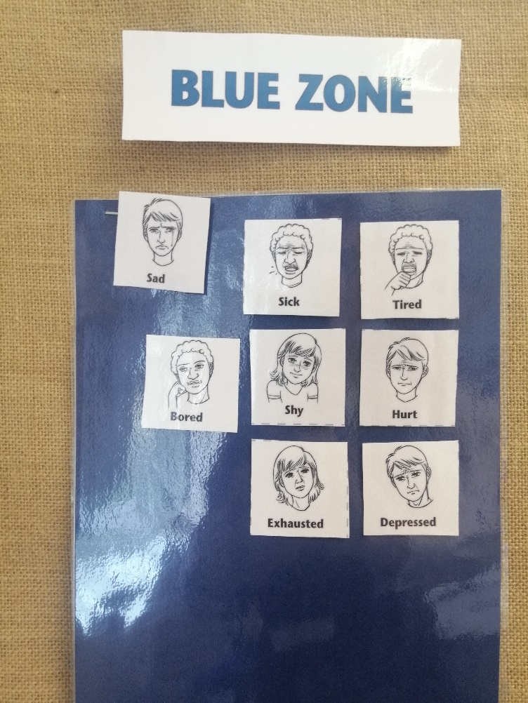
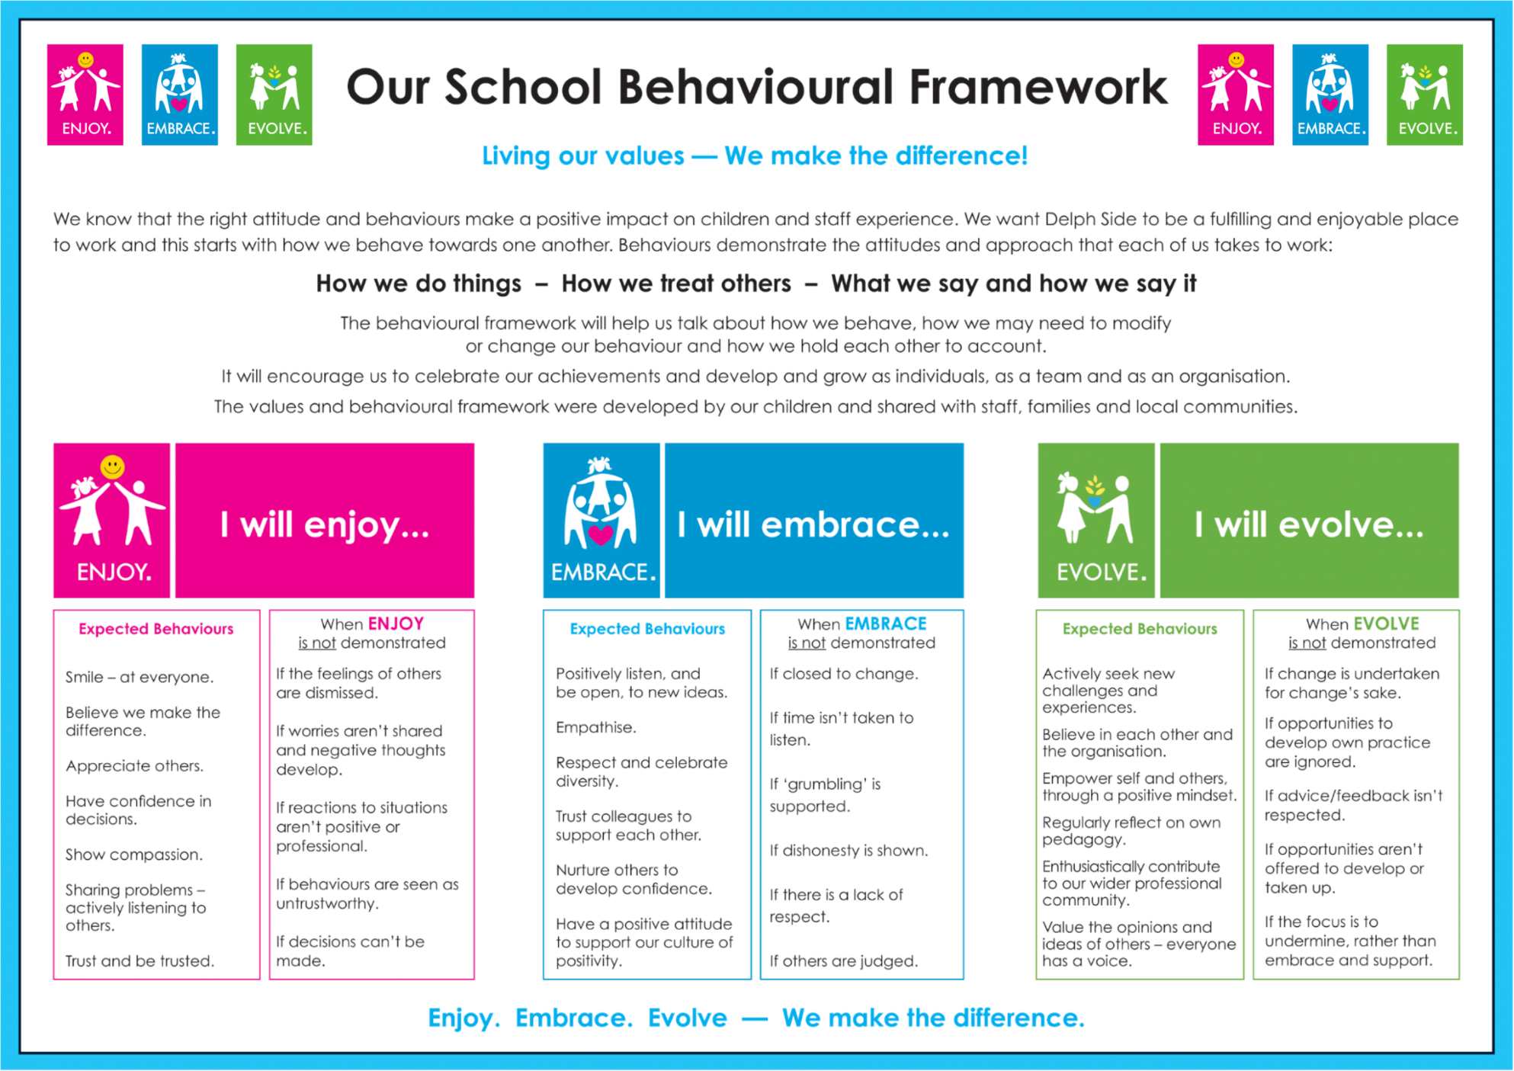
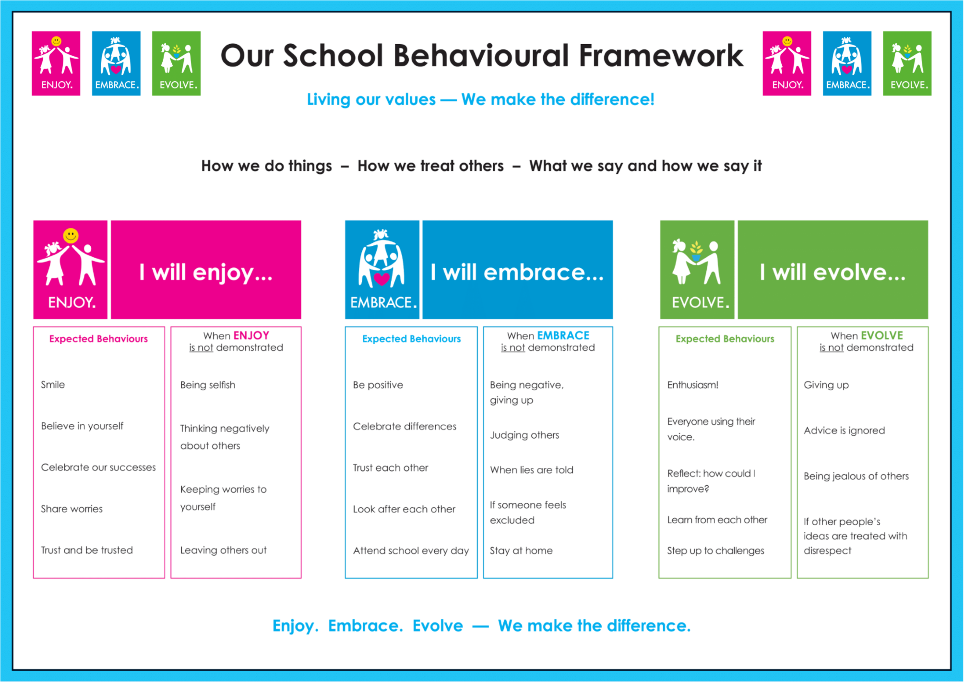

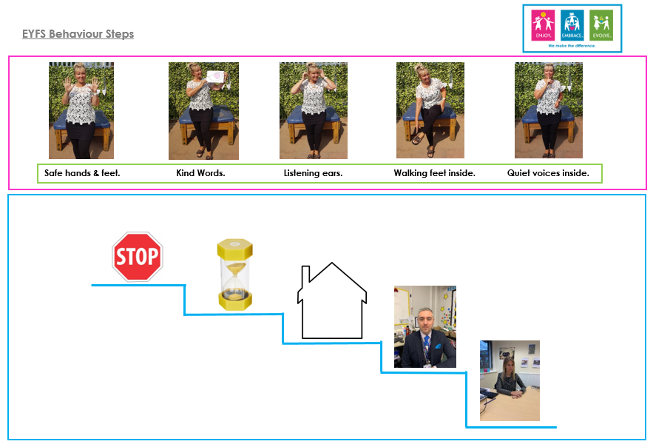
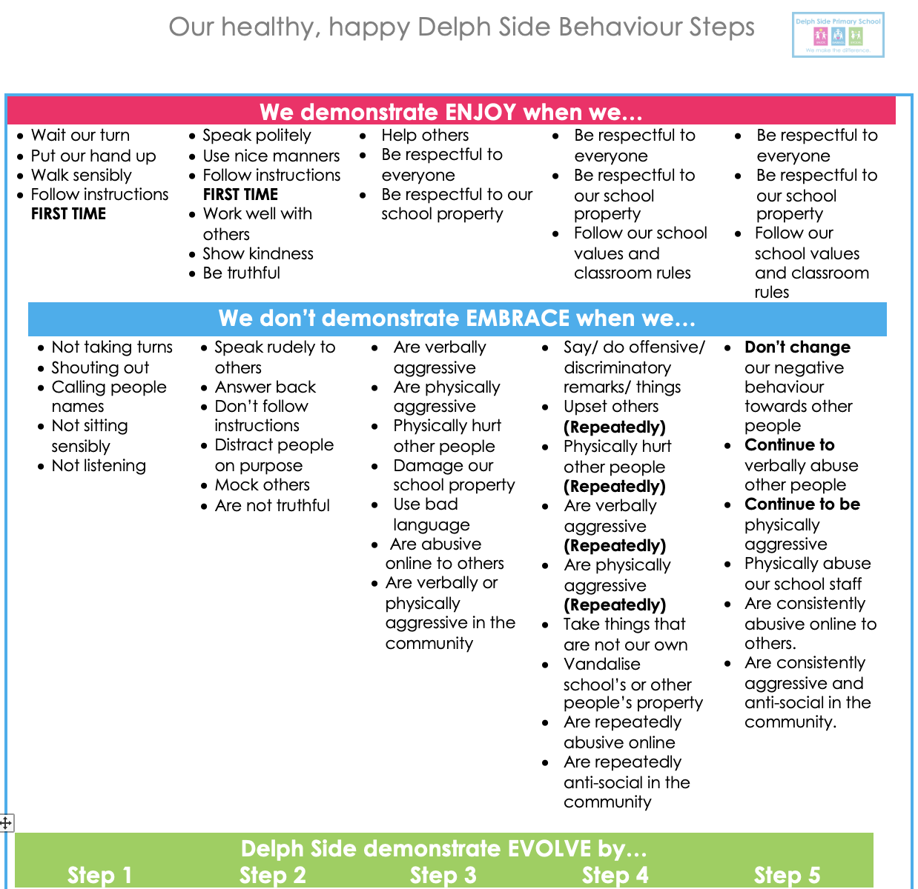
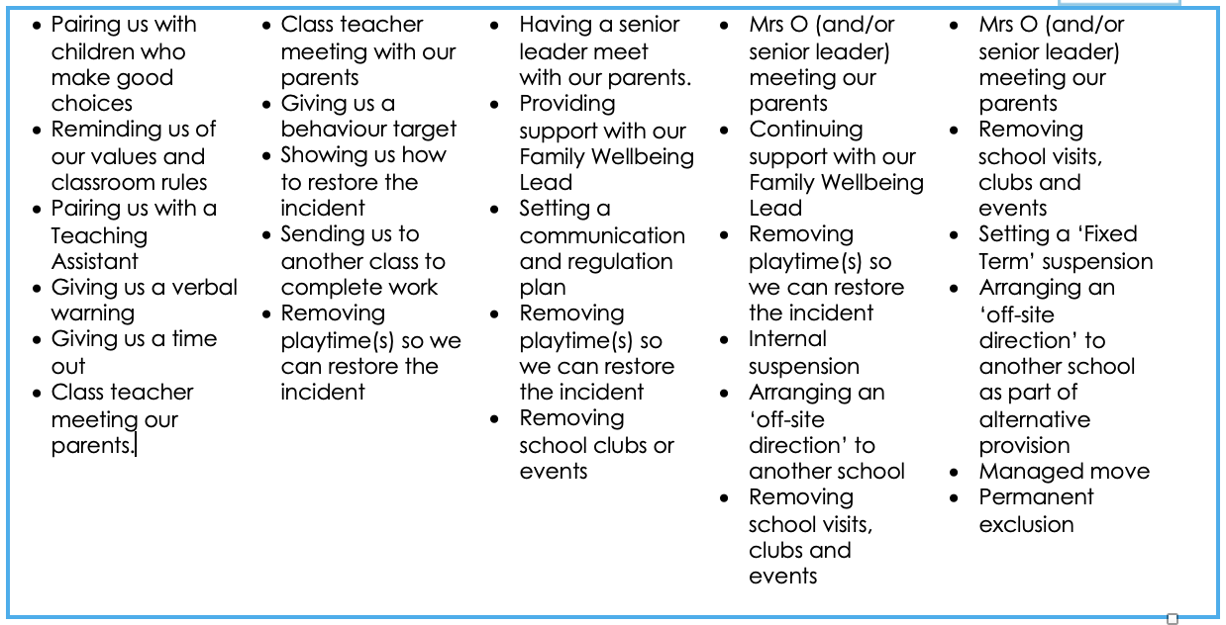

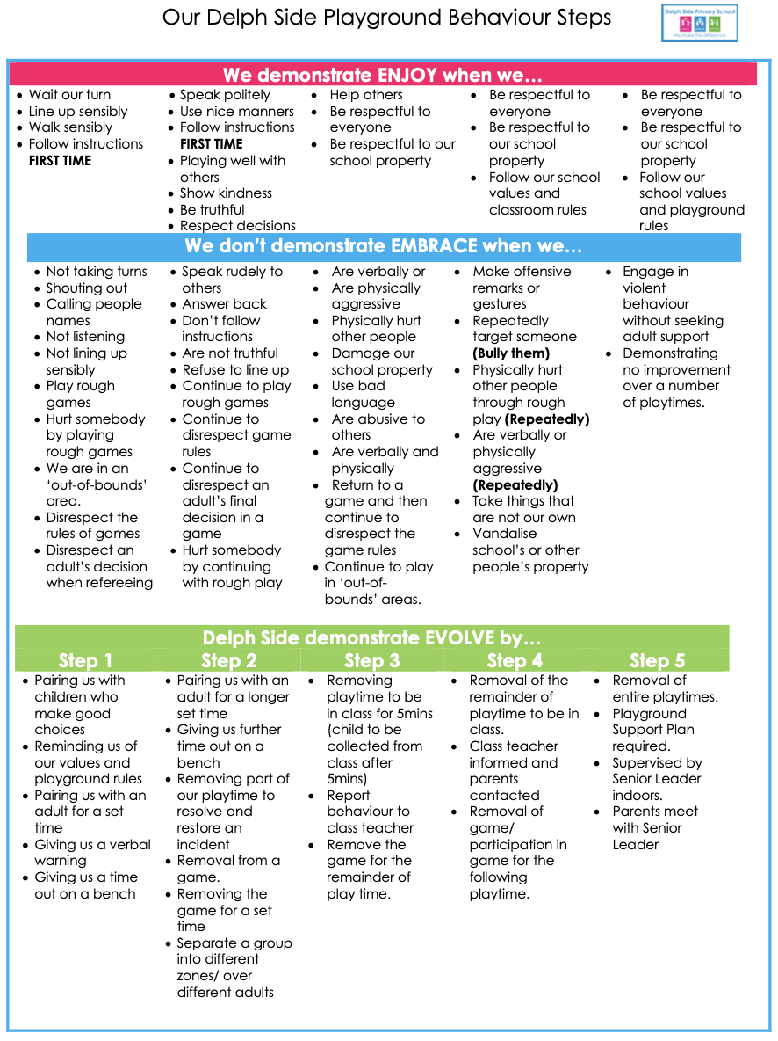

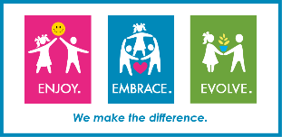

My communication and regulation plan
Name of pupil
Likes / Interests
Triggers

Stage 1 Anxiety Behaviour |  | Stage 2 Defensive Behaviour |  | Stage 3 Crisis Behaviour
Sensory seeking behaviour
De-escalation skills

Diversions and Distraction
Physical Intervention/ guides and escorts
How is the child’s wellbeing supported?
Signed…………………………………………Parent/Guardian

Signed

When a pupil receives a consequence for a negative behaviour choice, we aim to provide them with time to reflect on their behaviour and time to restore balance to any relationships that have been impact as a result. We will encourage pupils to engage with the below form, to reflect (in line with our values) in writing, and present this to the victim of a behavioural incident. This form is designed to provide restoration, justice and closure, by victim and aggressor being given time to discuss the incident. This form may also be provided to parents as proof of our endeavour to restore relationships and provide justice.
