Concept Progression from EYFS to KS2
Justice & Equality

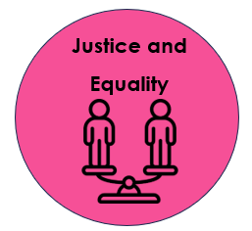

KS2
Black people were forced to become slaves due to the colour of their skin. Over time, equality has become more of a priority across the world and many countries have made it illegal. However, in some countries, it is still legal to enslave another person.

KS1
In the past, things weren’t always equal. Poor people were treated like criminals, and they would often be homeless and catch diseases.
EYFS
We are all equal and should treat each other with respect.

Concept Progression from EYFS to KS2
Civilisations
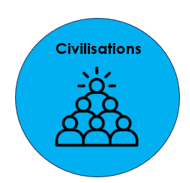

KS2
Civilisations from a very long time ago were often based nearby rivers for food, drinking water and washing.
KS1
My own civilisation (Skelmersdale) is different to civilisations in the past (Great Fire of London). Changes have been made to our civilisations because of events that have happened in the past (houses now made of bricks, wider streets etc).
EYFS
I can talk about what I might find in my local area e.g. houses, shops, cars, buses.

Concept Progression from EYFS to KS2
Leadership/Hierarchy
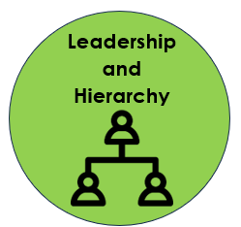

KS2
Leadership isn’t simple – hard decisions need to be made and they aren’t necessarily always the right ones. Leaders can cause huge consequences for their people.
KS1
We need leaders to keep order and peace. If we don’t have leaders, it can become chaotic and unsafe.
EYFS
My parents/carers are the leaders of my family because they look after me. They feed me, keep me clean and give me a place to live.
The headteacher is the leader of our school. She makes sure that we are learning and are following our school rules.

Concept Progression from EYFS to KS2
Trade
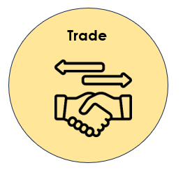

EYFS
Trading is when we swap. We trade when we go to the shop. We give the shop keeper money in exchange for an item that we want.
KS2
People trade with other countries for efficiency. They have access to items that they may not have available in their own countries.
KS1
Different items hold different values. King Edward VII would travel to Ormskirk just for gingerbread, meaning that it must’ve been valuable to him.

