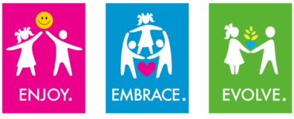
EYFS – National Curriculum
History

Subject | EYFS Outcome (ELG) | KS1 Key Learning | How do we prepare children in EYFS?
History | Understanding the World – People & Communities - ELG  To talk about past and present events in their own lives and in the lives of family members. They know about similarities and differences between themselves and others, and among families, communities and traditions.  Understanding the World – The World ELG Children know about similarities and differences in relation to places, objects, materials and living things. They talk about the features of their own immediate environment and how environments might vary from one another. | - changes within living memory. Where appropriate, these should be used to reveal aspects of change in national life  - events beyond living memory that are significant nationally or globally [for example, the Great Fire of London, the first aeroplane flight or events commemorated through festivals or anniversaries]  - the lives of significant individuals in the past who have contributed to national and international achievements. Some should be used to compare aspects of life in different periods [for example, Elizabeth I and Queen Victoria, Christopher Columbus and Neil Armstrong, William Caxton and Tim Berners-Lee, Pieter Bruegel the Elder and LS Lowry, Rosa Parks and Emily Davison, Mary Seacole and/or Florence Nightingale and Edith Cavell]  - significant historical events, people and places in their own locality. | Talk about day to day life – circle time, Jigsaw, Heart Smart etc.  Talk about significant past and present events which are important to them – sharing birthday, Christmas news.  Show interest in the lives of people who are familiar to them – children draw pictures of their families & family pictures are displayed in classrooms.  Become familiar with the language of time & associate days of the week with specific activities.  Ask questions about their own life history.  Find out about the life history of other people – joining in with whole school events e.g. Guy Fawkes day, Remembrance week, Apollo 11 Day etc.  Observe and notice differences between past & present – Comparing homes in the past/present linked to ‘Goldilocks & the Three Bears’  Begin to understand the concepts of old and new in relation to own experiences.  Experience and explore objects associated with the past, discussing who they might belong to and how they were used.  Observe and be aware of time through the sequence of events.  Compare differences between items which belong to present & past.  Find out about objects & events which happened in the past.

