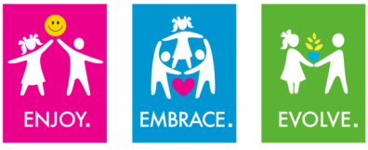
EYFS – National Curriculum
PE
Subject | EYFS Outcome (ELG) | KS1 Key Learning | How do we prepare children in EYFS?
PE | Physical Development – Moving & Handling – ELG  Children show good control and coordination in large and small movements. They move confidently in a range of ways, safely negotiating space. They handle equipment and tools effectively, including pencils for writing.  Physical Development – Health & Self-Care ELG Children know the importance for good health of physical exercise and a healthy diet, and talk about ways to keep healthy and safe.  Expressive Arts & Design – Being Imaginative- ELG  To represent their own ideas, thoughts and feelings through design and technology, art, music, dance, role play and stories. | - master basic movements including running, jumping, throwing and catching, as well as developing balance, agility and co-ordination, and begin to apply these in a range of activities  - participate in team games, developing simple tactics for attacking and defending  - perform dances using simple movement patterns. | Engage in activities planned to develop fundamental movement skills.  Engage in activities to develop a range of gross motor skills - PE lessons, parachute games, Woodland School etc.  Explore movement with body through creative & dance activities.  Explore moving in different ways.  Engage in activities involving hand-eye co-ordination & dexterity – Dough disco  Explore and manipulate a variety of malleable materials with hands and fingers.  Develop strength in wrists, hands and fingers.  Engage in activities which strengthen finger muscles.  Begin to control equipment used for creative activities.  Develop control when using tools and equipment for drawing & writing.  Develop pincer grip when handling resources.  Learn the correct way to form letters.  Engage in activities to develop upper body strength in shoulders & core stability.  Experience activities which allow movement and control from the shoulder.  Develop control when using tools to draw, paint, mark make and write.  Begin to make circular, horizontal, vertical and anti-clockwise patterns using gross-motor movements.  Develop manipulation & control of different types of equipment - brushes, containers, spades, knives etc.  Manipulate malleable materials using different techniques in order to achieve a desired effect.  Manipulate parts of construction kits in order to join pieces together.  Use scissors safely and competently.

