 | Autumn 1 | Autumn 2 | Spring 1 | Spring 2 | Summer 1 | Summer 2
EYFS
Understanding the World
Past and Present
• Talk about the lives of the people around them and their roles in society.
• Know some similarities and differences between things in the past and now, drawing on their experiences and what has been read in class.
• Understand the past through settings, characters and events encountered in books read in class and storytelling.
EYFS | -Can name & talk about immediate family members & pets  -Engages in role play, imitating everyday actions from own family life.  -Can sequence family members by name & size (baby, child, adult)  -Can name & describe people who are familiar to them  -Can talk about some of the similarities & differences in relation to their own family & other people’s families | Comments on historical figures through the story ‘Whatever Next’ (Neil Armstrong)  -Talks about members of their immediate family & community  - Can talk about past & upcoming events with their family.  -Shows an interest in different occupations  -Shows some understanding as to why we wear poppies (remembrance) | -Looks at transport from the past and present (though the story ‘The Naughty Bus).  -Compares toys from past and present (through the story The Magical Toybox)  -Shows an interest in different occupations (through the story The Dinosaur Who Lost his Roar) - palaeontologist | -Begins to be aware of & is able to name some different occupations (people who help us)  -Understand that they have similarities & differences to others around them | -Shows an interest in different occupations  (Postman- meerkat mail)
Year 1 | Significant Individuals  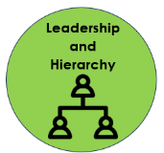  Explorers  Neil Armstrong  (significance)  What was difficult about travelling to a new place for the first time? |  | Changes within living memory  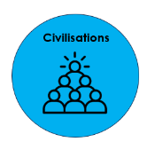  Toys – past and present  (change)  What toys/games did my parents/grandparents used to play with?  Resources: Shirley Hughes - Alfie |  | Events beyond living memory.  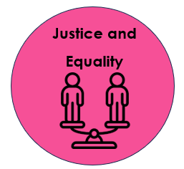  The Victorians  (change)  What was fair/unfair in Victorian times?
Year 2 | Events beyond living memory  The Great Fire of London  (cause)  What features, a long time ago, might have helped cause The Great Fire of London? |  | Significant historical events, people and places in their own locality.  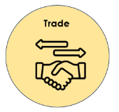  Ormskirk Gingerbread  (significance)  What can we find out about the homemade gingerbread industry in Ormskirk? |  | Significant Individuals  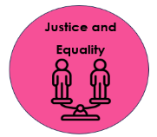  Explorers  Mary Seacole  (significance)  Why do we remember Mary Seacole?
Year 3 | Changes in Britain from the Stone Age to the Iron Age  (change)  How did life change for the people of Britain during the Stone Age/Iron Age?  What have we learnt from Skara Brae, Stonehenge and Iron Age hill forts? |  |  |  | Ancient Greece – a study of Greek life and achievements and their influence on the western world  (differences)  How were Athens and Sparta different?
Year 4 | The Roman Empire  (consequence)  What were the consequences of Boudicca’s resistance to the Romans? |  |  |  | Achievements of the first civilisations that appeared  (differences)  Ancient Sumer, The Indus Valley and The Shang Dynasty of Ancient China  What can we learn about early ancient civilizations? | In-depth study of Ancient Egypt  (differences)  What can we learn about Ancient Egypt through Tutankhamun’s tomb?
Year 5 | Britain’s settlement by Anglo-Saxons and Scots  (consequence)  What can we learn about the Anglo Saxons from the discoveries at Sutton Hoo? | The Viking and Anglo-Saxon struggle for the Kingdom of England to the time of Edward the Confessor  (interpretations)  Is it fair to describe all Vikings as brutal invaders? |  |  | A non-European society that provides contrasts with British history – Early Islamic civilisation  (significance)  Why was Baghdad important for trade?
Year 6 | A local history study  (continuity and change)  The History of Skelmersdale  What can we learn about the history of our town? |  |  |  | A study of an aspect or theme in British history that extends pupils’ chronological knowledge beyond 1066 – International Slave Trade  (cause and consequence)  Why was Lancashire involved in the transatlantic slave trade?  What led to the abolition of the transatlantic slave trade?

