 | Autumn 1 | Autumn 2 | Spring 1 | Spring 2 | Summer 1 | Summer 2
EYFS
Understanding the World
Past and Present
• Talk about the lives of the people around them and their roles in society.
• Know some similarities and differences between things in the past and now, drawing on their experiences and what has been read in class.
• Understand the past through settings, characters and events encountered in books read in class and storytelling.
EYFS | -Can name & talk about immediate family members & pets  -Engages in role play, imitating everyday actions from own family life.  -Can sequence family members by name & size (baby, child, adult)  -Can name & describe people who are familiar to them  -Can talk about some of the similarities & differences in relation to their own family & other people’s families | Comments on historical figures through the story ‘Whatever Next’ (Neil Armstrong)  -Talks about members of their immediate family & community  - Can talk about past & upcoming events with their family.  -Shows an interest in different occupations  -Shows some understanding as to why we wear poppies (remembrance) | -Looks at transport from the past and present (though the story ‘The Naughty Bus).  -Compares toys from past and present (through the story The Magical Toybox)  -Shows an interest in different occupations (through the story The Dinosaur Who Lost his Roar) - palaeontologist | -Begins to be aware of & is able to name some different occupations (people who help us)  -Understand that they have similarities & differences to others around them | -Shows an interest in different occupations  (Postman- meerkat mail)
Year 1 | Significant Individuals  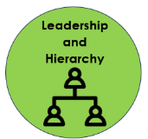  Explorers  Neil Armstrong  (significance)  What was difficult about travelling to a new place for the first time? |  | Changes within living memory  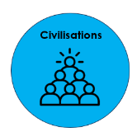  Toys – past and present  (change)  What toys/games did my parents/grandparents used to play with?  Resources: Shirley Hughes - Alfie |  | Events beyond living memory.  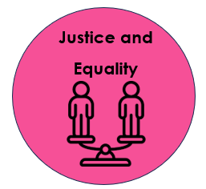  The Victorians  (change)  What was fair/unfair in Victorian times?
Year 2 | Events beyond living memory  The Great Fire of London  (cause)  What features, a long time ago, might have helped cause The Great Fire of London? |  | Significant historical events, people and places in their own locality.  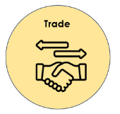  Ormskirk Gingerbread  (significance)  What can we find out about the homemade gingerbread industry in Ormskirk? |  | Significant Individuals  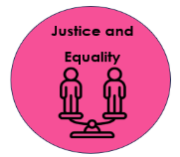  Explorers  Bessie Coleman  (significance)  Why was Bessie Coleman’s achievement so important?
Year 3 | Changes in Britain from the Stone Age to the Iron Age  (change)  How did life change for the people of Britain during the Stone Age/Iron Age?  What have we learnt from Skara Brae, Stonehenge and Iron Age hill forts? |  |  |  | Ancient Greece – a study of Greek life and achievements and their influence on the western world  (differences)  How were Athens and Sparta different?  How have the Greeks influenced life in Britain?  (Artefact – water clock)
Year 4 | The Roman Empire & Volcanoes/Earthquakes  (consequence)  What were the consequences of Boudicca’s resistance to the Romans? |  |  |  | Achievements of the first civilisations that appeared  (differences)  Ancient Sumer, The Indus Valley and The Shang Dynasty of Ancient China  What can we learn about religion and beliefs in ancient civilisations? | In-depth study of Ancient Egypt  (differences)  What can we learn about religion and beliefs in Ancient Egypt through Tutankhamun’s tomb?  (Artefact – water clock)
Year 5 | Britain’s settlement by Anglo-Saxons and Scots  (consequence)  What can we learn about the Anglo Saxons from the discoveries at Sutton Hoo? | The Viking and Anglo-Saxon struggle for the Kingdom of England to the time of Edward the Confessor  (interpretations)  Is it fair to describe all Vikings as brutal invaders? |  |  | A non-European society that provides contrasts with British history – Early Islamic civilisation  (significance)  What was the significance of Baghdad as a centre of imports and exports?
Year 6 | A local history study  (continuity and change)  The History of Skelmersdale  What can we learn about the history of our town? |  |  |  | A study of an aspect or theme in British history that extends pupils’ chronological knowledge beyond 1066 – International Slave Trade  (cause and consequence)  Why was Lancashire involved in the transatlantic slave trade?  What led to the abolition of the transatlantic slave trade?

