**History Policy**

**Key Aims of History:**

* To enable children to know about significant events in British history, to appreciate how things have changed over time and understand how Britain has influenced the wider world.
* To develop a sense of chronology and understand how they fit into the framework of the past, present and future.
* To know and understand how the British system of democratic government has developed and, in doing so, to contribute to a child’s citizenship education.
* To understand how Britain is part of a wider European culture and to study some aspects of European history.
* To have some knowledge and understanding of historical development in the wider world, including ancient civilisations empires and past non-European societies.
* To help children understand society and their place within it, so that they develop a sense of their cultural heritage;
* To develop in children, the skills of enquiry, investigation, analysis, evaluation and presentation.
* To ask historical questions and create their own structured accounts, including narratives and analysis.
* To gain and use historical vocabulary.
* To gain historical perspective by placing their growing knowledge into different contexts.
* To understand historical concepts such as continuity and change, cause and consequences and use them to make connections.

**Teaching & Learning:**

**EYFS:**

History is delivered to the Pre School and Reception pupils within the Knowledge and Understanding of the World Area of Learning through a cross curricular topic-based approach at various points throughout the academic year. Please see the ‘History in EYFS’ document on the website for more information on this.

**Key Stage 1:**

At Delph Side we continue the teaching of Foundation Subjects, including History, as a creative, cross curricular approach throughout the year. KS1 study topics in half termly blocks, giving children a breadth of knowledge and skills in smaller chunks. We base our teaching on the use of National Curriculum Programmes of Study and the development of historical skills. The following topics are covered in KS1 History lessons:

* Y1 - Explorers (Neil Armstrong), toys in the past and present & The Victorians
* Y2 – The Great Fire of London, Ormskirk Gingerbread & Explorers (Bessie Coleman)

**Key Stage 2:**

We teach History termly in KS2 in order to teach topics in depth and provide opportunities to deepen understanding. We teach the following topics in KS2:

* Y3 – Stone Age/Iron Age & Ancient Greece
* Y4 – The Romans & Ancient Egypt/Ancient Civilizations
* Y5 – Vikings/Anglo Saxons & Islamic Golden Age
* Y6 – History of Skelmersdale, International Slave Trade & Titanic

**The Hangout (SEN unit)**

The Hangout follow a 4-year cycle where topics are rotated to ensure that children learn about a breadth of different topics. These are mainly KS1 based to ensure that learning is suitable for all children in The Hangout.

Cycle 1: Remembrance Week, The King & Mary Anning

Cycle 2: Remembrance Week, Guy Fawkes, Ormskirk Gingerbread & Neil Armstrong

Cycle 3: Remembrance Week, Toys in the past and present & Great Fire of London.

Cycle 4: Remembrance Week, Titanic & Victorians.

**Teaching Approaches:**

A variety of teaching approaches are presented to children throughout their history lessons. These include:

* Teacher guided sessions, where information is provided.
* Mixed ability groups where children discuss problems in small groups.
* Class discussions lessons.
* The use of differentiation, allowing children of differing abilities to work at their appropriate pace and level.
* The use of audio-visual aids in presenting material to the children, such as DVD’s iPads/and/or the internet
* The use of field work where possible so that children gain first-hand experience of local and contrasting locations.
* The integrated use of ICT within the lessons - including QR codes in books to show interactive learning.
* Hands on experiences using artefacts or knowledgeable visitors.

**Curriculum**

At Delph Side we are pleased to have developed our own, bespoke curriculum, which incorporates all the statutory teaching and learning implemented in the curriculum. It is a theme-based learning approach, across the curriculum, includes skills-based learning for each year group and is an exciting and purposeful way of ensuring our children at Delph Side are obtaining a curriculum that is enjoyable, interesting and fulfils all the statutory guidelines.

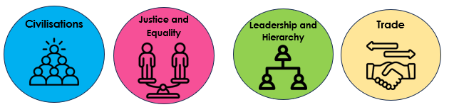We have based our curriculum around four substantive concepts:

These themes are discreetly taught throughout history topics and knowledge and understanding of these concepts are built on from EYFS to KS2.

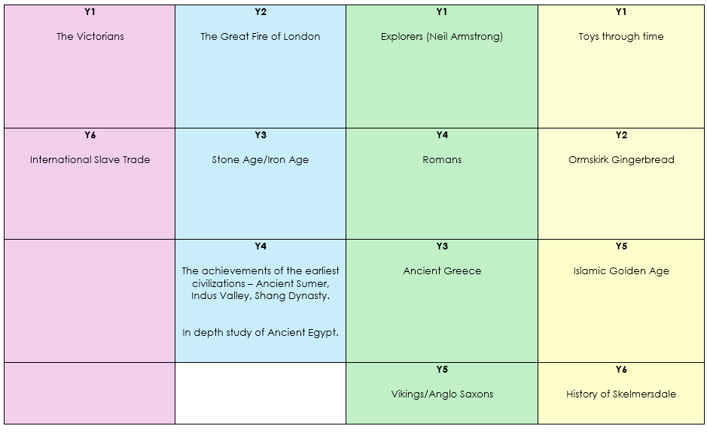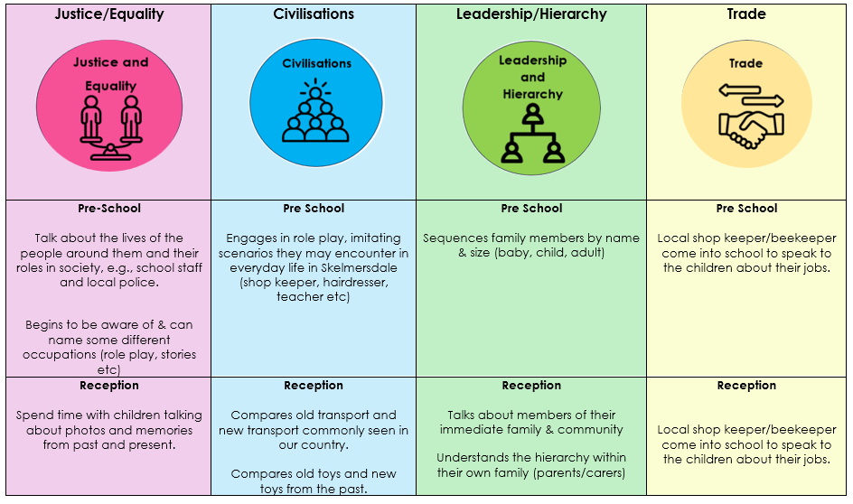

Concept progression maps give teachers a solid understanding of what children need to understand by the end of each key stage (see website for these).

*Trips and Visits*

As part of our curriculum offer, **all** year groups will access an educational trip or visitor relating to one of the topics they learn about throughout the year. We do this to embed learning and bring learning to life, providing children with unique and memorable learning experiences. Here are the current trips relating to History that we offer for each year group.

Y1 – WW2 visitor & Victorian’s visitor

Y2 – WW2 visitor

Y3 – WW2 visitor & Greek workshop

Y4 – Stockport Air Raid Shelter & Manchester Museum (Egyptians)

Y5 – Western Approaches

Y6 – Imperial War Museum & International Slavery Museum

*WW2/Remembrance Week*

At Delph Side, we host a Remembrance Week, where we base most of our learning around a specific topic relating to the war.

Each year group studies something different:

Y1 – Evacuation

Y2 – The Home Front

Y3 – D-Day

Y4 – The Blitz

Y5 – Battle of Britain

Y6 – The Holocaust

In addition to this, **all** year groups either attend an educational trip or have a visitor come in during this week relating to their topic.

*Black History*

At Delph Side, we value the importance of Black History within our curriculum. Black History is weaved throughout the curriculum in each year group. For example, in Year 4’s topic about Romans, children are taught about the Aurelian Moors as well as Julius Caesar. We believe it is paramount to children’s learning that exposure of Black History gives children a well-rounded view of the world in the past and in today’s society.

**Monitoring & Assessment**

Each topic will have an enquiry question which learning will be based around. Teachers will use these enquiry questions to assess children’s understanding at the end of each topic. Teachers will use their professional judgement to assess whether children have a basic or deeper understanding of their topic.

Curriculum leaders are responsible for monitoring the progress of the teaching of History and, during a focus week and throughout other points in the year, collect samples of the children’s work, scrutinise the work and review and re-write the action plan.

Class teachers complete half termly assessments on O-Track against age related expectations, grading children as ‘Working towards’ or ‘Working at’ the expected standard. This monitoring and evidence provides accurate data as an overview of the teaching of History at Delph Side. From the data, the subject leader can write an annual report to Governors, considering all contributing factors to a child’s development and presenting the data accordingly. Foundation Stage reporting appears within the Knowledge and Understanding of the World and is recorded throughout the Pre School and Reception years.