AUTUMN |  | SUMMER 1 | SUMMER 2
Ancient Rome |  | Ancient Civilisations | Ancient Egypt
What were the consequences of Boudicca’s resistance towards the Romans?  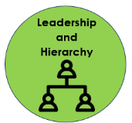 |  | What can we learn about ancient civilizations?  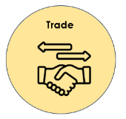  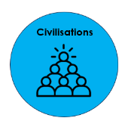 | What can we learn about religion and beliefs in ancient Egypt?  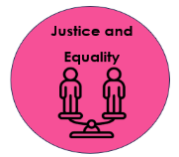
Key Knowledge  - Rome is a city in Italy in the continent of Europe.  - Before the Romans invaded, many people in Britain lived in hillforts and settlements. They had woven wood, straw and mud houses.  - Britain was invaded twice by Julius Caesar, both failing. Emperor Claudius was the first successful invader.  - Boudicca didn’t like how the Romans were treating her people, so she fought them and won. She stayed in power for around a year.  - After the Romans invaded Britain, they developed aqueducts, roads and amphitheatres.  - The Aurelian Moors were the first group of black people recorded in Britain. They worked along Hadrian’s Wall. |  | - Ancient Sumer was the first civilization (now modern-day Iraq)  - The most modern ancient civilization is ancient Rome.  - The Sumerians started writing using symbols on clay tablets.  - The first alphabet was created by the Phoenicians; however, it had no vowels and was read from right to left.  - There is evidence that trade occurred between the Indus Valley and ancient Sumer due to finding seals.  - Clay tokens were used by the Sumerians to keep track of any trading.  - Sumerians invented the wheel.  - We still use irrigation systems invented by ancient civilisations today. | Key Knowledge  - The River Nile was used by people for fishing, washing, transporting bodies and the nutrients from the riverbed soil helped to fertilise the crops.  - Tutankhamun was discovered by Howard Carter in 1922. He is the most famous mummy in society. He is known for his death mask.  - The Rosetta Stone was found by accident in a battlefield. It has helped us to understand what hieroglyphs mean.  - The Egyptians worshipped over 2,000 gods and goddesses. They believed that they determined the course of their lives.  - Mummification was important to Egyptians. They believed that they went to the afterlife once they died, so they prepared the body by drying it and wrapping it.
Skills

Chronology | - Sequence several events, artefacts or historical figures on a timeline using dates, including those that are sometimes further apart, and terms related to the unit being studied and passing of time.  - Understand that a timeline can be divided into BC (Before Christ) and AD (Anno Domini).
Knowledge of People/Events | - Find out about the everyday lives of people in time studied compared with our life today.  - Explain how people and events in the past have influenced life today.  - Sequence several events, artefacts or historical figures on a timeline using dates, including those that are sometimes further apart, and terms related to the unit being studied and passing of time.  - Describe connections and contrasts between aspects of history, people, events and artefacts studied.
Historical Enquiry | - Use a range of primary and secondary sources to find out about the past.  - Construct informed responses about one aspect of life or a key event in the past through careful selection and organisation of relevant historical information.  - Gather more detail from sources such as maps to build up a clearer picture of the past.  - Regularly address and sometimes devise own questions to find answers about the past.  - Begin to undertake their own research.
Historical Interpretation | - Look at two versions of the same event or story in history and identify differences.  - Investigate different accounts of historical events and be able to explain some of the reasons why the accounts may be different.  - Begin to understand some of the ways in which historians and others investigate the past.

