AUTUMN |  | SPRING | SUMMER
The History of Skelmersdale |  |  | International Slave Trade
What can we learn about the history of our town?  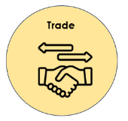  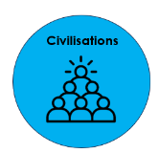 |  |  | Why was Lancashire involved in the transatlantic slave trade?  What led to the abolition of the transatlantic slave trade?  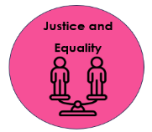  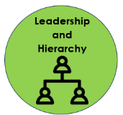
Key Knowledge  - The first recording of Skelmersdale was in the Domesday Book in 1086  - Skelmersdale existed during Normal Rule of Britain  - Skelmersdale was once a coal mining town and was home to many collieries  - There was a disaster at the Tawd Vale Colliery in 1897 (2 workers died)  - Skelmersdale was developed as a new town in the 60s  - The new town was to act as an overflow for Liverpool as it was overcrowded post-WWII  - Skelmersdale’s population was intended to be 80,000, but today it is only 35,000. This is because many big businesses left leaving much unemployment in the town. |  |  | Key Knowledge  - Britain joined the slave trade because they realised Africa was worth trading with  - African leaders captured many African people from towns and villages and traded them with the European slave traders  - Europe, Africa and the Americas created a transatlantic slave triangle  - Africa traded slaves, the Americas traded raw materials and Europe traded manufactured goods  - Conditions on slave ships were brutal and many died on the trip across the Atlantic  - The Zong poem and The Slave Ship painting both showed the people of Britain how brutal the slave trade was  - Olaudah Equiano was a slave who bought his own freedom and helped to abolish slavery in Britain  - Britain abolished slavery in 1807
Skills
Chronology | - Order an increasing number of significant events, movements and dates on a timeline using dates accurately.  - Accurately use dates and terms to describe historical events.  - Understand how some historical events/periods occurred concurrently in different locations, e.g. Indus Valley and Ancient Egypt.
Knowledge of People/Events | - Identify and note connections, contrasts and trends over time in the everyday lives of people.  - Use appropriate historical terms, such as culture, religious, social, economic and political when describing the connections, contrasts and trends over time.  - Describe the key features of the past, including attitudes, beliefs and the everyday lives of men, women and children.
Historical Enquiry | - Recognise when they are using primary and secondary sources of information to investigate the past.  - Use a wide range of different evidence to collect evidence about the past, such as ceramics, pictures, documents, printed sources, posters, online material, photographs, artefacts, historic statues, figures, sculptures, historic sites.  - Select relevant sections of information to address historically valid questions and construct detailed, informed responses.  - Investigate their own lines of enquiry by posing historically valid questions to answer.
Historical Interpretation | - Find and analyse a wide range of evidence about the past.  - Use a range of evidence to offer some clear reasons for different interpretations of events, linking this to factual understanding about the past.  - Consider different ways of checking the accuracy of interpretations of the past.  - Start to understand the difference between primary and secondary evidence and start to question its reliability.  - Show an awareness of the concept of propaganda.  - Know that people in the past represent events or ideas in a way that may be to persuade others.  - Continue to develop their understanding of how historians and others investigate the past.

