

SEND Information Report September 2024/25

*Carry each other's burdens, and in this way you will fulfil the law of Christ. Galatians 6:2*

Derby Cathedral School is a Christian community that welcomes students, families and visitors of all faiths and none. The diversity and richness of such a family brings depth and vibrancy to our core.

Students of Derby Cathedral School are given every opportunity and challenged to be the best that they can be, demonstrating FAITH in all they do.

* **Fellowship** - Collaborating with others, we treat everyone with respect, dignity and kindness.
* **Aspiration** - We are ready to learn and grow, striving to be the best that we can be in every aspect of our lives.
* **Integrity** – We demonstrate fairness, equality and honesty.
* **Tenacity** – We are determined and resilient when faced with challenges.
* **Humility** - We are gracious, calm and understand the importance of forgiveness.

All students will be well prepared for their next step in future education, training and employment. They will be happy, healthy, confident, life-long learners who ‘experience life in all its fullness’ (John 10:10)

|  |  |  |
| --- | --- | --- |
| **Approved by:** | LAC | **Date:** October 2024 |
| **Last reviewed on:** | August 2024 | |
| **Next review due by:** | September 2025 | |

**Contents**

SEND Information Report September 2021 1

1. Aims 2

2. Legislation and guidance 2

3. Definitions 2

4. Roles and responsibilities 2

5. SEN information report 3

6. Monitoring arrangements 7

7. Links with other policies and documents 7

# Aims

Our SEN policy and information report aims to:

# Make provision for children covering the four areas of need in cognition and learning, communication and interaction, behaviour, anxiety, and physical disabilities.

# 2. Legislation and guidance

This policy and information report is based on the statutory [Special Educational Needs and Disability (SEND) Code of Practice](https://www.gov.uk/government/uploads/system/uploads/attachment_data/file/398815/SEND_Code_of_Practice_January_2015.pdf) and the following legislation:

* [Part 3 of the Children and Families Act 2014](http://www.legislation.gov.uk/ukpga/2014/6/part/3), which sets out schools’ responsibilities for pupils with SEN and disabilities
* [The Special Educational Needs and Disability Regulations 2014](http://www.legislation.gov.uk/uksi/2014/1530/contents/made), which set out schools’ responsibilities for education, health and care (EHC) plans, SEN coordinators (SENCOs) and the SEN information report. This policy also complies with our funding agreement and articles of association.

# 3. Definitions

A pupil has SEN if they have a learning difficulty or disability that calls for special educational provision to be made for them.

They have a learning difficulty or disability if they have:

* A significantly greater difficulty in learning than many of the others of the same age, or
* A disability which prevents or hinders them from making use of facilities of a kind generally provided for others of the same age in mainstream schools

Special educational provision is educational or training provision that is additional to, or different from, that made generally for other children or young people of the same age by mainstream schools.

# 4. Roles and responsibilities

4.1 The SENCO

The SENCO is Sarah Oakes

The SLT link for SEND is Paul Hammerton – Assistant Headteacher

They will:

* Work with the headteacher and SEN governor to determine the strategic development of the SEN policy and provision in the school
* Have day-to-day responsibility for the operation of this SEN policy and the co-ordination of specific provision made to support individual pupils with SEN, including those who have EHC plans
* Provide professional guidance to colleagues and work with staff, parents, and other agencies to ensure that pupils with SEN receive appropriate support and high-quality teaching
* Advise on the graduated approach to providing SEN support
* Advise on the deployment of the school’s delegated budget and other resources to meet pupils’ needs effectively
* Be the point of contact for external agencies, especially the local authority (LA) and its support services
* Liaise with potential next providers of education to ensure that the school meets its responsibilities under the Equality Act 2010 regarding reasonable adjustments and access arrangements
* Ensure the school keeps the records of all pupils with SEN up to date

4.2 The SEN governor

The SEN governor will:

* Help to raise awareness of SEN issues at Local Academy Committee (LAC)
* Monitor the quality and effectiveness of SEN and disability provision within the school and update the Local Academy Committee (LAC) on this
* Work with the headteacher and SENCO to determine the strategic development of the SEN policy and provision in the school

4.3 The headteacher

The headteacher will:

* Work with the SENCO and LAC Link for SEN to determine the strategic development of the SEN policy and provision within the school
* Have overall responsibility for the provision and progress of learners with SEN and/or a disability

4.4 Class teachers

Each class teacher is responsible for:

* The progress and development of every pupil in their class
* Working closely with any teaching assistants or specialist staff to plan and assess the impact of support and interventions, and how they can be linked to classroom teaching
* Working with the SENCO to review each pupil’s progress and development, and decide on any changes to provision
* Ensuring they follow this SEN policy

# 5. SEN information report

5.1 The kinds of SEN that are provided for

Our school currently provides additional and/or different provision for a range of needs, including:

* Communication and interaction, for example, autistic spectrum disorder, Asperger’s Syndrome (ASD), speech and language difficulties
* Cognition and learning, for example, dyslexia, dyspraxia
* Social, emotional and mental health difficulties, for example, attention deficit hyperactivity disorder (ADHD)
* Sensory and/or physical needs, for example, visual impairments, hearing impairments, processing difficulties, epilepsy
* Moderate/severe/profound and multiple learning difficulties

5.2 Identifying students with SEN and assessing their needs

Using a graduated response and information from partner primary schools including each student’s current levels of attainment and current SEND type on entry, will determine entry on the Derby Cathedral School’s SEND register. Class teachers will make reasonable adjustments to accommodate students learning and differentiate accordingly with regular assessments of progress for all students. This will allow them to identify those whose progress:

* Is significantly lower than that of their peers starting from the same baseline
* Fails to match or better the child’s previous rate of progress
* Fails to close the attainment gap between the child and their peers
* Widens the attainment gap

This may include progress in areas other than attainment, for example, social needs.

When deciding whether special educational provision is required, we will start with the desired outcomes, including the expected progress and attainment, and the views and the wishes of the student and their parents. We will use this to determine the support that is needed and whether we can provide it by adapting our core offer, or whether something different or additional is needed. If you think that your child may have special educational needs or are concerned about your child’s progress, then you should speak to your child’s tutor and teachers on progress evenings in the first instance. If you continue to be concerned you may contact the school’s SENCO (Special Educational Needs Co-Ordinator).

If you think that your child may have special educational needs or are concerned about your child’s progress, then you should contact the school’s SENCO (Special Educational Needs Co-Ordinator).

5.3 Consulting and involving students and parents

We will have an early discussion with the students and their parents when identifying whether they need special educational provision. These conversations will make sure that:

* Everyone develops a good understanding of the pupil’s areas of strength and difficulty
* We consider the parents’ concerns
* Everyone understands the agreed outcomes sought for the child
* Everyone is clear on what the next steps are

Notes of these early discussions will be added to BROMCOM and shared with the parents.

We will formally notify parents when it is decided that a student will receive SEN support.

Every student on the SEND register is allocated a ‘Key Worker’. The key workers will make regular contact with parents and students to improve communication and information sharing.

5.4 Assessing and reviewing students' progress towards outcomes

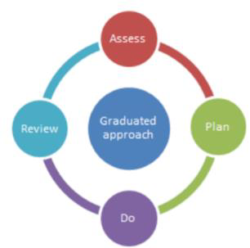We follow the graduated approach and the four-part cycle of **assess, plan, do, review**. The SENCO will carry out a clear analysis of the students’ needs. This will draw on:

* The teacher’s assessment and experience of the student
* Their previous progress and attainment or behaviour
* Other teachers’ assessments, where relevant
* The individual’s development in comparison to their peers   
   and national data
* The views and experience of parents
* The student’s own views
* Advice from external support services, if relevant

The assessment will be reviewed regularly. All teachers and support staff who work with the students will be made aware of their needs, the outcomes sought, the support provided, and any teaching strategies or approaches that are required. We will regularly review the effectiveness of the support and interventions and their impact on the student’s progress.

5.5 Supporting students moving between phases and preparing for adulthood

We will share information with the school, college, or other setting the pupil is moving to. We will agree with parents and students' which information will be shared as part of this.

The school will operate a full transition program for those pupils moving from Key Stage 2 and if appropriate this can be tailored for SEND students i.e. an individual visit or an accompanied visit.

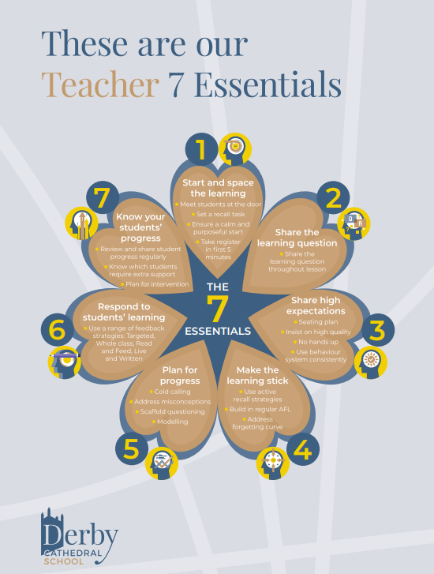5.6 Our approach to teaching students with SEN

Derby Cathedral School uses 7 teaching essentials to support quality first teaching and meet the needs of all students. These 7 teaching essentials ensure that students with special educational needs are met in the classroom. The classroom teacher is responsible for applying these 7 teaching essentials and making reasonable adjustments to lessons to meet the needs of all students. Some students will be allocated additional support via a teaching assistant.

Students with SEND who need significantly support for English and Mathematics will be supported by a nurture focused teacher. These curriculums are adapted to ensure that the gap in the students basic English and Mathematic skills are developed.

5.7 Adaptations to the curriculum and learning environment

When necessary, we make the following adaptations to ensure all students’ needs are met:

* Differentiating our curriculum to ensure all pupils can access it, for example, teaching style, lesson content, etc.
* Adapting our resources and staffing
* Using recommended aids, such as laptops, coloured overlays, larger font, etc.
* Differentiating our teaching using the 7 teaching essentials.

5.8 Evaluating the effectiveness of SEN provision

We evaluate the effectiveness of provision for students with SEN by:

* Reviewing students’ individual progress towards their goals each term
* Timely reviewing the impact of interventions
* Using student questionnaires
* Using parent questionnaires
* Monitoring by the SENCO/ SLT link
* Using BROMCOM to measure progress
* Holding annual reviews for students with EHC plans
* External reviews

5.9 Enabling students with SEND to engage in activities available to those in the school who do not have SEND

All our extra-curricular activities and school visits are available to all our students, including our before-and after-school clubs.

All pupils are encouraged to go on our residential trip(s)

All pupils are encouraged to take part in sports day/school plays/special workshops, etc.

No pupil is ever excluded from taking part in these activities because of their SEN or disability.

5.10 Support for improving emotional and social development

We provide support for students to improve their emotional and social development in the following ways:

* Students with SEN are encouraged to be part of the school voice activities
* Students with SEN have access to a training ELSA counsellor
* Where necessary, students with SEND will be supported by ‘Restore’, our internal alternative provision where they receive an adapted curriculum and full-time TFTF mentoring and personal development.
* All students, including those with SEND need have an extended pastoral team including a head of year and a year lead to provide extended opportunities to receive one-to-one advice and support
* Students with SEN are also encouraged to be part of the lunchtime nurture group to promote teamwork/building friendships.
* In addition to current intervention, specialist support from the STePS team can be bought in as required to meet the needs of students with social and emotional needs as part of an individual’s graduated response.

We have a zero-tolerance approach to bullying.

5.11 Complaints about SEN provision

Complaints about SEN provision in our school should be made to the link SLT Assistant Headteacher in the first instance. They will then be referred to the school’s complaints policy.

The parents of students with disabilities have the right to make disability discrimination claims to the first tier SEND tribunal if they believe that our school has discriminated against their children. They can make a claim about alleged discrimination regarding:

* Exclusions
* Provision of education and associated services
* Making reasonable adjustments, including the provision of auxiliary aids and services

5.12 Contact details of support services or raising concerns for parents of students with SEN

Sarah Oakes – SENDCO

[S.Oakes@derbycathedralschool.org.uk](mailto:S.Oakes@derbycathedralschool.org.uk)

Paul Hammerton – Link SLT (Assistant Headteacher)

[P.Hammerton@derbycathedralschool.org.uk](mailto:P.Hammerton@derbycathedralschool.org.uk)

Tel: 01332 325710

Rachel Blurton – LAC Link for SEN

[r.blurton@derbycathedralschool.org.uk](mailto:r.blurton@derbycathedralschool.org.uk)

5.13 The local authority local offer/ Contact details of support services for parents of students with SEN

Derby Cathedral School is supported by a wide range of services, including:

* an educational psychologist;
* specialist alternative provisions
* Specialist teachers for the physically impaired
* Specialist teachers for the visually impaired
* Specialist teachers service for the hearing impaired
* School Nurses
* Physiotherapy services (NHS)
* Occupational Health (NHS)
* CAMHS
* NHS – school nurse
* Derby City Specialist Teaching and Psychology Service (STePs)
* Autism Outreach services

Ambreen Razak is our SEND Officer at Derby City Council (DCC), who can offer additional advice on SEND issues. We also work in partnership with the DCC Inclusion/exclusion team.

Any further information regarding the support services we use can be obtained by contacting the school to discuss the local offer or by visiting the Derby City council website below:

<https://www.derby.gov.uk/education-and-learning/derbys-send-local-offer/>

The SEN team are available to discuss support available for your child and make the necessary referrals when appropriate to do so.

**5.14 Arrangements for admissions/access for disabled students**

Derby Cathedral School strives to ensure fair and equitable access for all students regardless of disability or physical impairment. We take its duty of care under the 2010 Equalities Act extremely seriously. As well as the information provided above further detail regarding how we support pupils with disabilities, the steps we take to prevent students being treated less favourable than other students and the facilities to help disabled pupils access the school, please refer to our Accessibility Plan located on the school website located under ‘Policies’.

# 6. Monitoring arrangements

This policy and information report will be reviewed by Sarah Oakes and Paul Hammerton **every year**. It will also be updated if any changes to the information are made during the year.

It will be approved by the governing board at a scheduled LGB meeting.

# 7. Links with other policies and documents

This policy links to the following documents:

* Accessibility plan
* Behaviour policy
* Equality information and objectives
* Supporting pupils with medical conditions policy
* Safeguarding policy
* Complaints policy – DDAT
* Supporting pupils with Medical Needs Policy