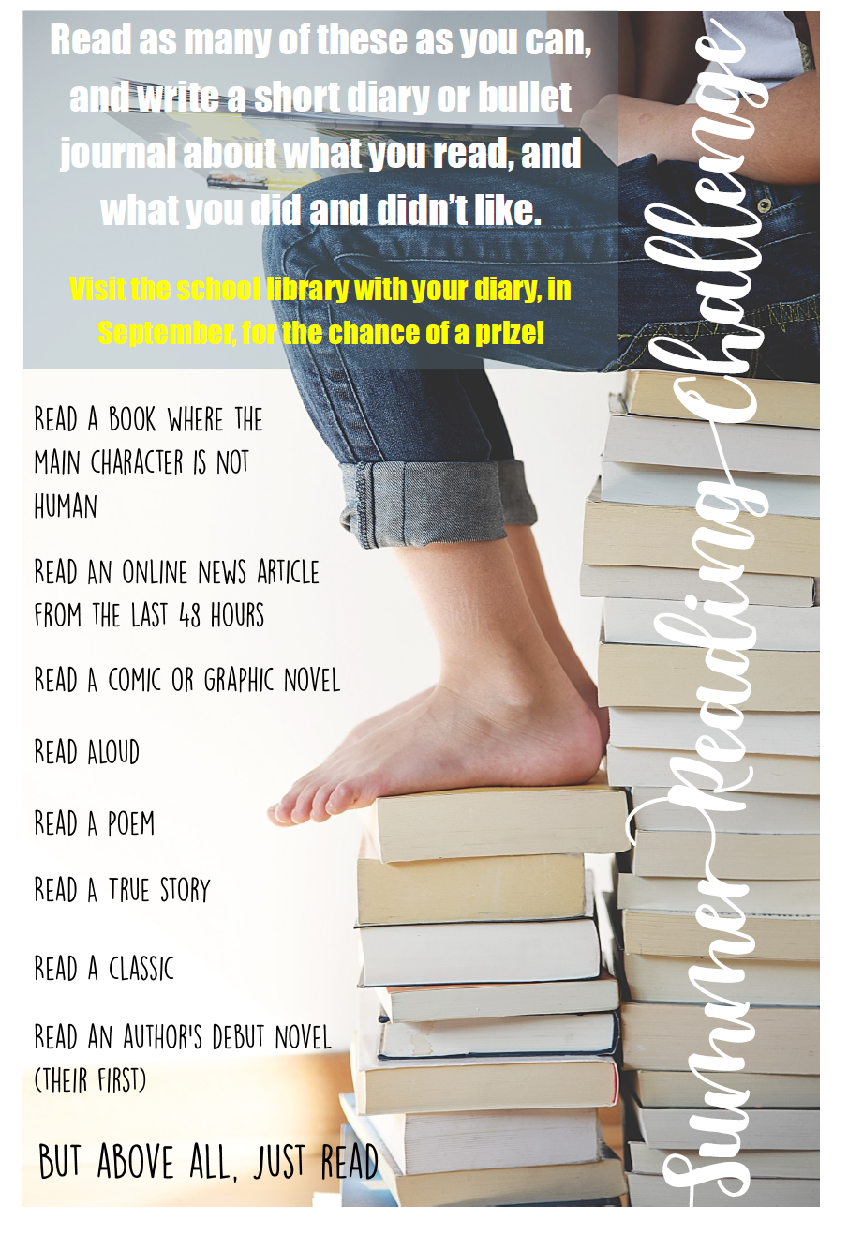

Summer Reading Task Diary

|  |  |  |  |
| --- | --- | --- | --- |
| Task | Title | Date Completed | Parent/carer signature |
| A book where the main character is not human |  |  |  |
| An online news article from the last 48 hours |  |  |  |
| A comic or graphic novel |  |  |  |
| Read aloud |  |  |  |
| Read a true story |  |  |  |
| Read a classic |  |  |  |
| Read an author’s debut novel |  |  |  |

Task 2 – Why not write a review of one of the books that you read over the summer, tell us what you enjoyed, who you would recommend it too and how many starts you would give it! Pass this to the Librarian in September to be entered in to our prize draw!

Summer Book Review

|  |
| --- |
| Title: |

|  |
| --- |
| Author: |

|  |
| --- |
| Write a brief synopsis (summary) of the book |
|  |
|  |
|  |
|  |
|  |

|  |
| --- |
| Write about the main character |
|  |
|  |
|  |
|  |
|  |

|  |
| --- |
| What was your favourite part of the book? |
|  |
|  |
|  |
|  |
|  |

|  |  |  |
| --- | --- | --- |
| What did you not like about the book? | | |
|  | |
|  | |
|  | |
| Write down three adjectives to describe the book | | |
| 1. ___________ 2. ____________ 3. ____________ | | |
|  | | |
| **Star Rating?**  **(out of 5) ____________________** |

Recommended Reading List for KS3

# "The more that you read, the more things you will know. The more that you learn, the more places you'll go!"

Why not look over the following list and see if you can work your way through some of these classics of Literature:

# *1984* by George Orwell

# *20,000 Leagues Under the Sea* by Jules Verne

# *A Christmas Carol* by Charles Dickens

# *A Little Princess* by Frances Hodgson Burnett

# *A Streetcat Named Bob* by James Bowen

# *A Wrinkle in Time* by Madeleine L'Engle

# *Alice's Adventures in Wonderland* by Lewis Carroll

# *Animal Farm* by George Orwell

# *Anne of Green Gables* by Lucy Maud Montgomery

# *Artemis Fowl* *Series* by Eoin Colfer

# *Ballet Shoes* by Noel Streatfeild

# *Bridge to Terabithia* by Katherine Paterson

# *Charlotte’s Web* by E.B. White

# *Emil and the Detectives* by Erich Kästner

# *Fahrenheit 451* by Ray Bradbury

# *Flowers for Algernon* by Daniel Keyes

# *Geek Girl* by Holly Smale

# *Greek Myths* by Geraldine McCaughrean

# *Gulliver’s Travels* by Jonathan Swift

# *Heidi* by Johanna Spyri

# *His Dark Materials* by Phillip Pullman

# *Holes* by Louis Sachar

# *I Capture the Castle* by Dodie Smith

# *Inkheart* by Cornelia Funke

# *Jane Eyre* by Charlotte Bronte

# *Journey to Jo’burg* by Beverly Naidoo

# *Little House on the Prairie series* by Laura Ingalls Wilde

# *Little Women* by Lousia May Alcott

# *One* by Sarah Grossman

# *Refugee Boy* by Benjamin Zephaniah

# *Skellig* by David Almond

# *Stig of the Dump* by Clive King

# *Stormbreake*r by Anthony Horowitz

# *Swallows and Amazons* by Arthur Ransome

# *The Adventures of Huckleberry Finn* by Mark Twain

# *The Adventures of Sherlock Holmes* by Sir Arthur Conan Doyle

# *The Adventures of Tom Sawyer* by Mark Twain

# *The Beasts of Clawstone Castle* by Eva Ibbotson

# *The Book Thief* by Markus Zusak

# *The Borrowers* by Mary Norton

# *The Chronicles of Narnia* by C.S. Lewis

# *The City of Ember* by Jeanne DuPrau

# *The Curious Incident of the Dog in the Night-time* by Mark Haddon

# *The Dark Is Rising series* by Susan Cooper

# *The Diary of a Young Girl* by Anne Frank

# *The Elephant's Child* from The Just So Stories by Rudyard Kipling

# *The Graveyard Book* by Neil Gaiman

# *The Happy Prince* by Oscar Wilde

# *The Harry Potter Books* by J.K. Rowling

# *The Hobbit* by J.R.R. Tolkien

# *The Knife of Never Letting Go* by Patrick Ness

# *The Lantern Bearers* by Rosemary Sutcliff

# *The Midnight Palace* by Carlos Zuis Zafron

# *The Moonstone* by Wilkie Collins

# *The Mozart Question* by Michael Morpurgo

# *The Never Ending Story* by Michel Ende

# *The Outsiders* by SE Hinton

# *The Owl Service* by Alan Garner

# *The Phoenix and the Carpet* by E. Nesbit

# *The Prince of the Mist* by Carlos Zuis Zafron

# *The Railway Children* by E Nesbit

# *The Secret Garden* by Frances Hodgson-Burnett

# *The Silver Sword* by Ian Serraillier

# *The Star of Kazan* by Eva Ibbotson

# *The Sword in the Stone* by T H White

# *The Talking Parcel* by Gerald Durrell

# *The Wind in the Willows* by Kenneth Grahame

# *The Wolves of Willoughby* *Chase* by Joan Aiken

# *To Kill a Mockingbird* by Harper Lee

# *Tom’s Midnight Garden* by Philippa Pearce

# *Treasure Island* by Robert Louis Stevenson

# *War Horse* by Michael Morpurgo

# *We Were Liars* by E. Lockhart

# *What Katy Did* by Susan Coolidge

# *When Hitler Stole Pink Rabbit* by Judith Kerr

# *Witch Child* by Celia Rees