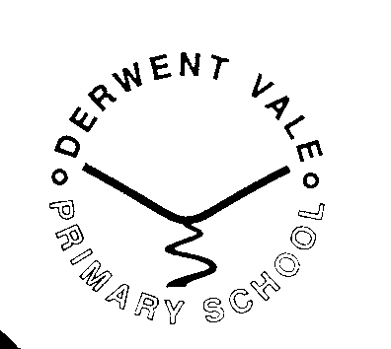
PERMANENT FULL TIME EARLY YEARS FOUNDATION STAGE (EYFS) TEACHER

Derwent Vale Primary & Nursery School, William Street, Great Clifton, WORKINGTON, Cumbria CA14 1WA

Salary M2-M6 | Community School | NOR 97 Aged 3 – 11 years
Required From 1st September 2026.
The Governors of Derwent Vale Primary & Nursery School are seeking to appoint an enthusiastic, passionate and highly motivated full time teacher to join the team at our successful school. The post is to lead and teach our Early Years Foundation Stage (EYFS) class.
The successful candidate will:
- Be an excellent EYFS classroom practitioner
- Be committed to providing the best outcomes for all children
- Understands the importance of high-quality adult interactions, oracy, and continuous provision to enhance personal development and our EYFS offer
- Be able to create an engaging and challenging learning environment
- Play a full and active role in wider school life and the local community
- Be able to build successful partnerships with parents, governors, colleagues and professionals
What we can offer:
- A commitment to personalised continued professional development
- A strong, supportive and experienced team
- The opportunity to lead or support a curriculum area
- Friendly children, staff, parents and governors
- An inclusive community school with a family ethos
Applicants should indicate curricular strengths & interests.
Our school is committed to safeguarding and promoting the welfare of children and young people and expects all employees and volunteers to share this commitment. A DBS enhanced disclosure will be required for this post.
Application forms and further details can be obtained from:
The school website: www.derwentvale.cumbria.sch.uk
Visits to the school are welcomed; please contact the school office (admin@derwentvale.cumbria.sch.uk) to arrange a suitable time.
Closing date for applications is Friday 1st May 2026 9.00am
Shortlisting will take place on Friday 1st May 2026
Interviews to be held on Friday 8th May 2026

