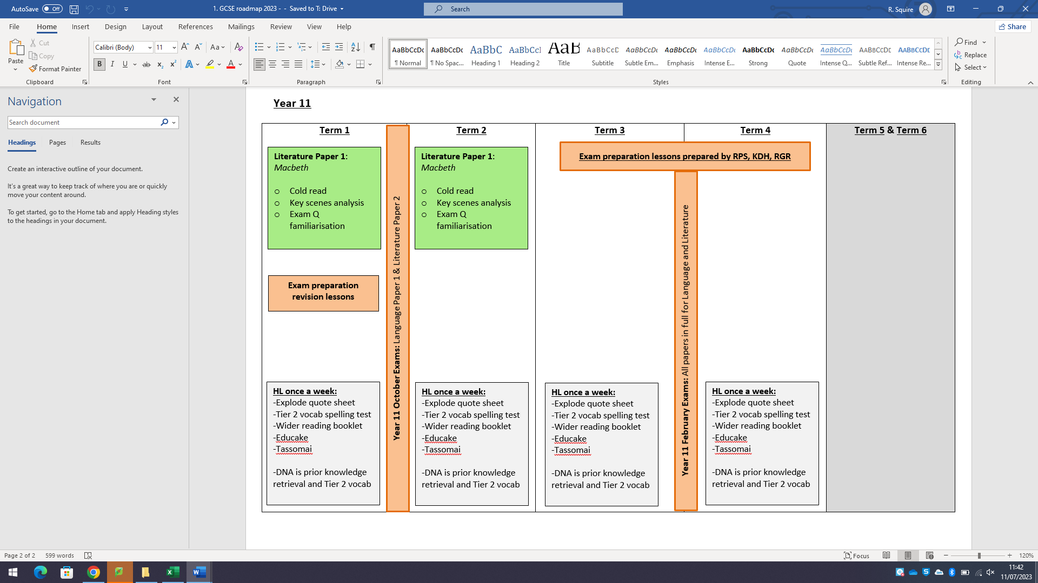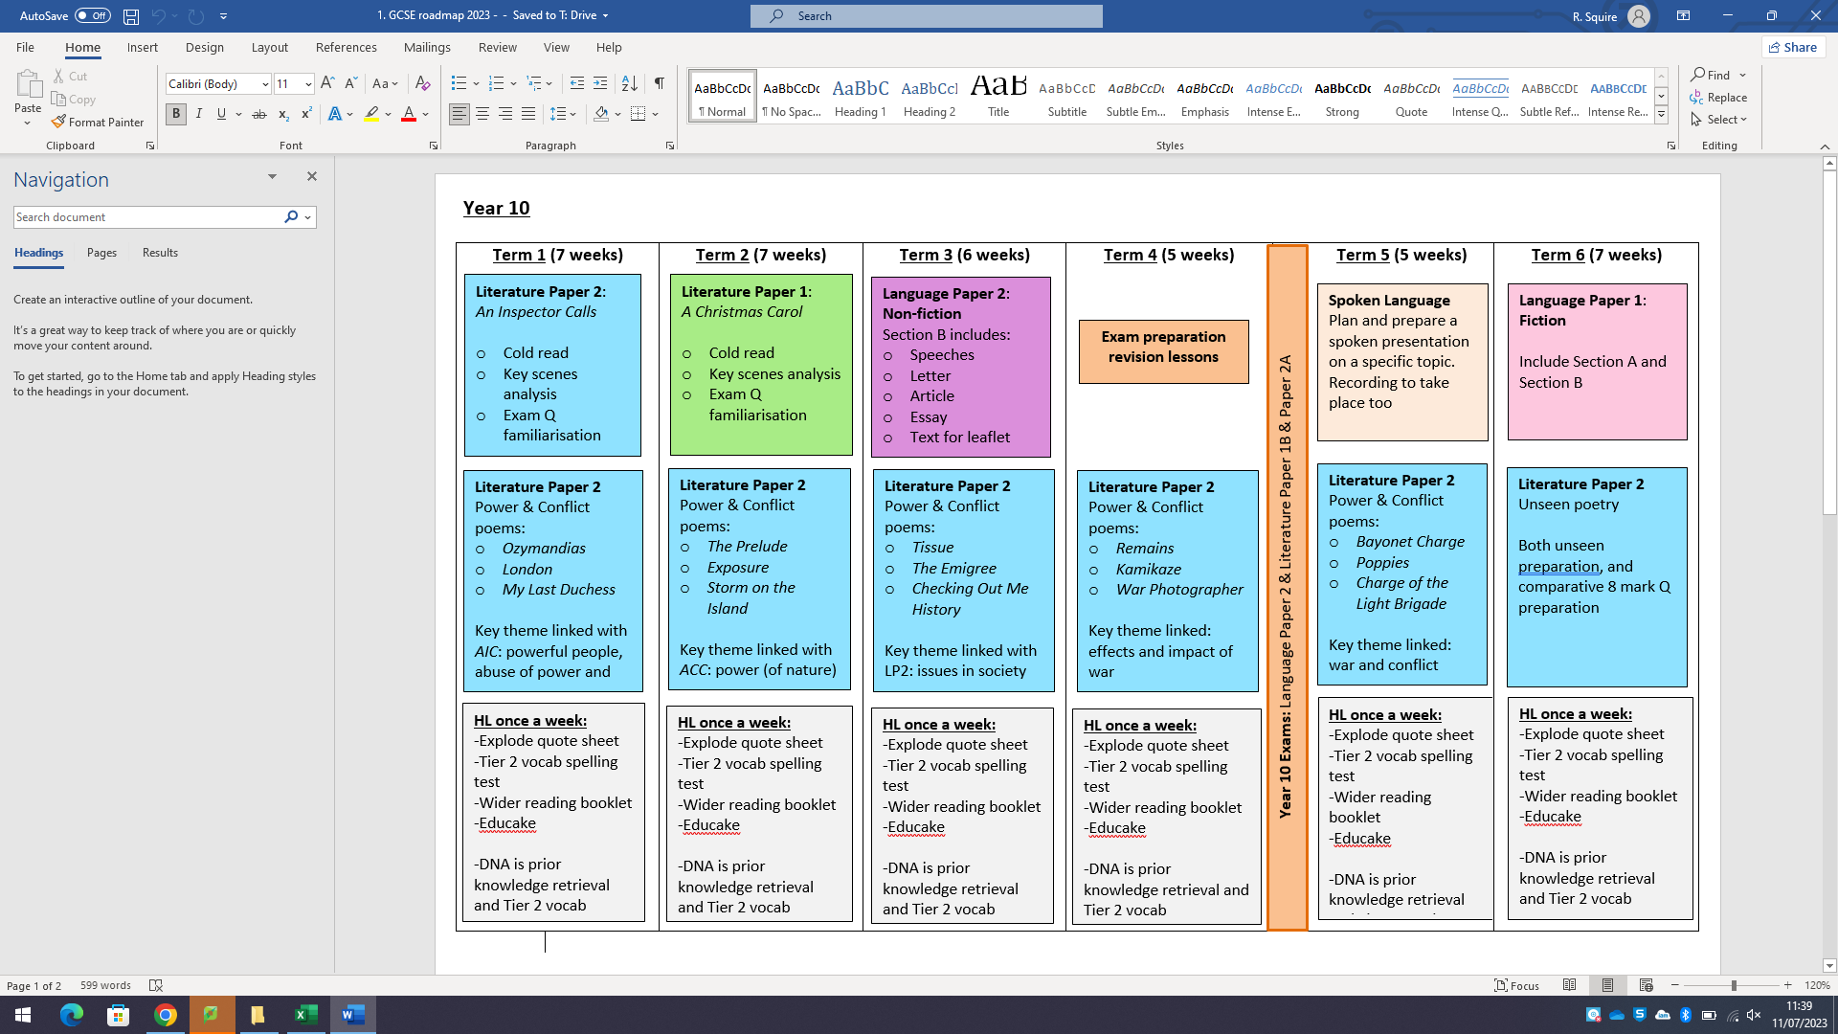

Language Paper 1

Language Paper 2

Literature Paper 1

Literature Paper 2