

**OCR**

**A-Level PE**

**CTECH SPORT**

**Bridging Booklet**

**Name:**



**Performance Profile**

**Name:**

**Sport:**

**Level that I play:**

**National Governing body of my sport:**

**How is the sport funded?**

**Grassroots**

**Elite**

**Are there any barriers to people participating in your sport? Think about access to facilities/equipment/coaches etc**

**As a performer, in terms of your skills, tactics and fitness levels, what are your:**

**Strengths:**

**Weaknesses:**

**Complete the table below on movement analysis using the pictures provided.**

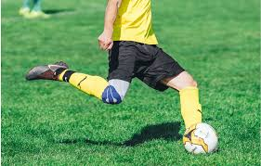

**Football kick:**

|  |  |  |  |  |
| --- | --- | --- | --- | --- |
| **Joint** | **Joint type** | **Movement** | **Agonist** | **Antagonist** |
| Knee | Hinge | Flexion |  |  |
| Ankle |  |  |  |  |

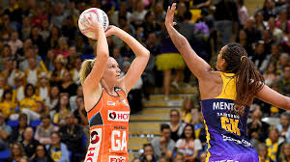

**Netball Shooting:**

|  |  |  |  |  |
| --- | --- | --- | --- | --- |
| **Joint** | **Joint type** | **Movement** | **Agonist** | **Antagonist** |
| Elbow |  |  |  |  |
| Shoulder |  |  |  |  |

**Mental Preparation**

**Explain how you mentally prepare for your sport?**

**Describe a time either you or a team you have watched have come back from a being behind to win a game.**

**What happened to help the team turn around the score/result?**

**Highlight the health & fitness benefits of taking part in the sport.**

**Physical Benefits:**

**(think about the cardiovascular/muscular/respiratory system)**

**Social benefits:**