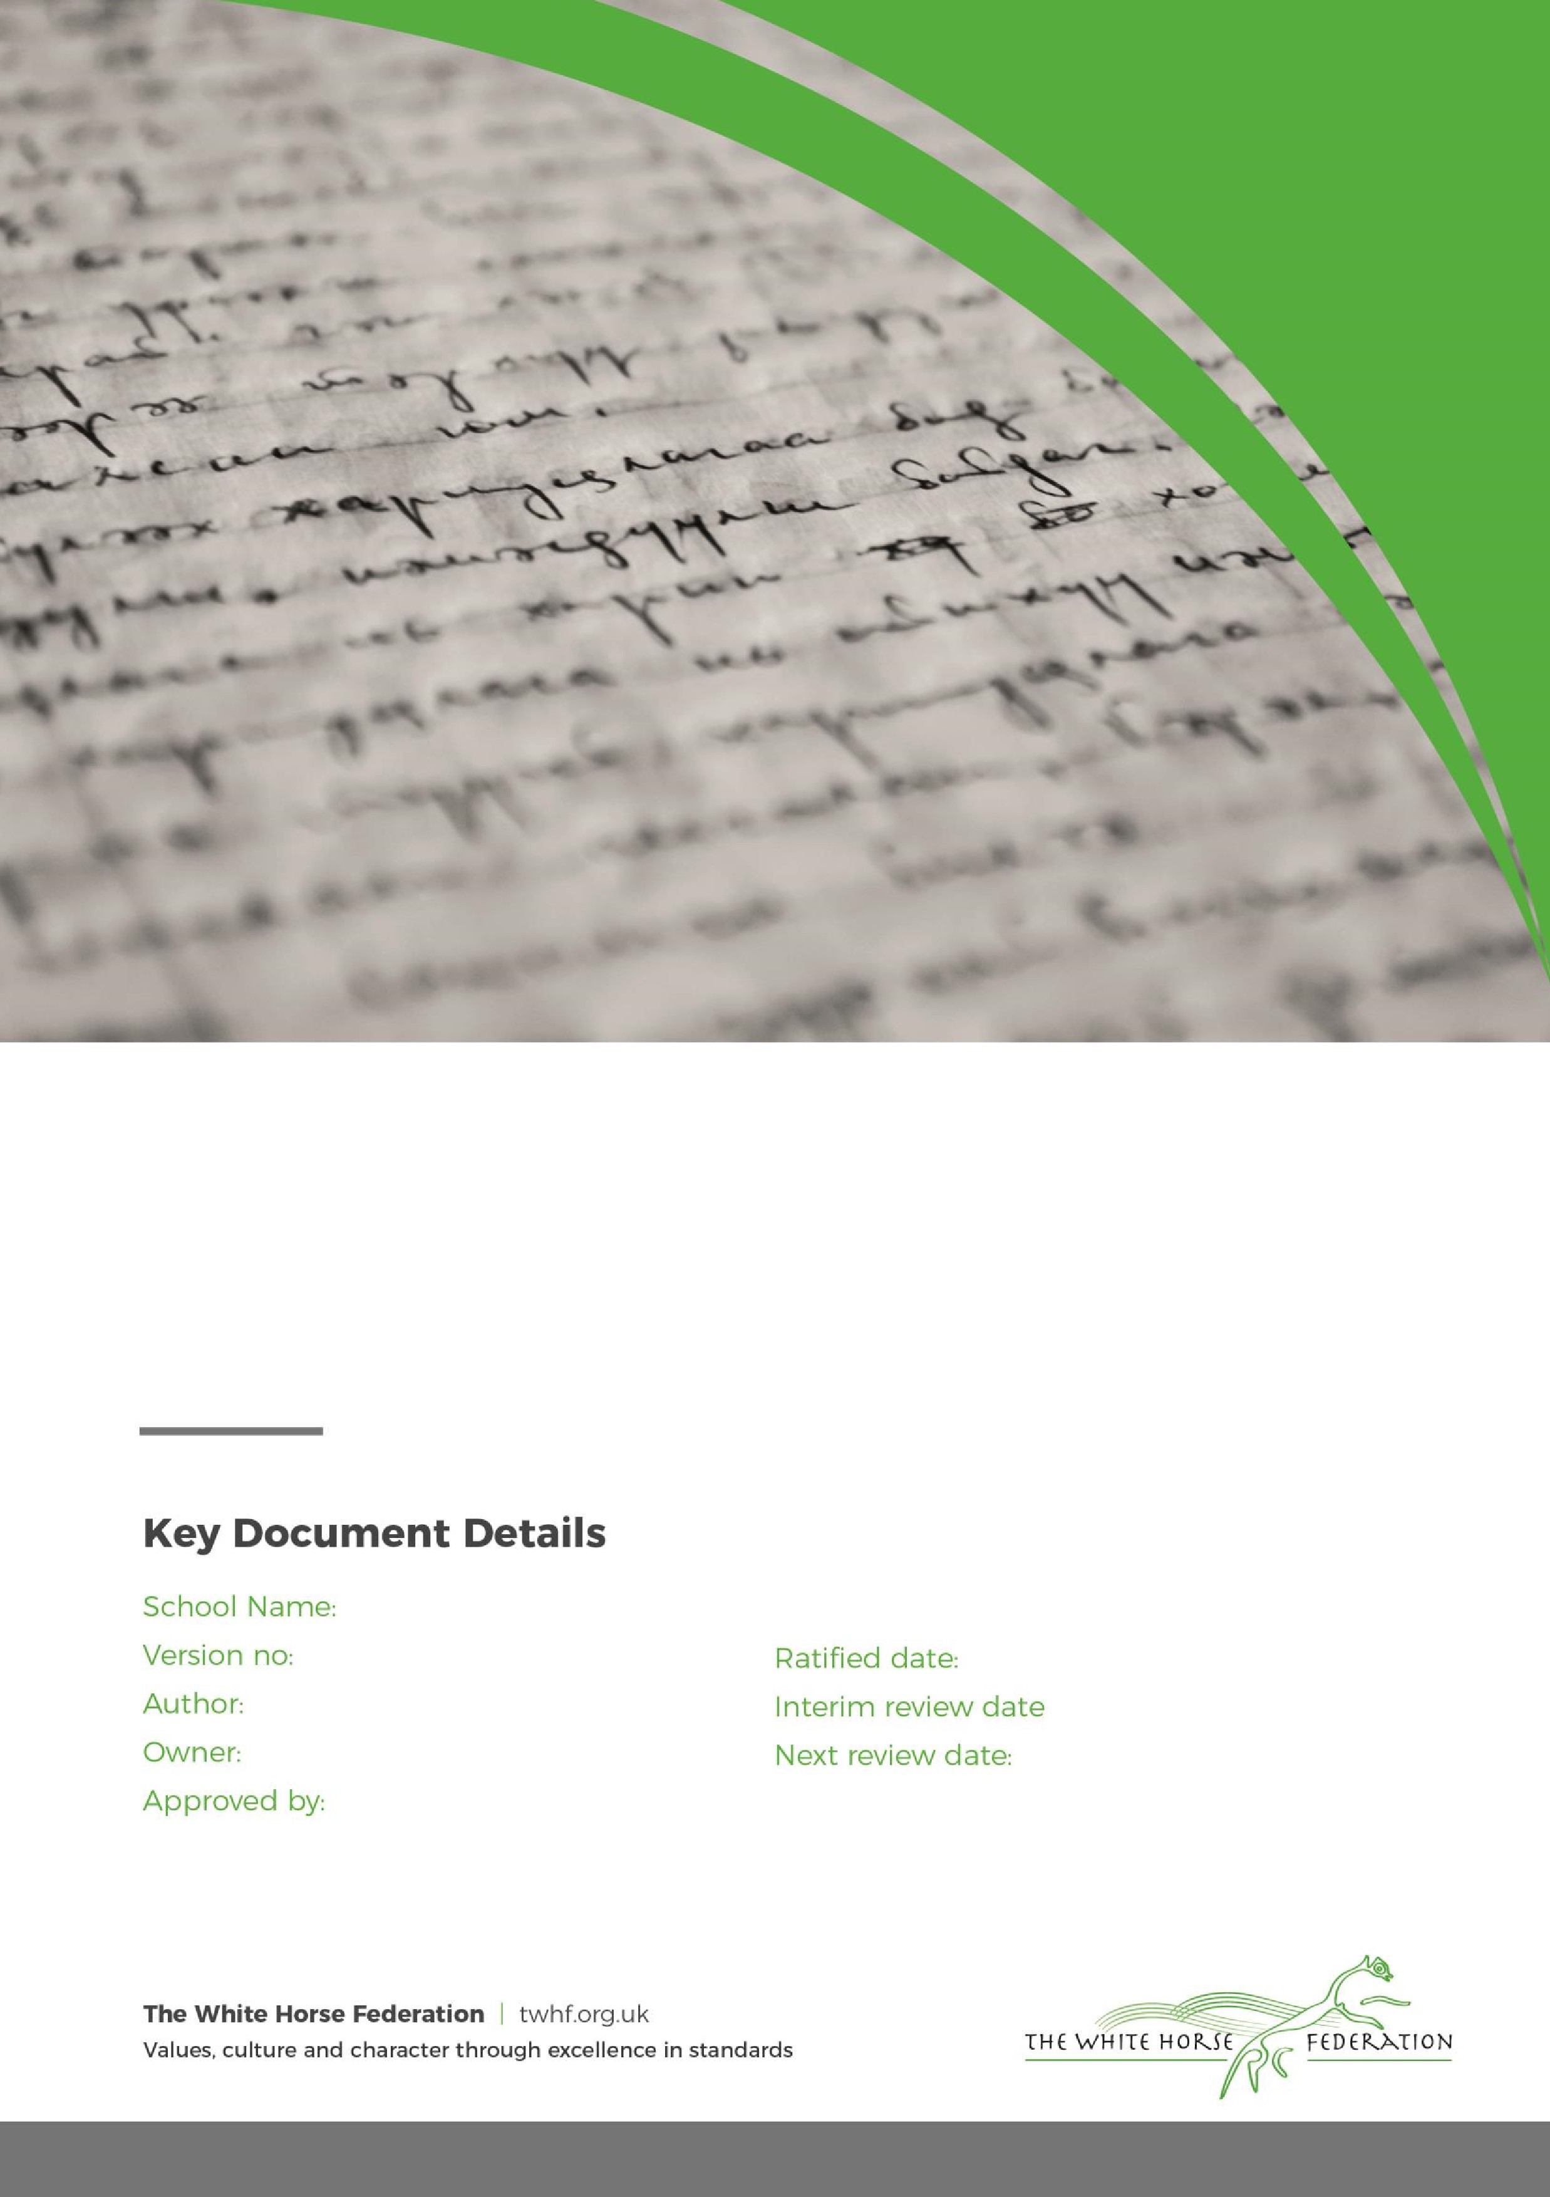

Special Education Needs (SEN)
Information Report

1

Tim James

Tim James

September 2025

September 2026

Devizes

February 2026
Approver

Dear Parents and Carers,

The aim of this information report is to explain how we implement our SEND policy. In other words, we want to show you how SEND support works in our school.
If you want to know more about our arrangements for SEND, read our SEND policy.
You can find it on our website Devizes School
Note: If there are any terms we’ve used in this information report that you’re unsure of, you can look them up in the Glossary at the end of the report.

1. What types of SEN does the school provide for?
Our school provides for pupils with the following needs:
Area of need | Condition
Communication and interaction | Autism spectrum disorder
Communication and interaction | Speech and language difficulties
Cognition and learning | Specific learning difficulties, including dyslexia, dyspraxia, dyscalculia
Cognition and learning | Moderate learning difficulties
Cognition and learning | Severe learning difficulties
Social, emotional and mental health | Attention deficit hyperactive disorder (ADHD)
Social, emotional and mental health | Attention deficit disorder (ADD)
Sensory and/or physical | Hearing impairments
Sensory and/or physical | Visual impairment
Sensory and/or physical | Multi-sensory impairment
Sensory and/or physical | Physical impairment

2. Which staff will support my child, and what training have they had?
Our special educational needs co-ordinator, or SENCO
Our SENCO is Mrs Kirsteen Fraser. You can contact Mrs Fraser via email kfraser@devizes.wilts.sch.uk Mrs Fraser has 16 years experience in this role and has worked for a total of 29 years in secondary schools as a qualified teacher. Mrs Fraser is Assistant Headteacher, is on the Senior Leadership Team and is the Designated Safeguarding Lead.
Mrs Fraser achieved the National Award in Special Educational Needs Co-ordination in 2010. Mrs Fraser also has a Post Graduate Diploma in Whole School Literacy, a Post Graduate Diploma in Special Educational Needs and a Master of Education degree in Inclusive Education and holds a Certificate of Psychometric Testing Certificate.

Assistant SENCO
Our SENCO assistant is Mrs Vicky Gale. You can contact Mrs Gale via email vgale@devizes.wilts.sch.uk Mrs Gale has worked at Devizes School since 2013 in a number of different roles. Mrs Gale is currently working towards the Assistant SENCO qualification, and is the Deputy Designated Safeguarding Lead.
Teachers
All of our teachers receive in-house SEN training, and are supported by the SENCO to meet the needs of pupils who have SEN. We are currently working towards the Autism Award.

Teaching assistants (TAs)
We have a team of TAs, including 3 higher-level teaching assistants (HLTAs) who are trained to deliver SEN provision.
We have teaching assistants who are trained to deliver interventions such as Lexia, Distar, ELSA and many more.

External agencies and experts
Sometimes we need extra help to offer our pupils the support that they need. Whenever necessary we will work with external support services to meet the needs of our pupils with SEN and to support their families. These include, but are not limited to:
- Speech and language therapists
- Educational psychologists
- Occupational therapists
- GPs or paediatricians
- School nurses
- Child and adolescent mental health services (CAMHS)
- Education welfare officers
- Social services and other LA-provided support services
- Voluntary sector organisations

3. What should I do if I think my child has SEN?
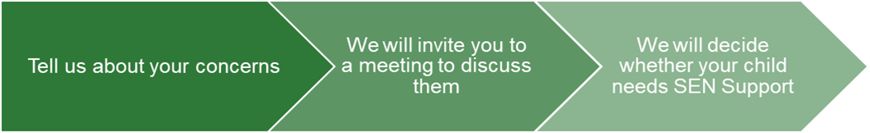
If you think your child might have SEN, the first person you should tell is your child’s tutor.  They will pass the message on to our SENCO, Mrs Fraser who will be in touch to discuss your concerns. | Where necessary we will meet with you to discuss your concerns and try to get a better understanding of what your child’s strengths and difficulties are.  Together we will decide what outcomes to seek for your child and agree on next steps.  We will make a note of what’s been discussed and add this to your child’s record. You will also be given a copy of this. | If we decide that your child needs SEN support, we will formally notify you in writing and your child will be added to the school’s SEND register.

4. How will the school know if my child needs SEN support?
All our class teachers are aware of SEN and are on the lookout for any pupils who aren’t making the expected level of progress in their schoolwork or socially. This might include communication and interaction difficulties, inconsistent or limited progress etc.
If the teacher notices that a pupil is falling behind, they try to find out if the pupil has any gaps in their learning. If they can find a gap, they will give the pupil extra tuition to try to fill it. Pupils who don’t have SEN usually make progress quickly once the gap in their learning has been filled.
If the pupil is still struggling to make the expected progress, the teacher will talk to the SENCO, and will contact you to discuss the possibility that your child has SEN.
The SENCO will observe the pupil in the classroom and in the playground to see what their strengths and difficulties are. They will have discussions with your child’s teacher/s, to see if there have been any issues with, or changes in, their progress, attainment or behaviour. They will also compare your child's progress and development with their peers and available national data.
The SENCO will ask for your opinion and speak to your child to get their input as well. They may also, where appropriate, ask for the opinion of external experts such as a speech and language therapist, an educational psychologist, or a paediatrician.
Based on all of this information, the SENCO will decide whether your child needs SEN support. You will be told the outcome of the decision in writing.
If your child does need SEN support, their name will be added to the school’s SEN register, and the SENCO will work with you to create a SEN support plan for them if this is deemed appropriate.

5. How will the school measure my child’s progress?
We will follow the ‘graduated approach’ to meeting your child’s SEN needs.
The graduated approach is a 4-part cycle of assess, plan, do, review.
Assess
If your child is not making the expected level of progress, we will make an assessment to find out what strengths and difficulties your child has. We will ask for you and your child’s input, as well as getting help from external professionals where necessary.
Review
We will assess how well the support we put in place helped the pupil to meet the outcomes we set. We will use our improved understanding of
your child’s needs to improve the support we offer.
Plan
In discussion with you and your child, we will decide what outcomes we are hoping to achieve. We will make a plan of the support we will offer your child to help them meet those outcomes. We will make a record of this and share it with you and all relevant school staff.
Do
We will put our plan into practice.
The class teacher, with the support of the SENCO, will be responsible for working with your child on a daily basis, and making sure the support we put in place is having the impact we intended.

As a part of the planning stage of the graduated approach, we will set outcomes that we want to see your child achieve.
Whenever we run an intervention with your child, we will assess them before the intervention begins. This is known as a ‘baseline assessment’. We do this so we can see how much impact the intervention has on your child’s progress.
We will track your child’s progress towards the outcomes we set over time and improve our offer as we learn what your child responds to best.
This process will be continual. If the review shows a pupil has made progress, they may no longer need the additional provision made through SEN support. For others, the cycle will continue and the school's targets, strategies and provisions will be revisited and refined.

6. How will I be involved in decisions made about my child’s education?
We will provide 2 academic reports on your child's progress each academic year. Parent are also invited to attend parents evening.
A member of the SEN or pastoral team will meet with parents of students with SEN where there are concerns that can’t be addressed through parent’s evening, or through initial contact with your child’s tutor.
- Set clear outcomes for your child’s progress
- Review progress towards those outcomes
- Discuss the support we will put in place to help your child make that progress
- Identify what we will do, what we will ask you to do, and what we will ask your child to do
We know that you’re the expert when it comes to your child’s needs and aspirations. So we want to make sure you have a full understanding of how we’re trying to meet your child’s needs, so that you can provide insight into what you think would work best for your child.
We also want to hear from you as much as possible so that we can build a better picture of how the SEN support we are providing is impacting your child outside of school.
If your child’s needs or aspirations change at any time, please let us know right away so we can keep our provision as relevant as possible.
After any discussion we will make a record of any outcomes, actions and support that have been agreed. This record will be shared with all relevant staff, and you will be given a copy.
If you have concerns that arise between these meetings, please contact the member of staff directly.

7. How will my child be involved in decisions made about their education?
The level of involvement will depend on your child’s age, and level of competence. We recognise that no 2 children are the same, so we will decide on a case-by-case basis, with your input.
We may seek your child’s views by asking them to:
- Attend meetings to discuss their progress and outcomes
- Prepare a presentation, written statement, video, drawing, etc.
- Discuss their views with a member of staff who can act as a representative during the meeting
- Complete a survey

8. How will the school adapt its teaching for my child?
Your child’s teaches are responsible and accountable for the progress and development of all the pupils in their class.
High-quality teaching is our first step in responding to your child’s needs. We will make sure that your child has access to a broad and balanced curriculum in every year they are at our school.
We will adapt how we teach to suit the way the pupil works best. There is no '1 size fits all’ approach to adapting the curriculum, we work on a case-by case basis to make sure the adaptations we make are meaningful to your child.
These adaptations include:
- Adapting our curriculum to make sure all pupils are able to access it, for example, by grouping, 1-to-1 work, adapting the teaching style or content of the lesson, etc.
- Adapting our teaching, for example, giving longer processing times, pre-teaching of key vocabulary, reading instructions aloud, etc.
- Adapting our resources and staffing
- Using recommended aids, such as laptops, coloured overlays, visual timetables, larger font, etc.
- Teaching assistants will support pupils in small groups for interventions
We may also provide the following interventions:
Area of need | Condition | How we support these pupils
Communication and interaction | Autism spectrum disorder | Visual timetables  Social stories
Communication and interaction | Speech and language difficulties | Speech and language therapy – this would be referral to external agency
Cognition and learning | Specific learning difficulties, including dyslexia, dyspraxia and dyscalculia | Quality first teaching, One page Profiles to inform staff of individual need, refer to specialist advisory teachers, academic interventions for literacy & numeracy.
Cognition and learning | Moderate learning difficulties | As above
Cognition and learning | Severe learning difficulties | Bespoke curriculum to meet the individual needs. Managed by SENCO in liaison with all stakeholders including the Local Authority
Social, emotional and mental health | ADHD, ADD | One page Profiles, Quality First Teacher, pastoral interventions, access arrangements where necessary, involvement of specialist advisory team as appropriate.
Social, emotional and mental health | Adverse childhood experiences and/or mental health issues | Pastoral support, referral to external/internal therapeutic agencies, close liaison with professionals and families.
Sensory and/or physical | Hearing impairment | Quality first teaching, adjustments to seating plans, TA support where appropriate, advisory team where required, access arrangements
Sensory and/or physical | Visual impairment | Support from VI team, assistive technology, access arrangements, TA support from VI trained members of the team
Sensory and/or physical | Physical impairment | Quality first teaching, adjustments to seating plans, TA support where appropriate, advisory team where required, access arrangements
These interventions are part of our contribution to Wiltshire’s local offer.

9. How will the school evaluate whether the support in place is helping my child?
We will evaluate the effectiveness of provision for your child by:
- Reviewing their progress towards their goals each term
- Reviewing the impact of interventions
- Using pupil questionnaires
- Monitoring by the SENCO
- Using provision maps to measure progress
- Holding an annual review (if they have an education, health and care (EHC) plan)

10. How will the school resources be secured for my child?
It may be that your child’s needs mean we need to secure:
- Extra equipment or facilities
- More teaching assistant hours
- Further training for our staff
- External specialist expertise
If that’s the case, we will consult with external agencies to get recommendations on what will best help your child access their learning.

11. How will the school make sure my child is included in activities alongside pupils who don’t have SEND?
All of our extra-curricular activities and school visits are available to all our pupils, including our before and after-school clubs.
All pupils are encouraged to go on our school trips, including our residential trips.
All pupils are encouraged to take part in all extra curricular activities.
No pupil is ever excluded from taking part in these activities because of their SEN or disability and we will make whatever reasonable adjustments are needed to make sure that they can be included.

12. How does the school make sure the admissions process is fair for pupils with SEN or a disability?
Information on our admissions policy can be found on the school’s website
Admissions | Devizes School

13. How does the school support pupils with disabilities?
- The majority of the site is wheelchair accessible.
- Maps are given to all students
- There are disabled toilets on site
- Steps are highlighted in yellow paint to support visually impaired students
- Quiet spaces available at social times for students who struggle with the sensory impact of busy environments

14. How will the school support my child’s mental health and emotional and social development?
We provide support for pupils to progress in their emotional and social development in the following ways:
- Pupils with SEN are encouraged to be part of all school activities
- Pupils with SEN are also encouraged to be part of the wide variety of after school clubs to promote teamwork/building friendships
- We provide extra pastoral support for listening to the views of pupils with SEN
- Pastoral support is given to students who need extra support with social or emotional development
We have a ‘zero tolerance’ approach to bullying.

15. What support will be available for my child as they transition between classes or settings, or in preparing for adulthood?
Between years
To help pupils with SEND be prepared for a new school year we:
- Provide a through handover between existing and new academic teachers
- Schedule lessons with the incoming teacher towards the end of the summer term
Between schools
When your child is moving on from our school, we will ask you and your child what information you want us to share with the new setting.
Between Phases
The SENCO of the primary school meets with our SENCO to discuss the needs of the incoming pupils near the end of the summer term.
We arrange meetings with the parents/carers of incoming pupils to discuss how we can best welcome their child into our community.
Onto Adulthood
We provide all our pupils with appropriate advice on paths into work or further education.
We work with the pupil to help them achieve their ambitions, which can include goals in higher education, employment, independent living and participation in society.

16. What support is in place for looked-after and previously looked-after children with SEN?
As well as being the SENCO, Mrs Fraser is also the designated teacher for looked after children. Mrs Fraser will make sure that all teachers understand how a looked-after or previously looked-after pupil’s circumstances and their SEN might interact, and what the implications are for teaching and learning.
Children who are looked-after or previously looked-after will be supported much in the same way as any other child who has SEND. However, looked-after pupils will also have a personal education plan (PEP). We will make sure that the PEP and any SEN support plans or EHC plans are consistent and complement one another.

17. What should I do if I have a complaint about my child’s SEN support?
Complaints about SEN provision in our school should be made to the SENCO in the first instance. They will then be referred to the school’s complaints policy.
If you are not satisfied with the school’s response, you can escalate the complaint. In some circumstances, this right also applies to the pupil themselves.
To see a full explanation of suitable avenues for complaint, see pages 246 and 247 of the SEN Code of Practice.

If you feel that our school discriminated against your child because of their SEND, you have the right to make a discrimination claim to the first-tier SEND tribunal. To find out how to make such a claim, you should visit: https://www.gov.uk/complain-about-school/disability-discrimination
You can make a claim about alleged discrimination regarding:
- Admission
- Exclusion
- Provision of education and associated services
- Making reasonable adjustments, including the provision of auxiliary aids and services
Before going to a SEND tribunal, you can go through processes called disagreement resolution or mediation, where you try to resolve your disagreement before it reaches the tribunal.

18. What support is available for me and my family?
If you have questions about SEND, or are struggling to cope, please get in touch to let us know. We want to support you, your child and your family.
To see what support is available to you locally, have a look at Wiltshire Council’s local offer. Wiltshire Council publishes information about the local offer on their website: https://localoffer.wiltshire.gov.uk/
Our local special educational needs and disabilities information advice and support services (SENDIASS) organisations are:
https://family-action.org.uk/services/wiltshire-sendiass/
National charities that offer information and support to families of children with SEND are:
- IPSEA
- SEND family support
- NSPCC
- Family Action
- Special Needs Jungle

19. Glossary
- Access arrangements – special arrangements to allow pupils with SEND to access assessments or exams
- Annual review – an annual meeting to review the provision in a pupil’s EHC plan
- Area of need – the 4 areas of need describe different types of needs a pupil with SEND can have. The 4 areas are communication and interaction; cognition and learning; physical and/or sensory; and social, emotional and mental health needs.
- CAMHS – child and adolescent mental health services
- Adapt – when teachers adapt how they teach in response to a pupil’s needs
- EHC needs assessment – the needs assessment is the first step on the way to securing an EHC plan. The local authority will do an assessment to decide whether a child needs an EHC plan.
- EHC plan – an education, health and care plan is a legally-binding document that sets out a child’s needs and the provision that will be put in place to meet their needs.
- First-tier tribunal/SEND tribunal – a court where you can appeal against the local authority’s decisions about EHC needs assessments or plans and against discrimination by a school or local authority due to SEND
- Graduated approach – an approach to providing SEN support in which the school provides support in successive cycles of assessing the pupil’s needs, planning the provision, implementing the plan, and reviewing the impact of the action on the pupil
- Intervention – a short-term, targeted approach to teaching a pupil with a specific outcome in mind
- Local offer – information provided by the local authority which explains what services and support are on offer for pupils with SEN in the local area
- Outcome – target for improvement for pupils with SEND. These targets don't necessarily have to be related to academic attainment
- Reasonable adjustments – changes that the school must make to remove or reduce any disadvantages caused by a child’s disability
- SENCO – the special educational needs co-ordinator
- SEN – special educational needs
- SEND – special educational needs and disabilities
- SEND Code of Practice – the statutory guidance that schools must follow to support children with SEND
- SEN information report – a report that schools must publish on their website, that explains how the school supports pupils with SEN
- SEN support – special educational provision which meets the needs of pupils with SEN
- Transition – when a pupil moves between years, phases, schools or institutions or life stages

