

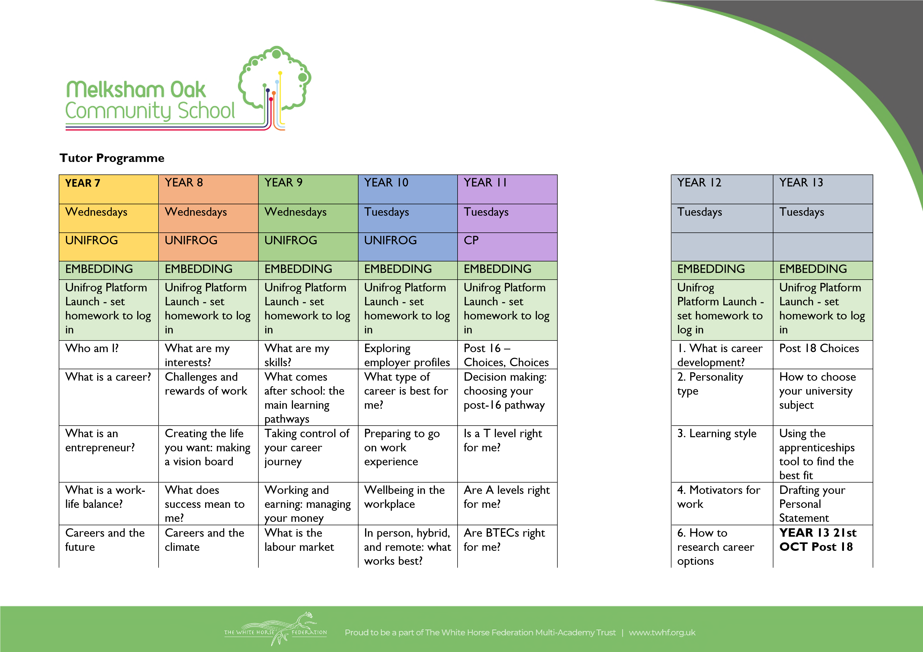

 |  | and why is it important? |  |  |  |  | DAY with Devizes
HOLIDAY | HOLIDAY | HOLIDAY | HOLIDAY | HOLIDAY |  | HOLIDAY | HOLIDAY
HOLIDAY | HOLIDAY | HOLIDAY | HOLIDAY | HOLIDAY |  | HOLIDAY | HOLIDAY
Green Careers  Week | Green Careers  Week | Green Careers  Week | Green Careers  Week | Green Careers  Week
Green Careers Week Video | Green Careers Week Video | Green Careers Week Video | Green Careers Week Video | Green Careers Week Video |  | Letters to your future self | Coping with change: entering the world of employment
Careers and the climate | Careers and the climate | Careers and the climate | Post 16 –  Choices, Choices | Is a UK apprenticeship right for me? |  | STUDENT  CHOICE OF  TOPIC | An introduction to student finance - assembly session
Greenwashing isn't Cool | Greenwashing isn't Cool | Greenwashing isn't Cool | Decision making: choosing your post-16 pathway | Using the College / Sixth Form tool to find the best fit (post-16) |  | STUDENT  CHOICE OF  TOPIC | The Gap year
How many Jobs | How many Jobs | How many Jobs | Is AI a threat to our jobs? | Using the Apprenticeships tool to find the best fit (post-16) |  | STUDENT  CHOICE OF  TOPIC | GUEST Assembly
Careers  Hangman | Careers  Hangman | Careers  Hangman | Types of Employment and paperwork 1 (CC) | Types of Employment and paperwork 1 (CC) |  | STUDENT  CHOICE OF  TOPIC | GUEST Assembly
Who am I | Who am I | Who am I | Types of Employment and paperwork 2 ( CC) | Types of Employment and paperwork 2 ( CC) |  | STUDENT  CHOICE OF  TOPIC | GUEST Assembly

Christmas Careers | Christmas Careers | Christmas Careers | Types of Employment and paperwork 3 (CC) | Types of Employment and paperwork 3 (CC) |  | STUDENT  CHOICE OF  TOPIC | GUEST Assembly
HOLIDAY | HOLIDAY | HOLIDAY | HOLIDAY | HOLIDAY |  | HOLIDAY | HOLIDAY
HOLIDAY | HOLIDAY | HOLIDAY | HOLIDAY | HOLIDAY |  | HOLIDAY | HOLIDAY
Skills (INTRO) | Skills (YE) | OPTIONS (BBC) | WEX -  Interactive |  |  | WEX
Communication | Communication | OPTIONS -  WHY CHOOSE  ASSEMBLY | WEX ROLL  OUT  ASSEMBLIES | Post 16  Applications and  Offers |  | WEX ROLL  OUT  ASSEMBLIES | GUEST Assembly
Problem Solving | Problem Solving | Decision making: choosing what to  study at KS4 (  UNIFROG) | 1. Understand  Employment Sectors x 3 sessions ( week  1,2,3) | Post 16  Applications and  Offers |  | 1. Understand  Employment Sectors x 3 sessions ( week  1,2,3) | GUEST Assembly
Team Work | Team Work | OPTIONS  Careers in  Option subjects | 1. Understand  Employment Sectors x 3 sessions ( week  1,2,3) | Post 16  Applications and  Offers |  | 1. Understand  Employment Sectors x 3 sessions ( week  1,2,3) | GUEST Assembly
Self Management | Self Management | OPTIONS  Careers in  Option subjects | 1. Understand Employment Sectors x 3 sessions ( week  1,2,3) | Post 16  Applications and  Offers |  | 1. Understand Employment Sectors x 3 sessions ( week  1,2,3) | GUEST Assembly
Self Belief | Self Belief | OPTIONS  Careers in  Option subjects | 2 Understand Different Types of Business | Post 16  Applications and  Offers |  | 2. Understand  Different Types of  Business | GUEST Assembly
Apprenticeships  NAW Video | Apprenticeships  NAW Video | Apprenticeships  NAW Video | 3.Understand changes in  Working World | Apprenticeships |  | 3. Understand changes in  Working World | GUEST Assembly
HOLIDAY | HOLIDAY | HOLIDAY | HOLIDAY | HOLIDAY |  | HOLIDAY | HOLIDAY

 |  |  | WEX -  Interactive |  |  | WEX
What is CLMI | What is CLMI | OPTIONS  Careers in  Option subjects | 4. Understand  Key business  Functions | Post 16 trackers  UNIFROG LOG,  Where Next, 1-  2-1's |  | 4. Understand  Key business  Functions | Post 18 Trackers  - UNIFROG  LOG, Where  Next, 1-2-1's
CLMI | CLMI | OPTIONS  Careers in  Option subjects | 5. Understand roles | Post 16 trackers  UNIFROG LOG,  Where Next, 1-  2-1's |  | 5. Understand roles | Post 18 Trackers  - UNIFROG  LOG, Where  Next, 1-2-1's
CLMI | CLMI | OPTIONS  Careers in  Option subjects | 6. Understand routes | Post 16 trackers  UNIFROG LOG,  Where Next, 1-  2-1's |  | 6. Understand routes | Post 18 Trackers  - UNIFROG  LOG, Where  Next, 1-2-1's
CLMI | CLMI | OPTIONS  Careers in  Option subjects | 7. Skills for  Employers | Post 16 trackers  UNIFROG LOG,  Where Next, 1-  2-1's |  | 7. Skills for  Employers | Post 18 Trackers  - UNIFROG  LOG, Where  Next, 1-2-1's
CLMI | CLMI | OPTIONS  Careers in  Option subjects | 8. Getting WEX and Volunteering | Post 16 trackers  UNIFROG LOG,  Where Next, 1-  2-1's |  | 8. Getting WEX and Volunteering | Post 18 Trackers  - UNIFROG  LOG, Where  Next, 1-2-1's
HOLIDAY | HOLIDAY | HOLIDAY | HOLIDAY | HOLIDAY |  | HOLIDAY | HOLIDAY
HOLIDAY | HOLIDAY | HOLIDAY | HOLIDAY | HOLIDAY |  | HOLIDAY | HOLIDAY
Creative Careers | Creative Careers | Creative Careers | Starting Point  ROA | Starting Point
Future Careers | Interests and Job Ideas | Understanding the workplace | 9. Building  Networks |  |  | 9. Building  Networks
Transition points | Labour market Information | Jobs and opportunities | Starting Point Lesson 1 | N/A |  | STUDENT  CHOICE OF  TOPIC | N/A
Personal  Qualities | Exploring | Occupation  Classifications | Starting Point Lesson 2 | N/A |  | STUDENT  CHOICE OF  TOPIC | N/A

Finding  Information | Making decisions for KS4 | Business  Structures | Starting Point Lesson 3 | N/A |  | STUDENT  CHOICE OF  TOPIC | N/A
Career  Management | Option Subjects | Work Hierarchy and Structure | Starting Point  ROA Skills and  Talents  4min:31 Video | N/A |  | STUDENT  CHOICE OF  TOPIC | N/A
Traits and Skills | Qualifications and pathways | Diversity,  Equality and  Sterotyping | Starting Point  ROA Skills and  Talents  4min:31 Video | N/A |  | STUDENT  CHOICE OF  TOPIC | N/A
HOLIDAY | HOLIDAY | HOLIDAY | HOLIDAY | HOLIDAY |  | HOLIDAY | HOLIDAY
Careers  Activities | Careers  Activities | Careers  Activities
Careers  Activities | Careers  Activities | Careers  Activities | WEX Trackers and 1-2-1's | N/A |  | STUDENT  CHOICE OF  TOPIC | N/A
Careers  Activities | Careers  Activities | Careers  Activities | WEX Trackers and 1-2-1's | N/A |  | STUDENT  CHOICE OF  TOPIC | N/A
Careers  Activities | Careers  Activities | Careers  Activities | WEX Trackers and 1-2-1's | N/A |  | STUDENT  CHOICE OF  TOPIC | N/A
Careers  Activities | Careers  Activities | Careers  Activities | WEX Trackers and 1-2-1's | N/A |  | STUDENT  CHOICE OF  TOPIC | N/A
Careers  Activities | Careers  Activities | Careers  Activities | WEX Trackers and 1-2-1's | N/A |  | STUDENT  CHOICE OF  TOPIC | N/A
Careers  Activities | Careers  Activities | Careers  Activities | WEX WEEK | N/A |  | WEX Week | N/A
Careers  Activities | Careers  Activities | Careers  Activities | WEX  Presentations | N/A |  |  | N/A
HOLIDAY | HOLIDAY | HOLIDAY | HOLIDAY | HOLIDAY |  | HOLIDAY | HOLIDAY

