Dove Bank Primary School - Curriculum Overview Reception

Autumn 1 |  | Autumn 2 | Spring 1 | Spring 2 | Summer 1 | Summer 2
  Writing: Peace At Last | 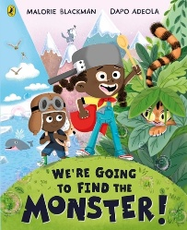  Black Lives Matter – We’re Going to Find the Monster! By Malorie Blackman and Dapo Adeola | Writing: The Three Little Pigs  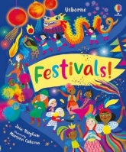 | 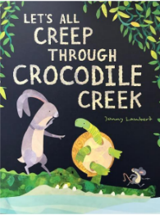  Writing: Let’s all creep through crocodile creek | Writing: The Pirates are coming  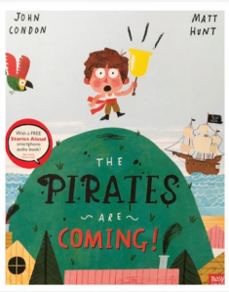 | Writing: Gigantosaurus  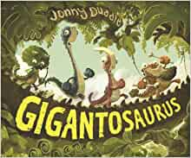 | Writing: The Sea Saw  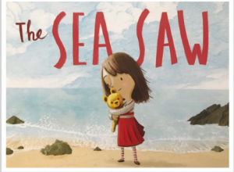
Suggested texts:  - All Jill Murphy Books  - Home by Corson Ellis  - The leaf thief by Alice Hemming  - Journey Home by Frann Preston-Gannon  - Whatever Next by Jill Murphy  - Blue Monster wants it all by Jeanne Willis |  | Suggested texts:  - Pattan’s Pumpkin by Chitra Sounder  - Funny Bones Janet and Allan Ahlberg  - The Three Ninja Pigs by Corey Rosen Schwartz  - The Three Little Wolves and The Big Bad Pig by Eugene Trivizas  - Goldilocks and the three bears  - Little Red Riding Hood. | Suggested texts:  - The last tiger by Petr Horacek  - Baby Goz by Steve Weatherill  - Handa’s surprise  - I am a Tiger by Karl Newson  - Rumble in the jungle Giles Andreae  - Find me a Tiger by Lynley Dodd | Suggested texts:  - Oi! Get off our train by John Burningham  - Through the magic mirror by Anthony Browne  - The Night Pirates by Peter Harris  - The Pirates Next Door by Jonny Duddle  - Ten Little Pirates by Mike Brownlow  - How I became a Pirate by Melinda Long Commotion in the Ocean by Giles Andreae | Suggested texts:  - Life on earth: dinosaurs by Heather Alexander  - Dinosaurs don’t draw by Elli Wollard  - The Fossil Hunter: how Mary Anning unearthed the truth about dinosaurs by Kate Winter  - Mad about dinosaurs by Giles Andreae  - Oi Dinosaurs by Kes grey and Jim Field  - The Huggasaurus by Rachel Bright | Suggested texts:  - SSSnapp! Mr Shark (peotry book) by Neal Zetter  - Sully the seahorse (self-esteem book) by Natalie Pritchard  - The Whale who wanted more y Rachel Bright  - That rabbit belongs to Emily Brown by Cressida Cowell  - Beck Where’s my teddy? By Jez Alborough  - Under the same sky by Britta Teckentrup
Mastering Numbers  Subitising and counting up to 5.  Comparing sets of objects and sorting. |  | Mastering Numbers  Exploring composition of numbers within 5.  Number bonds to 1,2 and 3. | Mastering Numbers  Counting beyond 5.  Part, part, whole  5 frame | Mastering Numbers  Doubles to 10  Composition 6 and 7- ten frame | Mastering Numbers  Counting out from a larger group.  One more to 10.  Number bonds to 5.  Composition 6,7,8, 9 and 10. | Mastering Numbers  Composition of numbers to 10.  One more and one less to 10.  Number bonds to 10.  Counting beyond 20.
Maths  shapes –circles and triangle  measure and pattern |  | Maths  It’s Me 1 2 3!  Light & Dark  Consolidation | Maths  Alive in 5!  Growing 6 7 8 | Maths  Building 9 and 10  Consolidation | Maths  To 20 and Beyond  First then Now | Maths  Find my Pattern  On the Move
Understanding the World  Our families and community  (geography/ history/ science)  Autumn season (science)  Nocturnal animals and their homes. (science)  Oral hygiene- dentist visit (science/ physical development)  History – birthday days.  Aspiration week- People who help us (science)  Black History Month – Marcus Rashford  Religious Education  Special Places and Festivals (1.4b) |  | Understanding the World -  Celebrations around the world (geography/ science)  Winter season (science)  Hibernating animals (Science)  Winter (science)  Religious Education  The birth of Jesus  (1.1b) | Understanding the World -  Different environments around the world. (science and geography)  Recognising different beliefs and celebrate special times in different ways – Chinese New Year and Easter.(geography, history and RE)  Winter (science)  Light and sound (science)  Religious Education  Relationships, promises and church wedding celebrations  (1.3b) | Understanding the World -  Living things and their habitats. (science)  Draw a simple map. (history and geography)  Spring season (science)  Earth and Space (science)  Forces (science)  Religious Education  Easter Celebrations  (1.1c) | Understanding the World  Life cycle of a butterfly (science)  Similarities and differences of now and the past (history).  Minibeasts (science)  Animals, excluding humans (science)  Religious Education  Caring for Creation  (1.5a) | Understanding the World  Under the sea- sea creatures (science)  Summer season (science)  Past and Present – old toys, old photos of family (science)  Living things and their habitats (science)  Religious Education  Helping Others  (1.4a)
Personal, Social and Emotional Development  PSHE  Aspiration  RSE- family and friendship |  | Personal, Social and Emotional Development  PSHE  Aspiration  RSE- family and friendship | Personal, Social and Emotional Development  PSHE  Kindness | Personal, Social and Emotional Development  PSHE  Kindness | Personal, Social and Emotional Development  PSHE  Resilience | Personal, Social and Emotional Development  PSHE  Resilience
No Outsiders-  To make a new friend  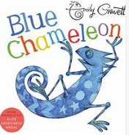  Text: Blue Chameleon |  | No Outsiders-  All families are different  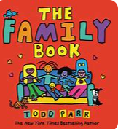  Text: The Family Book | No Outsiders-  To celebrate my family  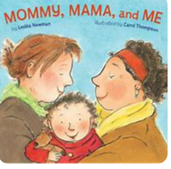  Text: Mommy, Mama and Me | No Outsiders-  To say hello  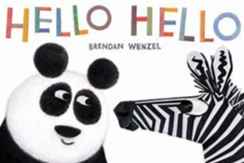  Text: Hello Hello | No Outsiders-  It’s ok to like different things  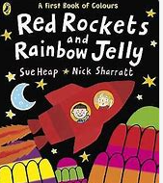  Text: Red Rockets and Rainbow Jelly | No Outsiders-  To choose what I like  Text: You Choose  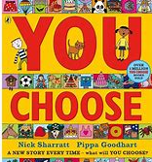
Expressive Arts and Design  ART- Drawing: Marvelous me  Music (KAPOW)  Exploring sound  Nursery Rhymes  1,2,3,4,5, Once I caught a fish alive  This Old Man  One finger, One thumb |  | Expressive Arts and Design  DT- Healthy eating: soup  Music (KAPOW)  Celebration music  Nursery Rhymes  Pat-a-cake, I’m A Little Teapot &  The Hokey Cokey | Expressive Arts and Design  ART- Creation station  Music (KAPOW)  Big band  Nursery Rhymes  The Grand Old Duke of York,  London Bridge & The Penguin song | Expressive Arts and Design  DT- Boats and junk modelling  Music (KAPOW)  Musical stories  Nursery Rhymes  Frere Jacque, Sing a song of sixpence & 10 Green Bottles | Expressive Arts and Design  ART- Paint my world  Music (KAPOW)  Music and movement  Nursery Rhymes  10 in the Bed, Three Blind Mice & The Farmer’s in his Den | Expressive Arts and Design  DT- Bookmarks  Music (KAPOW)  Transport  Nursery Rhymes  A sailor went to sea & When I was one…
Physical Development  Dough Disco  Physical health and hygiene  Fine motor skills  Fundamental |  | Physical Development  Dough Disco  Physical health and hygiene  Fine motor skills  Fundamental | Physical Development  Scissor skills  Toilet skills  Fine motor skills  Fundamental | Physical Development  Using utensil skills during dinner time  Getting dressed independently  Fundamental | Physical Development  Throwing and catching skills  Fundamental | Physical Development  Balancing skills  Fine motor skills  Fundamental
ASM  Bikeability |  | ASM  Bikeability | ASM  Dance | ASM  Dance | ASM  Athletics  Forest school | ASM  Athletics
Computing  ‘People Who Help Us’ |  | Computing  ‘Awesome Autumn’ | Computing  ‘Busy Bodies’ | Computing  ‘Boats Ahoy!’ | Computing  ‘Super Space’ | Computing  ‘How computers learn’
Enrichment Opportunities:  Local area walk – looking at buildings in the town and comparing to London city with towering buildings |  | Enrichment Opportunities:  Aspiration week – PCSO’s and fire brigade | Enrichment Opportunities  Visit to a Zoo- zoo lab  Trip to the museum - | Enrichment Opportunities  Visit to the library  Forest School 13th April to 11th May. | Enrichment Opportunities  Lambing season – glebe farm | Enrichment Opportunities  Trip to the seaside
Connection to modern day Britain |  | Connection to modern day Britain | Connection to modern day Britain | Connection to modern day Britain | Connection to modern day Britain | Connection to modern day Britain
Sustainability Theme  Adaptation for the Future  |  | Sustainability Theme  Farming for the Future  | Sustainability Theme  Energy and Climate Change  | Sustainability Theme  Cycles and Waste  | Sustainability Theme  Biodiversity  | Sustainability Theme  Health and Wellbeing 

