‹
Dove Bank Primary School - Curriculum Overview Year 1
Autumn 1 |  | Autumn 2 | Spring 1 |  | Spring 2 |  | Summer 1 | Summer 2
Writing – Lost and Found by Oliver Jeffers  Outcome: Adventure narrative | 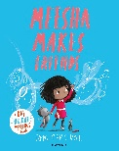  Black Lives Matter – Meesha Makes Friends by Tom Percival  Outcome: Diary | Writing – Nibbles the Book Monster by Emma Yarlett  Outcome: Diary | Writing – The Lion Inside by Rachel Bright  Outcome: Journey narrative |  | Writing – The Curious Case of the Missing Mammoth by Ellie Hattie  Outcome: Adventure narrative |  | Writing – Toys in Space by Mini Grey  Outcome: Fantasy narrative | Writing -Goldilocks and Just the One Bear by Leigh Hodgkinson  Outcome: Non-Chronological Report
Reading – Read Write Inc Phonics |  | Reading - Read Write Inc Phonics | 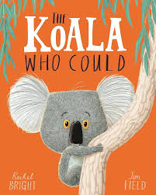  Reading – The Koala Who Could by Rachel Bright |  | 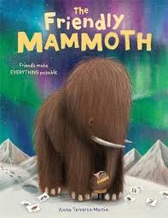  Reading – The Friendly Mammoth by Anna Terreros-Martin |  | 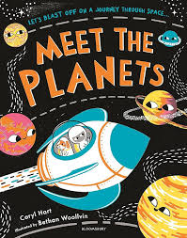  Reading – Meet the Planets by Caryl Hart | 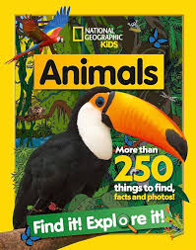  Reading – National Geographic Kids Animals
Maths  Counting within 100 |  | Maths  Comparison of quantities and part-whole relationships. Addition and subtraction facts within 10.  Numbers 0-5 | Maths  Recognise, compose, decompose, and manipulate 2D and 3D shapes.  Numbers 0-10 |  | Maths  Additive structures.  Addition and subtraction facts within 10 |  | Maths  Numbers 0-20.  Unitising and coin recognition | Maths  Position and direction.  Time
Science  Autumn |  | Science  Winter  Everyday materials | Science  Animals |  | Science  Animals, including humans. |  | Science  Spring and Summer | Science  Plants
Art & Design  Drawing: Make Your Mark |  | Design & Technology  Structures: stable pencil pot | Art & Design  Painting and Mixed Media: Colour Splash |  | Design & Technology  Mechanisms: Wheels and Axels |  | Art & Design  Sculpture and 3D: Paper Play | Design & Technology  Structures: Baby Bear’s Chair
Geography  Wonderful Weather  Black History Month – Rosa Parks |  | History  Changes in the living memory -history of toys | Geography  Our school and local area |  | History  Local history- Kidsgrove and the surrounding area in the past |  | History  Explorers  Christopher Columbus and Neil Armstrong | Geography  Our country
Music  Pulse and rhythm  (Theme: My favourite things) |  | Music  Tempo  (Theme: Snail and mouse) | Music  Musical vocabulary  (Theme: Under the sea) |  | Music  Pitch and tempo  (Theme: Superheroes) |  | Music  Vocal and body sounds (Theme: By the sea) | Music  Timbre and rhythmic patterns (Theme: Fairytales)
Physical Education  ASM – Games  Teacher - Gymnastics |  | Physical Education  ASM- Games  Teacher - Dance | Physical Education  ASM – TBC  Forest School |  | Physical Education  ASM – TBC  Teacher - Gymnastics |  | Physical Education  ASM – Athletics  Teacher - Yoga | Physical Education  ASM –Games  Teacher – Athletics
Computing  Technology around us |  | Computing  Digital painting | Computing  Moving a robot |  | Computing  Grouping data |  | Computing  Digital writing | Computing  Programming animations
Religious Education  Caring |  | Religious Education  Belonging | Religious Education  Celebrations |  | Religious Education  Families |  | Religious Education  Answers | Religious Education  Worship
No Outsiders I like the way I am  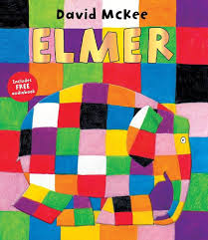  Text: Elmer by David McKee |  | No Outsiders To join in  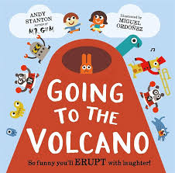  Text: Going to the Volcano by Andy Stanton | No Outsiders To find ways to play together  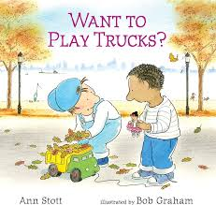  Text: Want to Play Trucks? By Ann Stott |  | No Outsiders Proud to be me  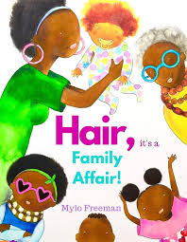  Text: Hair, It’s a Family Affair by Myla Freeman |  | No Outsiders I share the world with lots of people  Text: My World, Your World by Melanie Walsh  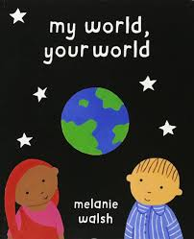 | No Outsiders To work together  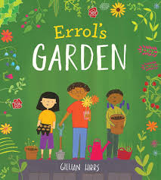  Text: Errol’s Garden by Gillian Hibbs
PSHE  Health and mental well-being | PSHE  Making friends: playing and learning together  Aspiration Week | PSHE  Celebrating me, you and our families | PSHE  Safety at home | PSHE  Random acts of kindness  Kindness day |  | PSHE  Being healthy. | PSHE  Showing kindness to others and ourselves  Resilience day | RSE  Growing and caring for ourselves
Enrichment Opportunities  Peak Wildlife Centre (Science) |  | Enrichment Opportunities  Brampton Museum (History) | Enrichment Opportunities  Zoo Lab (History) |  | Enrichment Opportunities  Local visit to the canal (Geography) |  | Enrichment Opportunities  People who help us visitors into school (PSHE) | Enrichment Opportunities -  Beach trip (geography)
Connection to modern day Britain |  | Connection to modern day Britain | Connection to modern day Britain |  | Connection to modern day Britain |  | Connection to modern day Britain | Connection to modern day Britain
Sustainability Theme  Energy and Climate Change  |  | Sustainability Theme  Cycles and Waste  | Sustainability Theme  Biodiversity  |  | Sustainability Theme  Adaptation for the Future  |  | Sustainability Theme  Health and Wellbeing  | Sustainability Theme  Food and Farming 

