Dove Bank Primary School - Curriculum Overview Year 2

Autumn 1 |  |  | Autumn 2 | Spring 1 |  | Spring 2 | Summer 1 | Summer 2
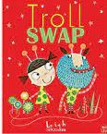  Writing - Troll Swap by Leigh Hodgkinson  Outcome: Lists and Riddles/Fiction: characters |  | 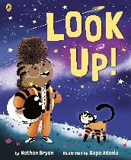  Black Lives Matter – Look Up! By Nathan Byron  Outcome: Recount: Diary | Writing - The Owl who was Afraid of the Dark by Jill Tomlinson  Outcome: Non-chronological report | Writing -The Dragon Machine by Helen Ward  Outcome: Adventure story with change of character |  | Writing - Major Glad, Major Dizzy by Jan Oke  Outcome: Diary of historical events | Writing - The Last Wolf by Mini Grey  Outcome: Letter | Writing - Grandad’s Secret Giant by David Litchfield  Outcome: Story with a moral
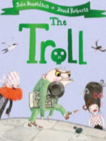  Reading – The Troll by Julia Donaldson | 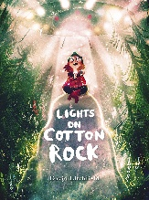  Black Lives Matter – Lights on Cotton Rock by David Litchfield |  | 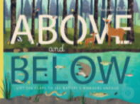  Reading – Above and Below by Patricia Hegarty | Reading - The Dragonsitter by Josh Lacey / Real Dragons! by  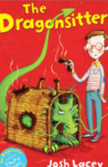  Jennifer Szymanski |  | 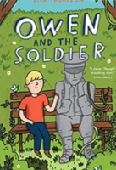  Reading- Owen and The Soldier by Lisa Thompson | 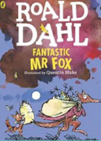  Reading – Fantastic Mr Fox by Roald Dahl | Reading – Grimm’s Fairytales (Usborne)  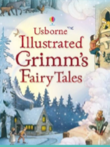
Maths - Number and Place Value / Addition and Subtraction / Money |  |  | Maths - Money /  Multiplication and Division /  Statistics | Maths - Number and Place Value / 4 operations / Properties of shape / Fractions |  | Maths - Mass, capacity and temperature/ Length and Height | Maths - Problem solving /  Fractions / Time | Maths - Statistics / Position and direction / Efficient methods / Problem solving
Science  Uses of everyday materials |  |  | Science  Uses of everyday materials | Science  Living things & their habitats |  | Science  Plants | Science  Plants | Science  Animals including humans
Design & Technology  Textiles: Puppets |  |  | Art & Design  Drawing: Tell a Story | Design & Technology  Mechanisms: Moving Monster |  | Art & Design  Sculpture and 3D: Clay Houses | Design & Technology  Cooking and Nutrition: Fruit and Vegetables Balanced Diet | Art & Design  Painting and Mixed Media: Life in Colour
History  Great Fire of London  Black History Month– Mae Jemison |  |  | Geography  What a wonderful world | History  Reginald Mitchell |  | Geography  Sensational safari | History  Victorians | Geography  Seaside
Music  Musical Me |  |  | Music  Space | Music  Myths & Legends |  | Music  Animals | Music  Musical storytelling | Music  On This Island
Physical Education  ASM - Games  Teacher led – Forest School |  |  | Physical Education  ASM - Games  Teacher led – Yoga | Physical Education  ASM – TBC  Teacher led – gymnastics |  | Physical Education  ASM - TBC  Teacher led – Dance | Physical Education  ASM – Athletics  Teacher led - Yoga | Physical Education  ASM - Games  Teacher led – Athletics
Computing  IT around us |  |  | Computing  Digital photography | Computing  Robot algorithms |  | Computing  Digital music | Computing  Programming quizzes | Computing  Pictograms
Religious Education  Caring for the natural world |  |  | Religious Education  Valuing new life | Religious Education  Worship and ceremonies |  | Religious Education  Belonging to a group | Religious Education  Story telling through sacred writings | Religious Education  Showing kindness and goodness
No Outsiders- To know I belong  Text: All Are Welcome by Alexandra Penfold  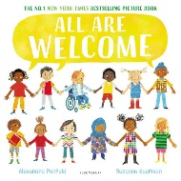 |  |  | No Outsiders- To welcome different people  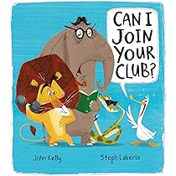  Text: Can I Join Your Club? by John Kelly | No Outsiders- To have self-confidence  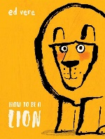  Text: How to be a Lion by Ed Vere |  | No Outsiders- To understand what diversity is  Text: The Great Big Book of Families by Mary Hoffman  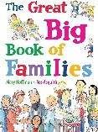 | No Outsiders- To think about what makes a good friend  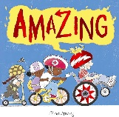  Text: Amazing by Steve Antony | No Outsiders- To communicate in different ways  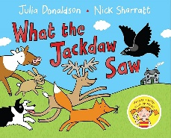  Text: What the Jackdaw Saw by Julia Donaldson
PSHE -  Mental health and well being |  | PSHE -  Money and work  Aspiration week | PSHE -  Me, my body and staying safe | PSHE -  Keeping Safe online | PSHE -  Random acts of kindness | PSHE -  Safety outside the home | PSHE -  Looking back and moving on | RSE -  Differences
Enrichment Opportunities  Ranger visit  Ford Green Hall |  |  | Enrichment Opportunities  Church visit | Enrichment Opportunities  Zoolab  Place of worship visit |  | Enrichment Opportunities  Local library visit  Eid celebration  African day | Enrichment Opportunities  Trentham Gardens | Enrichment Opportunities  Seaside visit – Llandudno
Connection to modern day Britain |  |  | Connection to modern day Britain | Connection to modern day Britain |  | Connection to modern day Britain | Connection to modern day Britain | Connection to modern day Britain
Sustainability Theme  Cycles and Waste   |  |  | Sustainability Theme  Health and Wellbeing   | Sustainability Theme  Biodiversity   |  | Sustainability Theme  Adaptation for the Future  | Sustainability Theme  Food and Farming   | Sustainability Theme  Energy and Climate Change 

