Dove Bank Primary School - Curriculum Overview Year 3

Autumn 1 |  |  | Autumn 2 | Spring 1 |  | Spring 2 |  | Summer 1 | Summer 2
Writing - Seal Surfer by Michael Foreman  Outcome: Letter | Black Lives Matter – Coming to England by Floella Banjamin  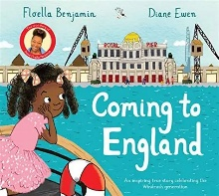  Outcome: Letter |  | Writing - Winter’s Child by Angela McAllister  Outcome: Fantasy narrative | Writing - Stone Age Boy by Satoshi Kitamura  Outcome: Historical narrative |  | Writing - Big Blue Whale by Nicola Davies  Outcome: Information article |  | Writing – Journey by Aaron Becker  Outcome: Adventure narrative | Writing - Zeraffa Giraffa by Dianne Hofmeyr & Jane Ray  Outcome: Persuasive writing
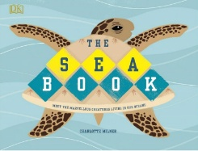  Reading - The Sea Book by Charlotte Milner | 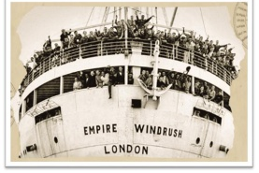  Black Lives Matter – The Windrush Story |  | Reading - Ice Palace by Robert Swindells  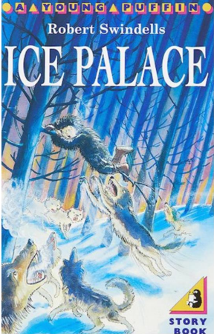 | Reading - The Iron Man by Ted Hughes  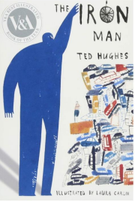 |  | Reading - The Morning I Met a Whale by Michael Morpurgo,  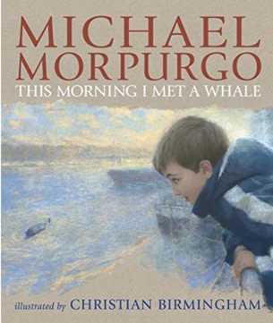 |  | Reading - Usborne Illustrated Atlas of Britain and Ireland by Struan Reid  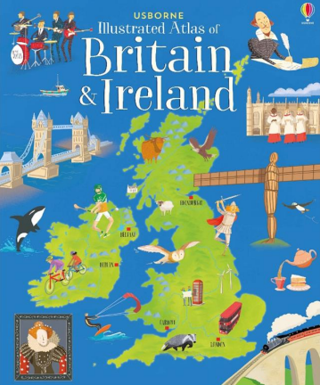 | Reading - Egyptian Cinderella by Shirley Climo  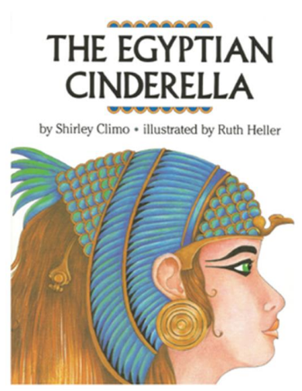
Maths - Place Value / Addition & subtraction |  |  | Maths - Addition & subtraction /Multiplication & division (A) | Maths - Multiplication & Division (B) / Length & Perimeter |  | Maths - Fractions (A) / Mass & Capacity |  | Maths - Fractions (B) / Money /  Time | Maths - Time / Shape / Statistics
Science - Forces & magnets |  |  | Science – Light | Science – Rocks |  | Science – Plants |  | Science – Plants | Science - Animals including humans
Sustainability link: Health & well being |  |  | Sustainability link: Adaptation for the future | Sustainability link: Energy and climate change |  | Sustainability link: Food and farming |  | Sustainability link: Biodiversity | Sustainability link: Cycles and waste
Art & Design - Drawing: Growing Artists |  |  | Design & Technology - Structures: Pavilions  Art & Design - Sculpture: Abstract Shape and Space | Art & Design - Mixed Media: Prehistoric Painting |  | Design & Technology - Mechanisms: Slingshot Cars |  | Design & Technology - Digital World – Wearable Technology | Art & Design - Craft & Design: Ancient Egyptian Scrolls
Geography - Volcanoes & Earthquakes  Black History Month – Floella Benjamin |  |  | Geography - Land Use | History - Stone Age to Iron Age |  | History - Stone Age to Iron Age |  | Geography - Rainforests | History - Ancient Egypt
Music – Ballads |  |  | Music – Kapow instrumental unit 1 (South Africa) | Music – Traditional instruments and improvisation (India) |  | Music – Kapow instrumental unit 2 (Caribbean) |  | Music - Jazz | Music – Kapow instrumental unit 3 (South America)
Physical Education  ASM - Invasion  Teacher led – Yoga & Forest School |  |  | Physical Education  ASM – Invasion  Teacher led -Forest School & Yoga | Physical Education  ASM –  Teacher led - Dance |  | Physical Education  ASM - Net and Wall  Teacher led - Gymnastics |  | Physical Education  ASM – Athletics  Teacher led - Gymnastics | Physical Education  ASM - Striking and Fielding  Teacher led - Athletics
Computing – Connecting Computers |  |  | Computing – Stop Frame Animation (linked to Writing) | Computing – Sequencing Sounds (linked to History & Music) |  | Computing – Desktop Publishing (linked to Writing) |  | Computing – Events & actions in programs (linked to rainforests in Geography) | Computing – Branching Databases (linked to Science)
Religious Education - Exploring living by rules |  |  | Religious Education - Religion in the home | Religious Education - Symbols of worship |  | Religious Education - Sharing special food |  | Religious Education - The beginning of the World | Religious Education - Religious Leaders
No Outsiders – To understand what discrimination means  Text: This Is Our House by Michael Rosen  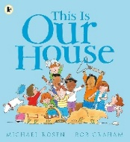 |  |  | No Outsiders – To understand what a bystander is  Text: We’re All Wonders by R. J. Palacio  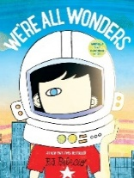 | No Outsiders – To be welcoming  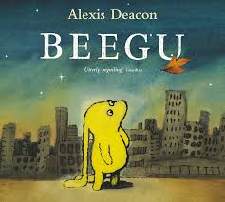  Text: Beegu by Alexis Deacon |  | No Outsiders – To recognise a stereotype  Text: The Truth About Old People by Elina Ellis  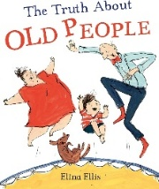 |  | No Outsiders – To recognise and help an outsider  Text: The Hueys in the New Jumper by Oliver Jeffers  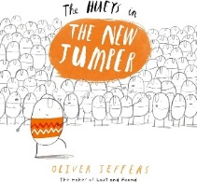 | No Outsiders – To welcome different people  Text: Keith Among the Pigeons by Katie Brosnan  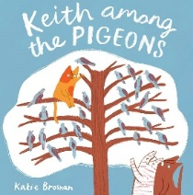
PHSE – Health and mental well being |  | PHSE – Me, my friends and belonging  Aspiration week | PHSE – Building healthy habits | PHSE – Making choices online | PHSE – Random acts of kindness, kindness day |  | PHSE – Keeping safe out and about | PHSE – Looking out for each other  Resilience day | RSE – Valuing difference and keeping safe
Spanish – A new start. |  |  | Spanish – The calendar and celebrations | Spanish - Animals |  | Spanish - Carnival and numbers |  | Spanish – The Hungry Giant | Spanish - Going on a picnic and where I live
Enrichment Opportunities  Think Tank (Science – Y3/4) |  |  | Enrichment Opportunities  Spanish Day (High School bistro visit, followed by hosting a bistro at Dove Bank) | Enrichment Opportunities  Stone Age Experience Day (History) |  | Enrichment Opportunities The Potteries Museum (History) or National Stone Centre (Science – Rocks) |  | Enrichment Opportunities  Hare Krishna Centre, Stoke (RE) | Enrichment Opportunities  Egyptians Workshop Day (History)  Local Library Visit
Connection to modern day Britain  Aspiration Week 19 October |  |  | Connection to modern day Britain  Careers link – Languages (Spanish) | Connection to modern day Britain  Kindness Day |  | Connection to modern day Britain  Careers link – Computing |  | Connection to modern day Britain  Resilience Day | Connection to modern day Britain  Careers link - Sport
Sustainability Theme  Health and Wellbeing   |  |  | Sustainability Theme  Adaptation for the Future   | Sustainability Theme    Energy and Climate Change |  | Sustainability Theme  Food and Farming   |  | Sustainability Theme  Biodiversity   | Sustainability Theme  Cycles and Waste  

