Dove Bank Primary School - Curriculum Overview Year 4
Autumn 1 |  |  | Autumn 2 | Spring 1 | Spring 2 | Summer 1 | Summer 2
Writing – Gorilla by Anthony Browne  Outcome: Fantasy narrative |  | Black Lives Matter -  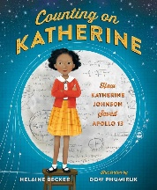  Counting on Katherine by Helaine Becker  Outcome: Non-chronological report | Writing – Leon and the Place Between by Angela McAllister  Outcome: Diary | Writing – Escape from Pompeii by Christina Ballit  Outcome: Historical narrative | Writing – Koji’s Island by The Literacy Company  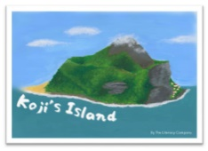  Outcome: Adventure narrative | Writing – Where the Forest Meets the Sea by Jeannie Baker  Outcome: Non-chronological report | Writing - Blue John by Berlie Doherty  Outcome: Explanation - letter
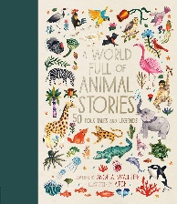  Reading - A World Full of Animal Stories 50 Folktales and Legends by Angela McAllister |  | 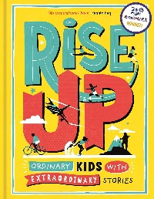  Black Lives Matter – Rise Up by Amanda Li | Reading - The Train to  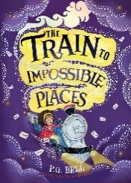  Impossible Places by P G. Bell | 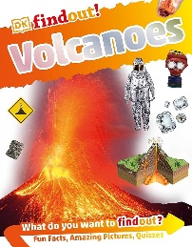  Reading – Volcanoes by Maria Gill | 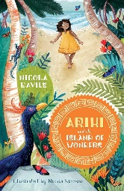  Reading - Ariki and the Island of Wonders by Nicola Davies | Reading - Fantastically Great Women Who Saved the Planet  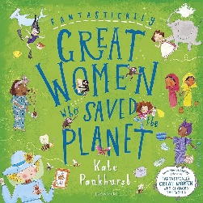  by Kate Pankhurst | 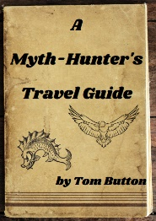  Reading - A Myth-hunter’s Travel Guide by The Literacy Company
Maths - Place value / Addition & Subtraction |  |  | Maths - Multiplication & Division / Measurement | Maths - Multiplication & Division / Measurement | Maths – Fractions and Decimals | Maths – Decimals / Money / Time | Maths – Shape / Statistics / Position & Direction
Science – Teeth and Digestion |  |  | Science – All living things (animals and plants) | Science – Electricity | Science – States of matter | Science – States of Matter continued and the Water Cycle | Science – sound
Design & Technology – Cooking and nutrition; adapting a recipe |  |  | Art & Design - Painting and Mixed Media-Light and Dark | Design & Technology - Torches | Design & Technology - Pneumatic Toys | Art & Design - Fabric of nature | Art & Design - Sculpture-Mega Materials
Geography – London (UK city study)  Black History Month – Katherine Johnson |  |  | History – Local history study of Pottery | History – Romans | History – Romans | Geography - Rivers (link to science) | Geography - Paris (European Study)
Music – Samba and carnival sounds and instruments (South America) |  |  | Music – Rock and roll | Music – Adapting and transposing motifs (Romans) | Music – Haiku music and performance (Hanami) | Music – Body and tuned percussion (Rainforests) | Music – Changes in pitch, tempo and dynamics (Rivers)
Physical Education – Invasion games and dance |  |  | Physical Education – Invasion games and forest school | Physical Education - Gymnastics | Physical Education – Outdoor and Adventurous Activities | Physical Education – Striking and Fielding and gymnastics | Physical Education - Athletics
Computing – The Internet (linked to Geography) |  |  | Computing – Datalogging (linked to Science) | Computing – Repetition in Shapes (linked to Romans) | Computing – Audio Production (Podcast linked to Romans) | Computing – Repetition in Games (linked to English) | Computing – Photo editing (linked to English trip)
Religious Education – Environment (Harvest) |  |  | Religious Education – Landmarks in life | Religious Education – Commitment: Lent | Religious Education – Study a chosen religion – Sikhism | Religious Education – Thinking about God | Religious Education – Features & patterns of worship
No Outsiders - To help someone accept difference  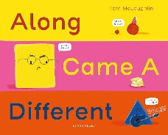  Text: Along Came a Different by Tom McLaughlin |  |  | No Outsiders - To choose when to be assertive  Text: Dogs Don’t Do Ballet by Anna Kemp  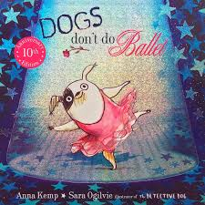 | No Outsiders - To be proud of who I am  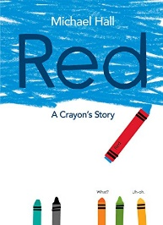  Text: Red: A Crayon’s Story by Michael Hall | No Outsiders - To find common ground  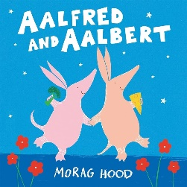  Text: Aalfred and Aalbert by Morag Hood | No Outsiders - To look after my mental health  Text: When Sadness Comes to Call by Eva Eland  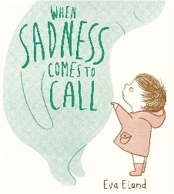 | No Outsiders - To show acceptance  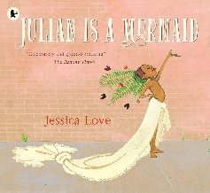  Text: Julian is a Mermaid by Jessica Love
PSHE – Mental Health and Wellbeing | PSHE – Money matters and news literacy  Aspiration Week  Nationwide Money Module 3 & 4 |  | PSHE – Forming respectful relationships | PSHE – Exploring ways to manage risk  Random acts of kindness day | PSHE – Families and growing together | PSHE – Me, my body and growing up  Resilience Day | RSE – Growing Up
Spanish – A New Start |  |  | Spanish – Calendar & Celebrations | Spanish - Animals | Spanish – Carnival & numbers | Spanish – The hungry giant | Spanish – Going on a picnic / Where I live
Enrichment Opportunities - Think Tank Birmingham- Digestion workshop (Science) |  |  | Enrichment Opportunities - Gladstone Pottery Museum (History)  Emma Bridgewater | Enrichment Opportunities -  Standon Bower- (PSHRE focus) | Enrichment Opportunities -  Trip to Chester or Roman Soldier visit to the school (History focus) | Enrichment Opportunities -  French visit- Local High School  (MFL and Geography)  Local Kidsgrove Canal- Walking visit (Geography-Science). | Enrichment Opportunities -  Treak Cliff Cavern -Derbyshire
Connection to modern day Britain |  |  | Connection to modern day Britain | Connection to modern day Britain | Connection to modern day Britain | Connection to modern day Britain | Connection to modern day Britain
Sustainability Theme  Health and Wellbeing   |  |  | Sustainability Theme  Food and Farming   | Sustainability Theme  Energy and Climate Change   | Sustainability Theme  Adaptation for the Future   | Sustainability Theme  Biodiversity   | Sustainability Theme  Cycles and Waste  

