Dove Bank Primary School - Curriculum Overview Year 5 2026-2027
Autumn 1 |  |  |  | Autumn 2 | Spring 1 | Spring 2 | Summer 1 | Summer 2
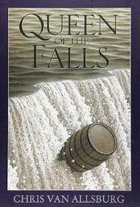  Writing – Queen of the Falls by Chris Van Allsburg  Outcome: Diary |  | Black Lives Matter – Young, Gifted and Black by Jamia Wilson  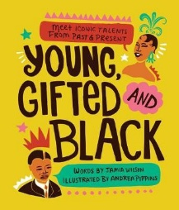  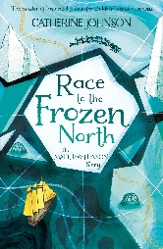  Outcome: Diary |  | Writing – The Lost Happy Endings by Carol Ann Duffy and Jane Ray  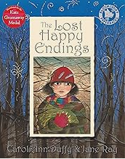  Outcome: Traditional Stories | Writing – Arthur and the Golden Rope by Joe Todd-Stanton  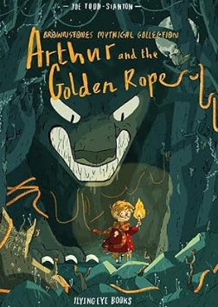  Outcome: Viking myth | Writing – The Darkest Dark by Chris Hadfield  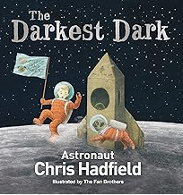  Outcome: Biography | Writing – The Paperbag Prince by Colin Thompson  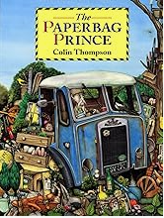  Outcome: Persuasive/ explanation text | Writing – Radiant Child by Javaka Steptoe  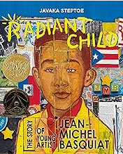  Outcome: Writing a review
Reading – Little People Big Dreams Treasury  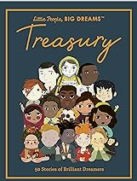 | Black Lives Matter - Young, Gifted and Black by Jamia Wilson |  |  | Reading – Hansel and Gretel by Neil Gaiman and Lorenzo Mattetti  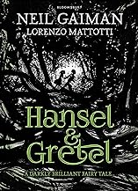 | Reading – Odd and the Frost Giants by Neil Gaiman  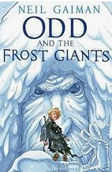 | 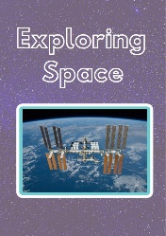  Reading – Exploring Space by The Literacy Company | Reading – Pollution – A Look Behind the Scenes by The Literacy Company  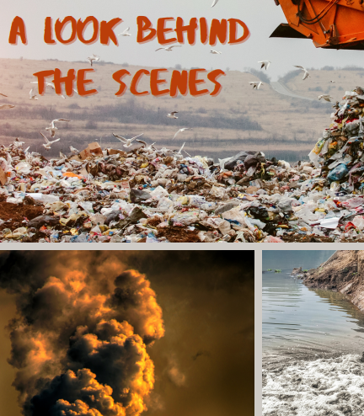 | Reading – African Tales by Gcina Mhlophe and Rachel Griffin  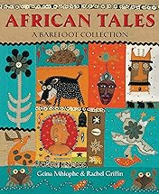
Maths - Place value, addition & subtraction, statistics |  |  |  | Maths - Multiplication & division, perimeter and area | Maths - Multiplication & division, fractions | Maths – Fractions, decimals and percentages | Maths – Decimals, properties of shape, angles, position and direction | Maths – Shape, statistics, volume
Science – Materials – sorting and classifying |  |  |  | Science – Materials – changes | Science – Forces | Science – Earth and Space | Science – Life cycles and reproduction | Science –Puberty
Art & Design –  Drawing: Depth, emotion and movement |  |  |  | Art & Design  Craft & design - Architecture | Design & Technology –  Mechanical systems: Gears and pulleys | Design & Technology  Cooking and nutrition – developing a recipe | Design & Technology –  Textiles: stuffed toys | Art & Design –  Painting and mixed media -portraits
History –  Anglo-Saxons and Scots  Black History Month – Mary Prince |  |  |  | Geography –  Eastern Europe | History –  Vikings | Geography –  Marvellous Maps | Geography –  Enough for Everyone – resources and recycling | History –  Crime and Punishment
Music – Mr Foxall specialist teacher – steel pans |  |  |  | Music – Mr Foxall specialist teacher – steel pans | Music – Mr Foxall specialist teacher – steel pans | Music – Mr Foxall specialist teacher – steel pans | Music – Mr Foxall specialist teacher – steel pans | Music – Mr Foxall specialist teacher – steel pans
Physical Education –  ASM - Invasion games  Class PE - Gymnastics |  |  |  | Physical Education –  ASM – Invasion games  Class PE - Gymnastics | Physical Education –  ASM - Net and wall  Class PE - Dance | Physical Education –  ASM - Net and wall  Forest school | Physical Education –  ASM - Athletics  Swimming | Physical Education –  ASM - Striking and fielding  Swimming
Computing – Systems and searching the Internet |  |  |  | Computing –  Video production (iPad camera iMovie) | Computing – Flat file databases | Computing –  Introduction to Vector Drawings | Computing –  Selection in physical computing | Computing –  Selection in quizzes
Religious Education – Sacred Writings - Hinduism |  |  |  | Religious Education –  Peace | Religious Education –  Religious diversity – happiness - Buddhism | Religious Education –  Suffering and hardship at Easter | Religious Education –  Wise words – Bible and  Qu-ran | Religious Education –  Inspirational leaders
No Outsiders -  Text: Kenny Lives with Erica and Martina by Olly Pike  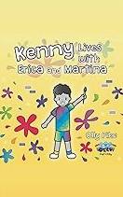 |  |  |  | No Outsiders -  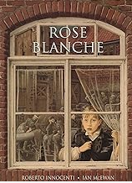  Text: Rose Blanche by Ian McEwan and Roberto Innocenti | No Outsiders -  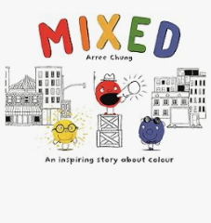  Text: Mixed by Arree Chung | No Outsiders -  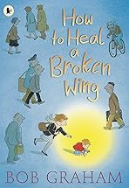  Text: How to Heal a Broken Wing | No Outsiders -  Text: The Girls by Lauren Lee and Jenny Lovie  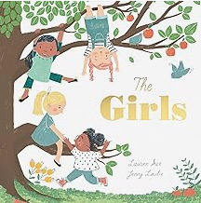 | No Outsiders -  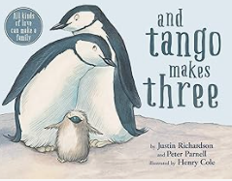  Text: And Tango Makes Three
PSHE  Mental Health and Wellbeing |  |  | PSHE  Friendships, stereotypes and bullying Aspiration Week  Nationwide Money Module 1&2 | PSHE  Positively engaging with our world | PSHE  Safe connections online Random acts of kindness day | PSHE  Respecting boundaries | PSHE  Embedding healthy habits and learning first aid  Resilience day | Week 2-6 RSE:  Puberty  Additional Unit Respect and Equality
Spanish  Stage 3 – Me and my friends |  |  |  | Spanish  Stage 3 – Time in the city | Spanish  Stage 3 – At the market | Spanish  Stage 3- Clothes | Spanish  Stage 3 – Out of this world | Spanish  Stage 3 – Going to the seaside
Enrichment Opportunities  Anglo Saxon day |  |  |  | Enrichment Opportunities  Eastern Europe visitor (Mrs Hybner)  Library visit | Enrichment Opportunities  Young Voices tbc | Enrichment Opportunities  Trip to Jodrell Bank linked to Science | Enrichment Opportunities  PSHE – safe and sound visit | Enrichment Opportunities  Visits to the local high school
Sustainability Theme  Adaptation for the Future   |  |  |  | Sustainability Theme  Food and Farming   | Sustainability Theme  Biodiversity   | Sustainability Theme  Climate Change   | Sustainability Theme  Cycles and Waste   | Sustainability Theme  Health and Wellbeing

