Dove Bank Primary School - Curriculum Overview Year 6
Autumn 1 |  | Autumn 2 | Spring 1 | Spring 2 | Summer 1 | Summer 2
Writing - King Kong by Anthony Brown  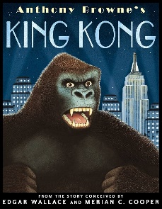  Outcome: Story ending | Black Lives Matter – The Place for Me by K. N. Chimbiri  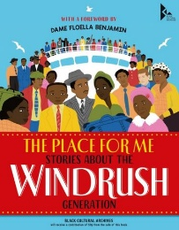  Outcome: Hybrid | 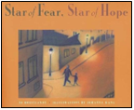  Writing - Star of Fear, Star of Hope by Jo Hoestland  Outcome: Flashback | Writing - Can We Save The Tiger? by Martin Jenkins  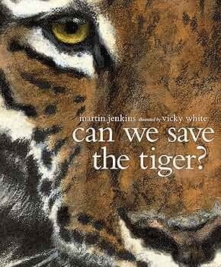  Outcome: Hybrid | Writing - The Selfish Giant by Oscar Wilde  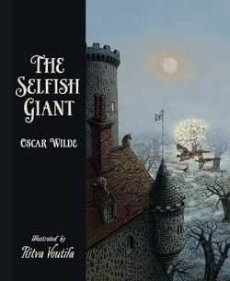  Outcome: Classic | Writing – Manfish by Jennifer Berne  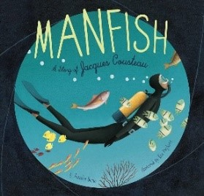  Outcome: Biography | Writing - The Island by Jason Chin  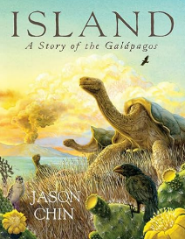  Outcome: Journalistic
Reading -The Explorer by Katherine Rundell  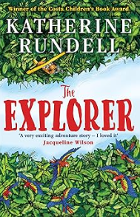 | Black Lives Matter - The Place for Me by K. N. Chimbiri  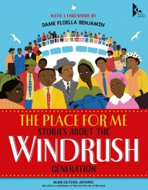 | Reading - When We Were Warriors by Emma Carroll  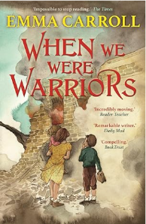 | Reading – Into the Jungle by Katherine Rundell  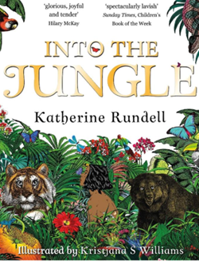 | Reading - The Happy Prince and Other Stories by Oscar Wilde  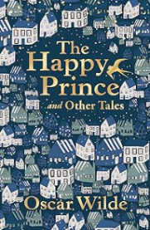 | Reading -Great Adventurers by Alastair Humphreys  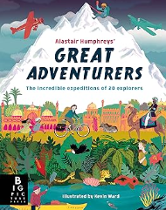 | Reading - Sky Chasers by Emma Carroll  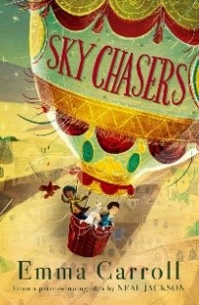
Maths - Place value, addition/ subtraction/ multiplication/ division |  | Maths – Fractions, converting units | Maths – Ratio, algebra, decimals, fractions/ decimals/ percentages | Maths – Area/ perimeter/ volume, statistics | Maths – Shape, position/ direction | Maths – Themed projects/ consolidation/ problem solving
Science - Electricity |  | Science - Light | Science - Adaptation | Science - Heart/Exercise/Health | Science - Classification | Science - Evolution
Design & Technology – Digital World: Navigating the World |  | Design & Technology – Structures: playgrounds | Art & Design – Mixed media: artist study | Design & Technology – Textiles: waistcoats | Art & Design – Drawing: making my voice heard (Mayan art) | Art & Design – Sculpture and 3D: Making Memories
Geography - The Americas  Black History Month – Malcolm X |  | History - WW2 | History – Ancient Greece | Geography - Trade and Economics | History - The Maya | Geography - Coastal Erosion
Music – Film Music |  | Music – Songs of WWII | Music - Baroque | Music – Dynamics, Pitch and Texture | Music – Themes and Variations | Music - Composing and Performing a Leavers’ Song
Physical Education –  ASM - Invasion  Swimming/Outdoor activities |  | Physical Education –  ASM – Invasion  Swimming | Physical Education –  ASM – Gymnastics  Dance | Physical Education –  ASM - Net and Wall  Athletics | Physical Education –  ASM – Athletics  Yoga | Physical Education –  ASM - Striking and fielding  Forest school/Rounders
Computing – Webpage creation |  | Computing – 3D modelling | Computing - Introduction to spreadsheets | Computing – Sensing movement | Computing – Variables in games | Computing – Communication and collaboration
Religious Education – Commitment |  | Religious Education – Words of wisdom | Religious Education – Taking Part | Religious Education – Belief in action | Religious Education – The importance of hope | Religious Education – Justice: rich or poor
No Outsiders- To consider responses to immigration  Text: King of the Sky by Nicola Davies  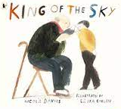 |  | No Outsiders- To consider language and freedom of speech  Text: The Only Way Is Badger by Stella J. Jones  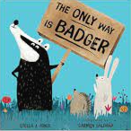 | No Outsiders- To overcome fears about difference  Text: Leaf by Sandra Dieckmann  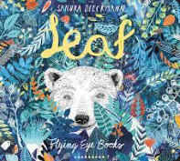 | No Outsiders- To consider causes of racism  Text: The Island by Armin Greder  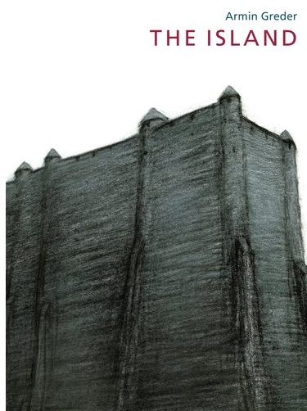 | No Outsiders- To show acceptance  Text: Introducing Teddy by Jessica Walton  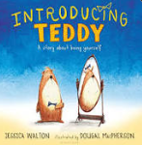 | No Outsiders- To consider democracy  Text: A Day In the Life of Marlon Bundo by Jill Twiss  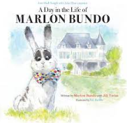
PSHE  Mental Health and well being  Aspiration Week |  | PSHE  Managing money and online spending – Nationwide units 3 & 4 | PSHE  Drug education – assessing risks and managing influences | PSHE  Looking to the future | PSHE  Changes in puberty  Kindness day | PSHE  Puberty – relationships and reproduction
Spanish – This is me |  | Spanish – Homes and Houses | Spanish – Playing Sport | Spanish – My Best Day Ever | Spanish – Tapas Culture | Spanish – Let’s Celebrate
Enrichment opportunities  York  Electrician Visitor |  | Enrichment opportunities  WW2 Memorabilia Visitor  Brampton Museum | Enrichment opportunities  Chester Zoo  Greyhound Visit | Enrichment opportunities  Haematologist Lab Video (heart dissection) | Enrichment opportunities Specialist visitor (Maya)  Hanley Museum | Enrichment opportunities  Llandudno
Connection to modern day Britain |  | Connection to modern day Britain | Connection to modern day Britain | Connection to modern day Britain | Connection to modern day Britain | Connection to modern day Britain
Sustainability Theme  Biodiversity   |  | Sustainability Theme  Energy and Climate Change   | Sustainability Theme  Food and Farming   | Sustainability Theme  Health and Wellbeing   | Sustainability Theme  Cycles and Waste   | Sustainability Theme  Adaptation for the Future  

