School Newsletter Article
Information to be placed in the school newsletter

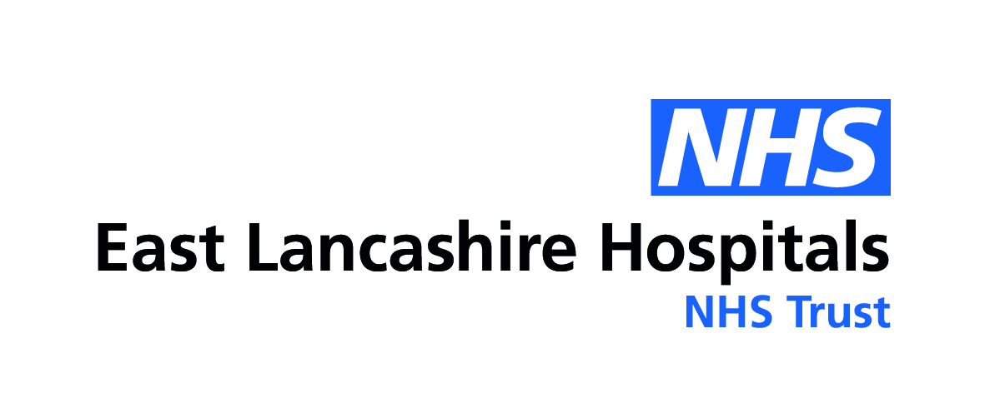
Vision Screening in Lancashire
Vision screening is an integral part of the universal delivery of the national Healthy Child Programme.
Every child in the Reception class will receive an invitation to have their vision tested in school.
A detailed letter will be sent home with your child closer to the screening date.


Vision Screening in Lancashire
Vision screening will be taking place for the reception class children on
_________________________________________
An Opt-out consent form will be sent home with your child closer to the screening date. If you do not receive one and wish to Opt-out, please contact the school.

