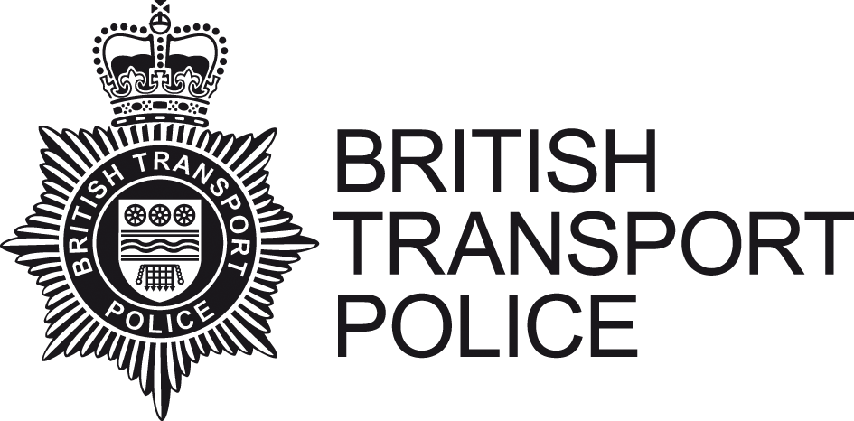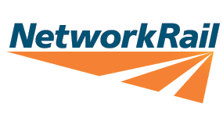
Dear Parent / Guardian

Trespassing on the railway network is extremely dangerous and endangers not only the lives of those on the track, but also passengers, railway staff and the general public.
Many people - especially young people - fail to understand the danger they put themselves and others in, when they make the choice to stray onto the rail network.
As summertime approaches, we are already seeing an increase in the number of incidents being reported.
Incidents we’re seeing involve children and young people:
- Hanging around on station platforms and crossing the tracks.
- Walking along the railway lines.
- Throwing stones at trains.
- Placing objects on the railway lines.
- Using the railway as a playground.
I am sure you agree that all the above activities are extremely dangerous.
The British Transport Police and Network Rail are seeking the support of parents and guardians to highlight the danger and implications of these activities to help us reduce the number of young people putting themselves and others at significant risk.
To assist with the conversation there are several online videos available and range depending on the age group of your child.
Links to Videos
https://youtu.be/pWVvjFqH0UE
Home - Switched On! (switchedonrailsafety.co.uk)
Educational resources for children - Network Rail
Home - You vs. Train (youvstrain.co.uk)
Stay Safe with Thomas - Network Rail

Key Messages
Trains are always running on the railway and can differ in times meaning that you can never predict when a train will pass. The Electricity is ALWAYS switched on around the railway.
Always Stop, Look and Listen before using a Level Crossing.
DO YOU KNOW WHERE YOUR CHILDREN ARE?
Trespassing on the railway is also a criminal offence which can involve your child obtaining a criminal record and a fine of £1000.
If you wish to report any information to us, please call us on Freephone 0800 40 50 40 or text the information to 61016.

