**Sunday 8th December 4pm**

St Thomas’ Light in the darkness a reflective carol service

**Sunday 15th December 4pm**

St Cuthbert’s Carols and Mulled Wine

with the Marshside Brass band

**Sunday 22nd December 7pm**

St Thomas’ Nine lessons and Carols

**Tuesday 24th December 4pm**

**Christingle Services at both St Cuthbert’s and St Thomas’**

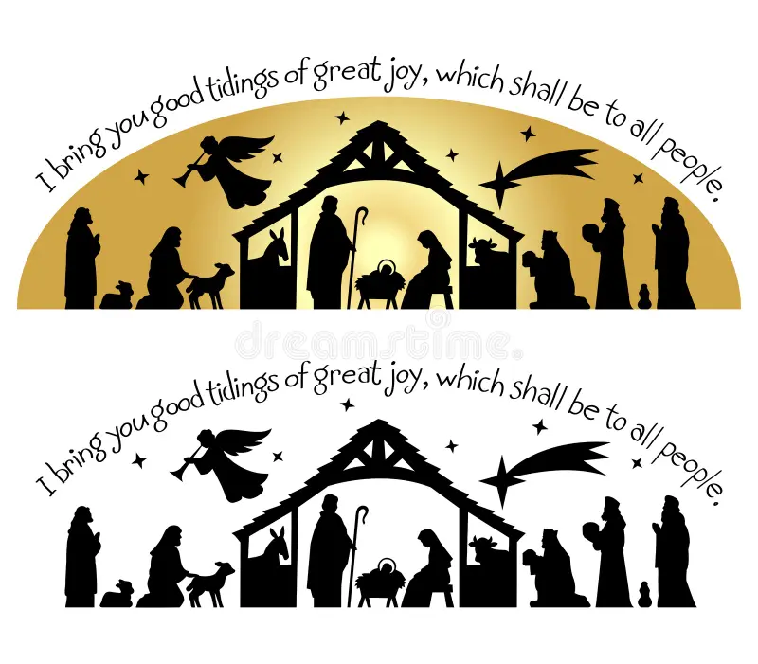

**Tuesday 24th December 11pm**

St Thomas’ Midnight Communion

**Tuesday 24th December 11.30pm**

St Cuthbert’s Midnight Communion

**Wednesday 25th December 9.00am**

St Cuthbert’s Communion

**Wednesday 25th December 10.30am**

St Thomas’ All age Communion

**Saturday 28th December 7pm**

Holy Innocents said Holy Communion