Fleming |  |  | Date: |  |  | Spring 1 week 6
 |  |  | Class: |  |  | Oak
Day | Activity
Monday | Green workbook  Spring Week 3 - Number: Multiplication & Division | White Rose Maths  Orange workbook  Spring Week 4 - Measurement: Money | White Rose Maths |  |  | To engage with the text (thenational.academy) | ‘Crafty Creator’ mini project.  Choose your activities from the link below but make sure one of them is our ‘Positive Messages Mission!’  CBBC recommendation of the day  Art Ninja – 11:05am
Tuesday | Green workbook  Spring Week 3 - Number: Multiplication & Division | White Rose Maths  Orange workbook  Spring Week 4 - Measurement: Money | White Rose Maths |  |  | To answer questions on the text (Part 1) (thenational.academy) | ‘Crafty Creator’ mini project.  Choose your activities from the link below but make sure one of them is our ‘Positive Messages Mission!’  CBBC recommendation of the day  CBBC Live Lesson-Safer Internet Day – 11:00am
Wednesday | Green workbook  Spring Week 3 - Number: Multiplication & Division | White Rose Maths  Orange workbook  Spring Week 4 - Measurement: Money | White Rose Maths |  |  | To analyse characters (thenational.academy) | ‘Crafty Creator’ mini project.  Choose your activities from the link below but make sure one of them is our ‘Positive Messages Mission!’  CBBC recommendation of the day  Operation Ouch! 11:35am
Thursday | Green workbook  Spring Week 3 - Number: Multiplication & Division | White Rose Maths  Orange workbook  Spring Week 4 - Measurement: Money | White Rose Maths |  |  | To answer questions on the text (Part 2) (thenational.academy) | ‘Crafty Creator’ mini project.  Choose your activities from the link below but make sure one of them is our ‘Positive Messages Mission!’  CBBC recommendation of the day  Operation Ouch! 11:35am
Friday | Green workbook  Spring Week 3 - Number: Multiplication & Division | White Rose Maths  Orange workbook  Spring Week 4 - Measurement: Money | White Rose Maths |  |  | To analyse the author's use of language (thenational.academy) | ‘Crafty Creator’ mini project.  Choose your activities from the link below but make sure one of them is our ‘Positive Messages Mission!’  CBBC recommendation of the day  Wild and Weird – 11:35am

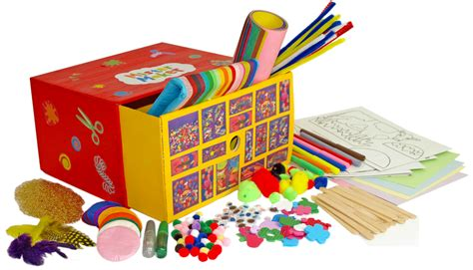
Crafty Creators!
For the last week of this half term in the afternoon lessons we would like you to really enjoy getting very creative. The link below has a range of art projects you may like to try yourself. If you have an idea of your own, feel free to create something which reflects your own interest.
https://static1.squarespace.com/static/5ea810465f8e353c3163604e/t/5ed914d3a2751d4f03619d42/1591284996917/ArtJumpStart+Full+Collection.pdf
Remember to send us photographs of anything you make so that you have your ‘time to shine’.
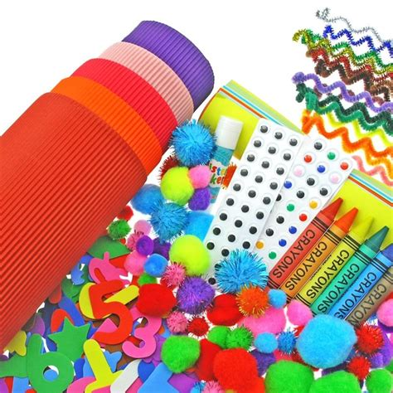

Hello everyone,
We hope you are all doing okay. We miss you at school and can’t wait to welcome you back, hopefully very soon. We know you are all missing your friends and so we would like you to create a message in the most creative way possible for all your friends at school and home to see. For example, draw it, write it, paint it, go outside and write your message in rocks, stones or even some twigs or leaves. Your message could be something personal to your friends or a simple positive quote or word that will make someone smile.
Once you have created your message ask a grown up to take a picture of you, with your message and email it to your class teacher. We will use all your pictures of positive messages and words to create a video that we will put on the website.
We can’t wait to see your messages and pictures. We may even make a surprise appearance on the video ourselves- keep an eye out!!
Best wishes,
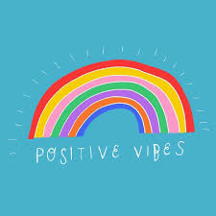
Mrs Hains, Mrs Gibson and Miss Grant.

Here is a link for Born 2 move which has been provided by our PE teachers. It is an excellent way to keep children active and having fun!! Choose the age range that is appropriate for you and then choose the activity you wish to complete.
https://borntomove.lesmills.com/channels
The login details are:
head@haskayne.lancs.sch.uk
haskayne12
This week’s ‘Family pack’ includes challenges which the children can attempt with their families during the week or weekend. This weeks pack includes;
- OAA challenge - Wild Art card.
- Forest School Challenge – Pine Cone Fire Starters card.
- Forest School – Fire Safety card.

https://drive.google.com/drive/folders/12wmGK9cA4iMCK4nMTM0zCKokTkt6DwUg

