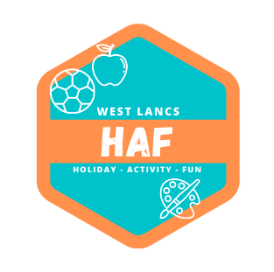
17th March 2024

Dear Parents and Carers,

We are writing to let you know of a fantastic opportunity for your child to access FREE activities and holiday camps over the Easter holiday period.

Due to government funding, we can offer eligible children free places at our holiday activities and camps delivered by a variety of providers across West Lancashire. We are pleased to let you know that as someone in receipt of benefits related Free School Meals your child is eligible for a free place. Places will be allocated on a first come first served basis, so we would encourage you to sign up for these places as soon as possible. All activities will include a free lunch as part of the offer.

Camps and activities are running at various locations across West Lancashire, in order to ensure that as many children as possible can access these opportunities. Eligible children can access any site or activity. The main week of activities is taking place between Monday 8th – Thursday 11th April 2024, but we have also organised a reduced programme to take place between Tuesday 2nd – Friday 5th April 2024.

Bookings will open at 9am on the 19th March 2024 and will close at 5pm on Wednesday 27th March 2024. Please complete the booking form fully to reserve your child’s place. To see what is on offer and to book, please visit the West Lancs HAF website at: https://westlancashirehaf.com

Please only book your child onto one activity on each of the days. We have previously seen families book several activities taking place on the same day, and if this occurs in the future, we reserve the right to cancel bookings. If you make a booking and can no longer attend, please email us at westlancs.haf@gmail.com to cancel, so that we can reallocate the place.

We are also providing free access to a whole range of activity videos and downloadable activity sheets from our Lancashire HAF Online website, which is available at: https://lancashirehafonline.com

We look forward to seeing your child attending these exciting activities and enjoying a fun packed Easter.

Yours sincerely

The West Lancashire HAF Team

