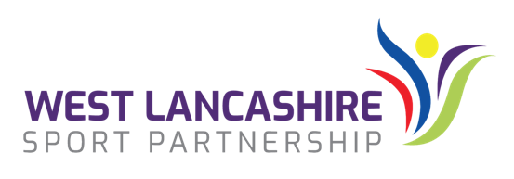
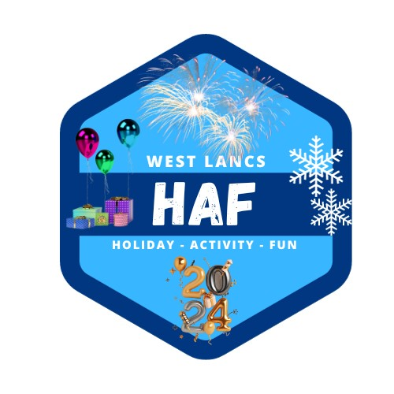
28th November 2023
Dear Parents and Carers,

We are writing to let you know of a fantastic opportunity for your child to access FREE activities and holiday camps over the Christmas period between Tuesday 2nd and Friday 5th January 2024.

Due to government funding, we can offer eligible children free places at our holiday activities and camps delivered by a variety of providers across West Lancashire. Places will be allocated on a first come first served basis, so we would encourage you to sign up for these places as soon as possible. All activities will include a free lunch as part of the offer. To be eligible to access the West Lancs Winter HAF Programme, you must be eligible for benefits related Free School Meals.

Camps and activities are running out of various locations across West Lancashire and eligible children can access any site or activity, but please only book one activity per child for each day. We have previously seen parents/carers booking more than one activity for the same time and therefore to ensure that as many families as possible benefit from this programme any duplicate bookings will be cancelled. Closing date for Activities will be 9am on Monday 18th December 2023

We are also providing free access to a whole range of activity videos and downloadable activity sheets from our Lancashire HAF Online website, which is available at: https://lancashirehafonline.com

The West Lancashire HAF Team are pleased to announce that we are once again offering a limited number (which can be booked on a first come first served basis) of food boxes as part of our Winter HAF Programme. Food Boxes which can be booked one per eligible family (Families in receipt of benefits related Free School Meals) will contain:
4kg Potatoes, 4 jacket potatoes, 900g-1kg carrots, 1 medium/large swede, 1 medium/large white cabbage, 2 medium sized leeks, 500g sprouts, 3 medium sized parsnips, 750g onions, 1 net of clems/satsumas, 1 bag apples, 1 bunch bananas, 1 box of vegetable stock cubes, 500g pearl barley, 500g broth mix, 500g white rice, 500g pasta, 500g porridge oats, 1 tin beans (400g), 1 tin chopped tomatoes (400g) and 1L long-life milk.
Closing date for Food Boxes will be 9am on Wednesday 13th December 2023 and food boxes will be delivered to your child's school on Wednesday 20th or Thursday 21st December 2023 for you to collect.
The West Lancs HAF website will go live at 5pm on Wednesday 29th November 2023. To see what is on offer and to book activities and/or a Food Box, please visit the West Lancs HAF website at:
https://westlancashirehaf.com

Yours sincerely

The West Lancashire HAF Team

