



Heads up from Health Protection - July 2025

This months edition includes:-

* Changes to the Routine Childhood Immunisation Programme.
* Changes to the Cervical Screening Programme.
* Hydration.
* Water Safety.

# Childhood Vaccines – What Parents Need to Know

From 1st July this year there are changes to the routine vaccine schedule given to your little ones after recommendations from the Joint Committee on Vaccination and Immunisation (JCVI) which will optimise the Childhood Immunisation programme and increase overall protection of children in the UK.

Here's what you need to know:

The timings of the MenB and PCV13 vaccines are set to change:

* The first dose of the of the Pneumococcal Conjugate Vaccine (PCV13) will be moved to 16 weeks of age instead of 12 weeks.

And

* the second dose of the Meningitis B (MenB) vaccine will be given at 12 weeks of age instead of 16 weeks. This is to offer better protection against Men B to younger babies who are most vulnerable.

The Haemophilus influenzae type b (Hib) and Meningitis C (Hib/MenC) vaccine:

* will no longer be offered to children born on or after 1st July 2024. Though the second PCV13 and third doses will remain at this age.

Changes coming into force from January 2026:

The biggest change parents need to know about if your child turns one after 1st July 2025, is the new 18-month vaccine appointment where they will be given two vaccines on the same day:

* A 4th dose of the Hexavalent vaccine also known as a 6-in-1 vaccine.
* Your toddler's second MMR dose (the first will be given as usual at 12 months).

for more information, please go to:

[Changes to the childhood vaccination programme: why they are happening - GOV.UK](https://www.gov.uk/government/publications/changes-to-the-childhood-vaccination-programme-why-are-they-happening/changes-to-the-childhood-vaccination-programme-why-they-are-happening)

Please click on the image below to view the tables, summarising the changes from 2025 and 2026:

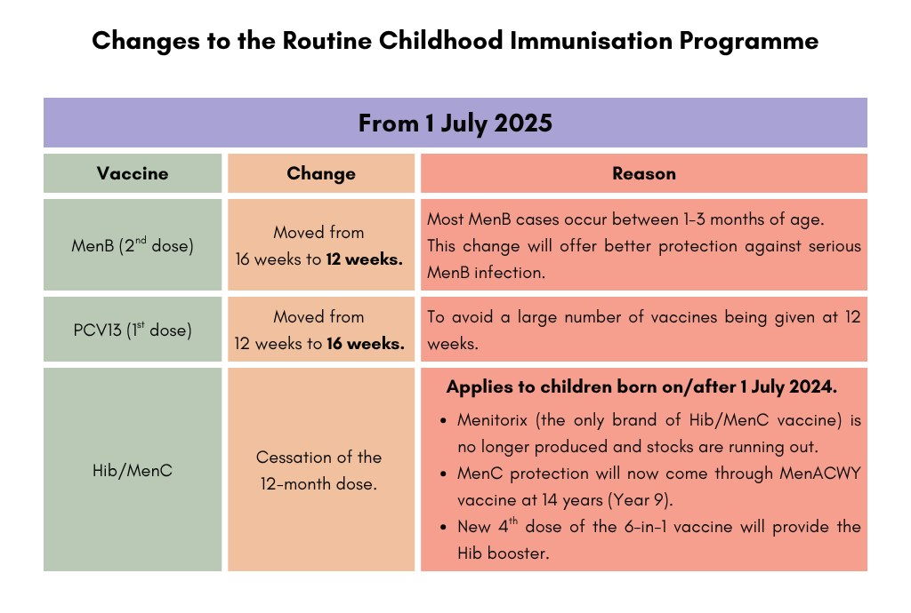

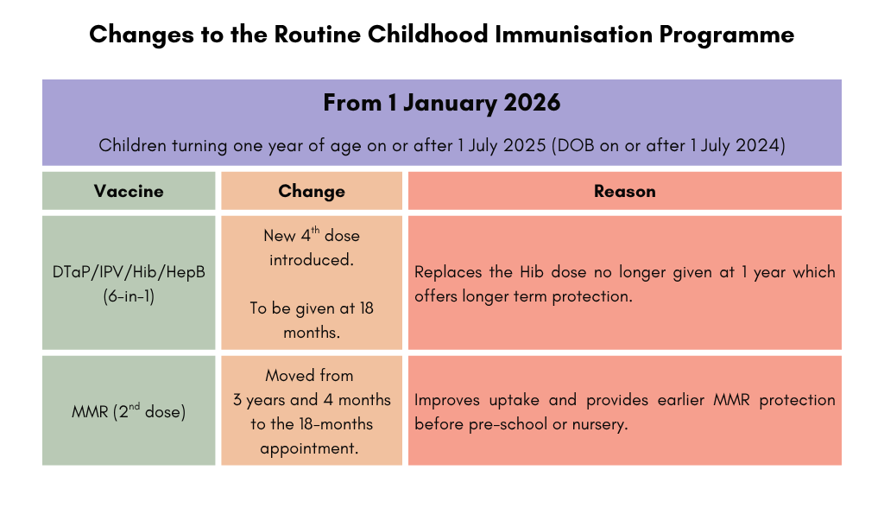

# Changes to the Cervical Screening Programme

The NHS recently announced a major shift in its cervical screening programme (smear test), changing how often women who test negative for the human papillomavirus (HPV), which causes most cases of cervical cancer, are called back to be tested again.

When:

The changes come into force from 1st July 2025 in England, aligning with Scotland & Wales.

Why:

This follows recommendations by the UK National Screening Committee, robust clinical evidence with better and more accurate testing for HPV.

Research shows that if a person tests negative for HPV, they are extremely unlikely to develop cervical cancer within the next decade. Cervical screening every five years is just as safe as screening every three years, with the same number of cervical cancers detected.

The move aims to spare women from screenings they don't need, while giving access to "life-saving" services to those who need it most.

What is the change?

Younger women aged 25 to 49 who are screened on or after 1st July 2025, and test negative for HPV will now be tested again every five years instead of three years. Women who were screened before 1st July 2025, and tested negative for HPV, will stay on the three yearly recall for their next screening. The changes won't affect those with HPV or a recent history of the virus. These women will continue to be invited to more frequent screenings to check that the virus has cleared and, if not, to check for cell changes in the cervix.

## Did you know?



You can now receive your cervical screening invitations & reminders digitally via the NHS App, making it easier and quicker to access. Click on the link below and download the app, remembering to enable the notifications. If a digital invitation isn't possible, a letter will be sent as a backup.

[NHS App and your NHS account - NHS](https://www.nhs.uk/nhs-app/)

Even if you’ve had the HPV vaccination, it’s important that you attend your cervical screening appointment.  If you think you are due but have not yet had an invitation, or if you think you've missed your last invitation, even if that came weeks, months, or years ago, you can contact your GP practice to book an appointment.

For further information, please go to: [When you'll be invited for cervical screening - NHS](https://www.nhs.uk/tests-and-treatments/cervical-screening/when-youll-be-invited/)

For a PDF copy of the poster for you to print, please email healthprotection@lancashire.gov.uk

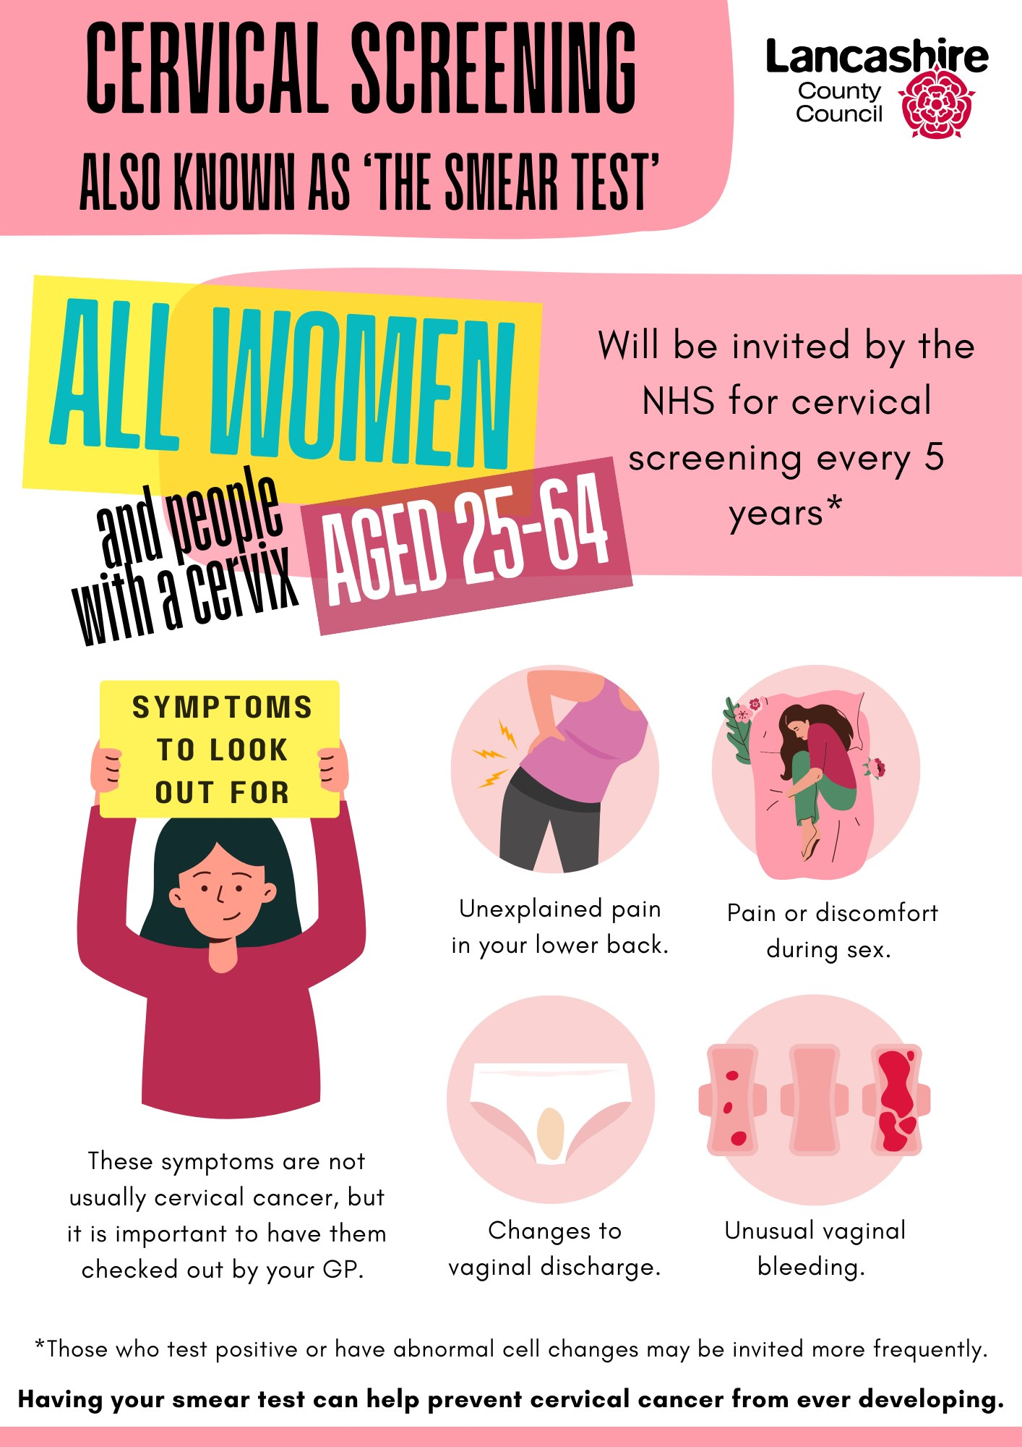

# Hydration

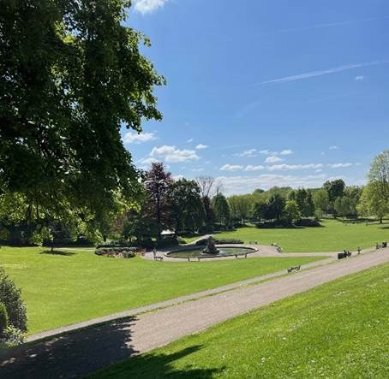

Water in the body is essential for many important processes to take place. From our blood system carrying essential glucose, oxygen and nutrients to cells, to the kidneys getting rid of waste products we no longer want, fluid in the body is vital to allow these to occur. It also lubricate your joints and eyes, helps the digestive system function and keeps your skin healthy.

How to stay hydrated

Heat makes you sweat, which cools you down. However, that also means you’re losing fluid. Approximately 60% of your body is made up of water so it's important to make sure you're replenishing your losses, especially when the weather is hot. Children, pregnant/breastfeeding women, older adults, and anyone exercising must remember to drink enough fluids regularly. Indicators of dehydration include fatigue; dizziness; light-headedness; dry mouth and/or lips; and not going for a wee very often – usually less than four times a day. The colour of your urine is a good way to check your hydration level.

Sip water throughout the day.

Don’t wait until you’re thirsty! Drink water throughout the day to prevent dehydration. We’ve all heard the eight-glasses-a-day recommendation, but hydration needs vary from person to person and change depending on heat, humidity, and activity levels.

Alcohol is dehydrating

It’s important to have at least one glass of water for every alcoholic beverage consumed.

Hydrating foods.

Water isn’t the only thing that contributes to overall hydration. Foods with high water content such as watermelon and tomatoes and other beverages count too.

Juices and ice lollies can replenish fluids as well, but as these choices tend to be high in sugar, they are best consumed in moderation.

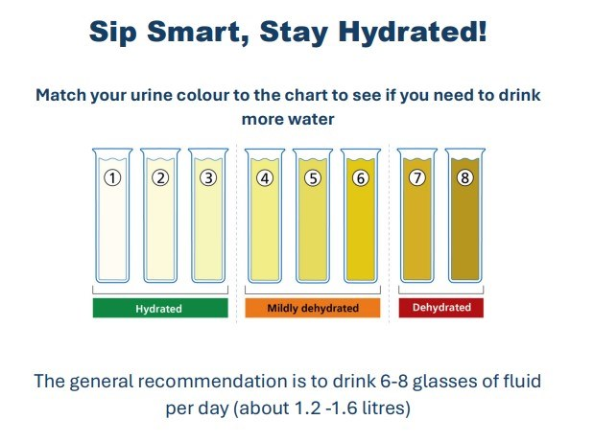

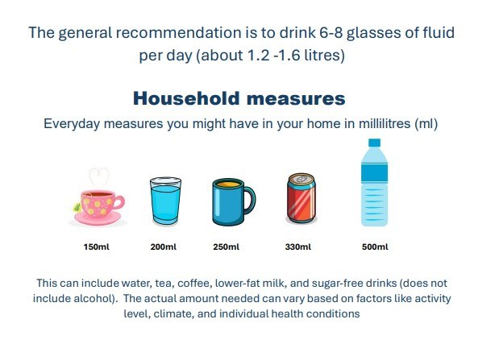

# Water Safety

Water safety advice

Being by water can be fun, but it’s important you know how to keep yourself, and your friends, safe. Water may look safe, especially a stretch of water familiar to you but even in summer, outdoor water is cold enough to kill and most people who drown in the UK can swim.

Being aware of the risks on and around water and knowing how to behave could save your life. There are no lifeguards along canals and rivers to help you and if you’re in a secluded area, it may take emergency services much longer to reach you.

Think! Do you know...

* How deep the water is? If its shallow, you could easily hit the bottom if you jump from a height.
* What might be hidden in the water? Landing on something in the water could really hurt you. Consider that there may be reeds and plants that can tangle around your limbs and drag you down.

Cold water shock.

In cold water the body can go into ‘cold water shock’ where it reacts by drawing blood away from your muscles to protect the organs, making it difficult to move your limbs.

Cold water will make you gasp uncontrollably and you may breathe in water. Your heart will beat faster, you’ll lose energy quickly, and eventually your muscles will become paralysed.

Float to live.

It is important that you float on your back to help keep your airways clear, make a starfish shape and paddle gently to keep afloat. Control your breathing and allow the cold-water shock to pass, then call out for help or swim to safety if you can.

Do not enter the water to save someone, instead throw them a life ring if available or something that floats like a ball or an empty plastic bottle.

For more water safety advice, click on the video below and visit- [The Royal Life Saving Society UK (RLSS UK)](https://www.rlss.org.uk/)

[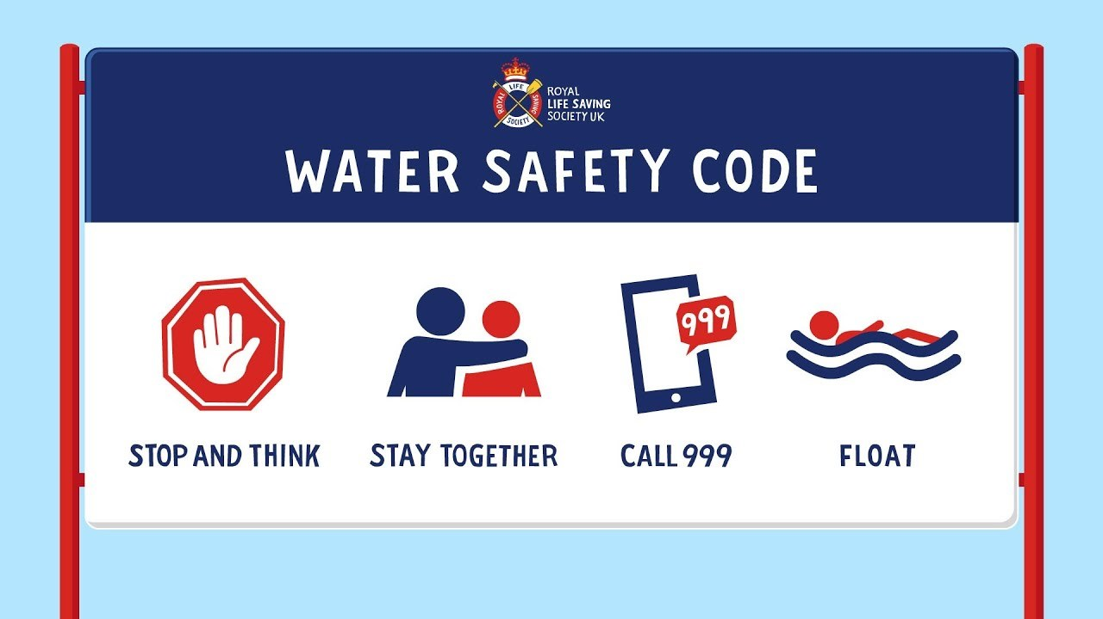](https://youtu.be/zwzB7So7jSM)

# A small reminder...

## Travelling abroad this summer?

Make sure you're up to date with your MMR (measles, mumps and rubella) vaccinations as there has been a significant global increase in cases of measles, with European cases already double the number reported last year – the highest since 1997.

Parents are urged to check their children's vaccination records and ensure they've received both doses of the MMR vaccine, which is free on the NHS. It's never too late to catch up on missed vaccinations and measles is still common in many countries worldwide.

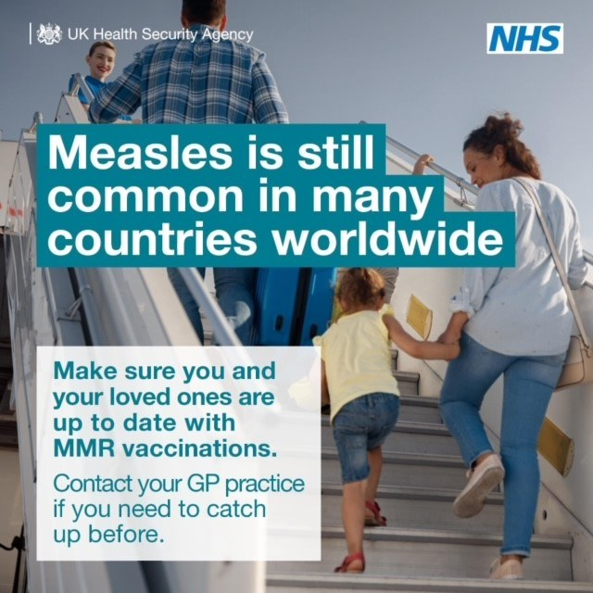

# Meet the team

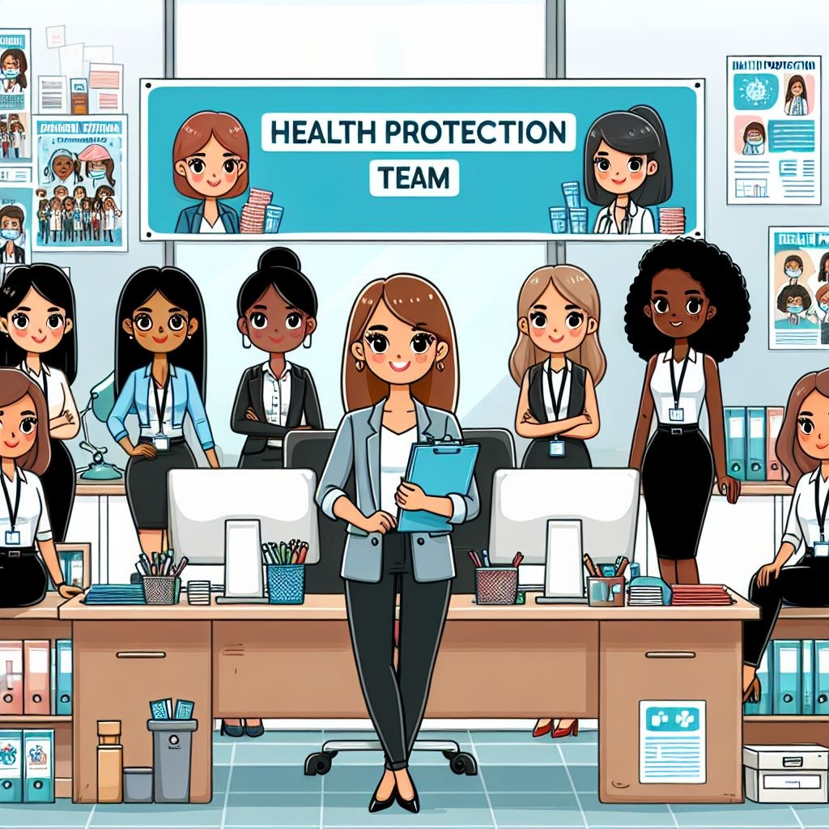



1 - image designed by AI copilot

The Health Protection Team is getting out and about, speaking to local residents to raise awareness of the national screening and vaccination programmes.

In August, we'll be at...

Beacon Fell Country Park, Goosnargh, PR3 2NL - 5th August

Towneley Park, Burnley BB10 4PJ - 19th August

Come along and say hello!

Many thanks to all at Skelmersdale library for hosting us this month. It was great to meet and speak to so many lovely people.

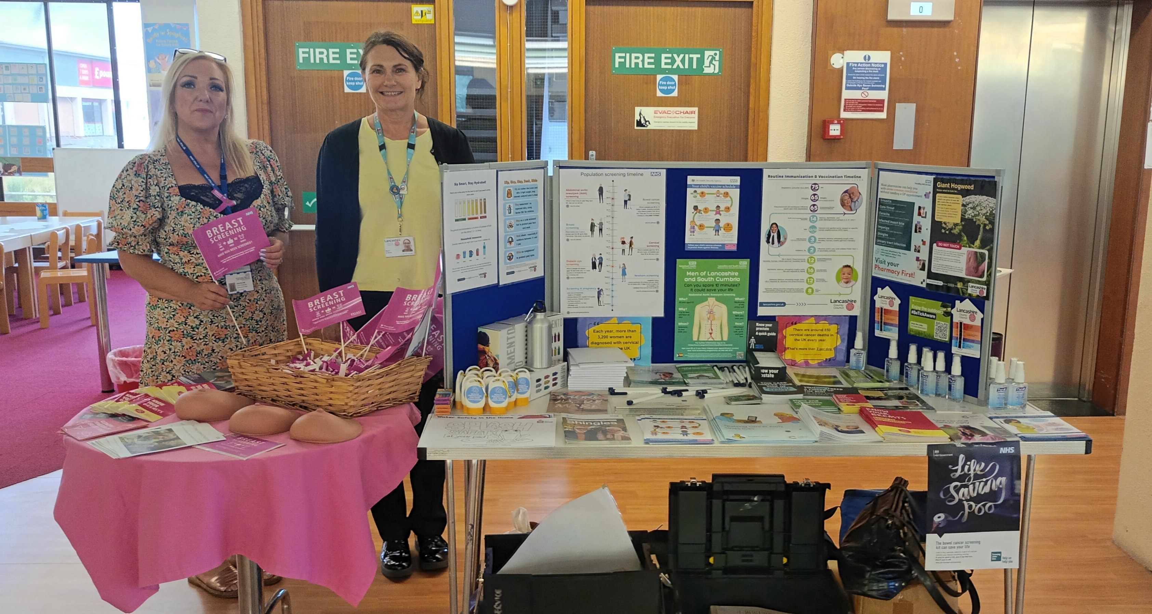

In next months edition:-

* Starting school advice
* Wildfires
* BBQ safety

## Just one more thing before you go...

To help us improve future bulletins, please complete the questionnaire by either clicking the link below or scanning the QR code.

[Tell us what you think - July bulletin](https://forms.office.com/e/ketisuwJ9i?origin=lprLink)



# Sources and further information

[Changes to routine childhood immunisation programme: 2025 and 2026 - GOV.UK](https://eur03.safelinks.protection.outlook.com/?url=https%3A%2F%2Fwww.gov.uk%2Fgovernment%2Fpublications%2Fchanges-to-routine-childhood-immunisation-programme-2025-and-2026&data=05|02|Louise.Coultas%40lancashire.gov.uk|0a99e34360c9448b23c708ddb87b9607|9f683e26d8b946099ec4e1a36e4bb4d2|0|0|638869563126819565|Unknown|TWFpbGZsb3d8eyJFbXB0eU1hcGkiOnRydWUsIlYiOiIwLjAuMDAwMCIsIlAiOiJXaW4zMiIsIkFOIjoiTWFpbCIsIldUIjoyfQ%3D%3D|0|||&sdata=5PRDKp0ye5vufcuZ%2F5yOWMnweFAgvqg4ThVUxrYnwn8%3D&reserved=0)

[Changes to the childhood vaccination programme: why they are happening - GOV.UK](https://www.gov.uk/government/publications/changes-to-the-childhood-vaccination-programme-why-are-they-happening/changes-to-the-childhood-vaccination-programme-why-they-are-happening)

[NHS England » NHS rolls out more personalised cervical screening for millions](https://eur03.safelinks.protection.outlook.com/?url=https%3A%2F%2Fwww.england.nhs.uk%2F2025%2F06%2Fnhs-rolls-out-more-personalised-cervical-screening-for-millions%2F&data=05|02|Louise.Coultas%40lancashire.gov.uk|0a99e34360c9448b23c708ddb87b9607|9f683e26d8b946099ec4e1a36e4bb4d2|0|0|638869563126861093|Unknown|TWFpbGZsb3d8eyJFbXB0eU1hcGkiOnRydWUsIlYiOiIwLjAuMDAwMCIsIlAiOiJXaW4zMiIsIkFOIjoiTWFpbCIsIldUIjoyfQ%3D%3D|0|||&sdata=GbXlNUus8gZsIkXovybU3Hw5TrGo%2Bi%2B%2B1jpLwx%2FmcyU%3D&reserved=0)

[The importance of hydration - BDA](https://www.bda.uk.com/resource/the-importance-of-hydration.html#:~:text=From our blood system carrying essential glucose%2C oxygen,digestive system function and keeps our skin healthy.)

[The Royal Life Saving Society UK (RLSS UK)](https://www.rlss.org.uk/)

[Measles outbreaks continue with risk of holidays causing surge - GOV.UK](https://www.gov.uk/government/news/measles-outbreaks-continue-with-risk-of-holidays-causing-surge#:~:text=It's essential that everyone%2C particularly,close links to the UK.)

This information has been produced by the Heath Protection team at Lancashire County Council.

If you require a printable version of this Health Protection bulletin please email the team at [healthprotection@lancashire.gov.uk](mailto:healthprotection@lancashire.gov.uk)

(Information correct at July 2025)