Downholland Haskayne
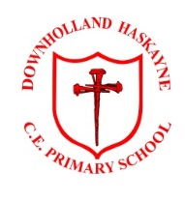
C.E. Primary School

Black-a-Moor Lane,
Haskayne.
L39 7HX

Tel: 0151 526 0614
head@haskayne.lancs.sch.uk
29th September 2021

Dear Parents/Carers
Parents’ Consultations
Parents’ consultations will be held on Wednesday 20th October and Thursday 21st October between the times set out below. Please take this opportunity to discuss your child’s work, progress and targets for the rest of the year. It is important for you to attend so if you cannot make this date please contact the school office. For parents with more than one child in school we will try to co-ordinate appointments to be close together.
Please circle a convenient time for your appointment to discuss your child/children’s progress. Although we cannot guarantee your required time we will try our best. Each meeting will last ten minutes.
________________________________________________________________________
Child’s Name:……………………………………
20th October 21st October
3pm – 3.30pm | 3.30pm – 4pm
4pm – 4.30pm | 4.30pm – 5pm
5pm – 5.30pm
1pm – 1.30pm | 1.30pm – 2pm
2pm-2.30pm | 2.30pm – 3pm
3pm – 3.30pm
Yours sincerely,

Mrs Hains
Headteacher

