Online Safety Newsletter

September 2023

Back to school photos
The W App - Anonymous polls

The W App is rated as 12+ in the App store and as ‘Parental Guidance’ on Google Play. Once an account has been created, the user picks their school and participates in polls.

A user can choose any school (no verification takes place) and then you can see all users at that school (includes their name/year group and profile picture if that has been added). In the polls, users are asked a question (for example ‘Hallway crush’) and then the user selects one of four random people from that school. Whilst the app says that it is anonymous, users can purchase a membership that allows users to see who chose them in a poll.

You should be aware that this app does include in app purchases and can be linked to other social media accounts. You can block and report other users.

Further information

Internet Matters have produced an article outlining what you need to know about anonymous apps in general and the risks your child might face in using them, including cyberbullying.

https://www.internetmatters.org/resources/anonymous-apps-guide-what-parents-need-to-know/

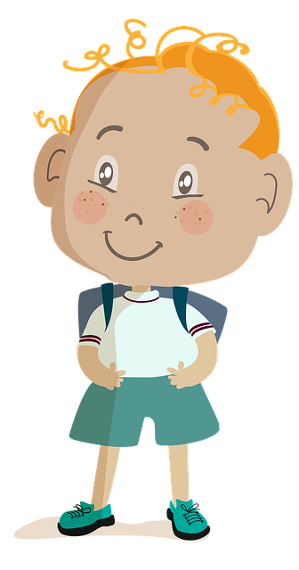
With the excitement of a new school year and your child reaching a new milestone, many of us share photos of our child online without thinking about the associated risks. If you post online, then try following these basic rules:

- Don’t post any photos of your child that show their school logo/name or recognisable places by where they live that can make it easy for people to find out their location.
- Never include your child’s full name.
- Are there any other children in the pictures you share online? If yes, do you have permission from their parent/carer to upload it?
- Would your child be happy for your comment/photo about them to be online – remember what might be ‘cute’ now may be embarrassing to them in the future.
- Make sure appropriate privacy settings are on.

Alternatively, you could just share photos with those who you really want to share the photo with (grandparents etc.) via WhatsApp or iMessage rather than via social media.

Further information
CEOP have published this article which includes advice on sharing photos of your child online:
https://www.thinkuknow.co.uk/parents/articles/Sharing-pictures-of-your-children/
Meta introduces more parental supervision tools.

Meta have announced new features for some of their products. Firstly, they have added parental supervision to Messenger (users must be 13+), which includes the ability to see who your child interacts with. Also, Meta have added a feature to encourage teens to set time limits on Facebook (users must be 13+) and new parental supervision features on Instagram (users must be 13+). Find out more here:

https://about.fb.com/news/2023/06/parental-supervision-and-teen-time-management-on-metas-apps/

Users of this guide do so at their own discretion. No liability is entered into. Current as of the date released 1.9.23.

Age ratings

There is so much that we can do online nowadays including playing games, chatting with others, watching TV or sharing our videos/photographs. One of the ways we can help keep our children safe online is by checking age restrictions/ratings as detailed below:

- Films: The British Board of Film Classification (BBFC) rate films. This page includes a link to a ‘Parents' Guide to Age Ratings’: https://www.cbbfc.co.uk/resources/viewing-films-safely-online.
- Video games: PEGI provides age classifications for video games. PEGI considers the age suitability of a game, not the level of difficulty. It is important to note that PEGI do not take into consideration the chat facilities within games.
- Apps: Check the individual age ratings within the relevant app store. We also recommend that you download any apps and use them yourself to check their suitability.
- Social Media networks: All social media networks have a minimum age rating; they are all at least 13+.

Threads (13+)
Threads was launched by Meta (creators of Facebook, Instagram and WhatsApp) in July and is similar in design to Twitter. As with Twitter, users can share text posts (with images and videos) and then other users can respond to create a thread. You need to have an Instagram account to login to Threads and you must be at least 13 years old to create an Instagram account.

For everyone 13 – 17 years old (in the UK), their account will automatically be set as private when they join Threads. As with Instagram, users can choose specific words to filter out of replies as well as hide comments that may be offensive. Users can also unfollow, block and report a profile. Any accounts that you have blocked on Instagram will automatically be blocked on Threads as well. Users can also change their settings on Threads so other users are unable to mention them in replies.

If you have supervision set up on Instagram for your child (aged 13 – 17) then it will automatically be set up for Threads and the same settings will be applied, such as time limits and scheduled breaks. You can find out more here: https://help.instagram.com/658522825492278

Threads is still being developed so new functions will be added but currently you are unable to direct (private) message other users.

You need to be aware that your child may come across content that is not appropriate for your child. If your child us using this app, then make sure they know how to use the reporting/blocking facilities, that appropriate privacy/safety settings are applied and they know to speak to a trusted adult should they need to.

Further information
https://www.childnet.com/blog/instagram-threads-a-guide-for-young-people-and-parents/

Roblox: new checklist

Does your child have speech, language and communication needs?

Parent Zone understand that talking about life online with a young person who has speech, language and communication needs (SLCN) makes it difficult, so they have created a selection of visual and spoken resources to help you. You can find out more here:

https://parentzone.org.uk/TalkTech

PEGI rate Roblox with a ‘Parental Guidance’ label (icon shown right), this is because of the huge level of user generated content within Roblox. It is rated for ‘Teens’ on Google Play and 12+ on the App store.

You can either use Roblox to create games or play games that other users have created. As a lot of the content is user generated, it may mean not all games will be suitable for your child to view/play. It is important to set up Parental controls appropriate to your child.

New Roblox Checklist
The 2023 Roblox Checklist created by SWGfL and the UK Safer Internet Centre in partnership with Roblox is now available to download here:
https://swgfl.org.uk/magazine/new-roblox-checklist-available/

