Curie |  |  |  | Date: |  | Spring Week 4
Mixed curriculum |  |  |  | Class: |  | Acorn
Day | Here is a link from our lovely PE teachers. Choose an activity and a time to suit you. Nursery & Reception PE Week 3 link  Whilst there are lots of lessons for your child to engage with, please remember to provide plenty of time for your child to enjoy ‘free choice play’. It is amazing how much children learn when playing, whether they are role playing different characters, creating their own narratives with small world play or constructing a masterpiece!  Activity
Monday | https://whiterosemaths.com/homelearning/early-years/growing-6-7-8-week-2/  Matching 6, 7 and 8 |  | https://classroom.thenational.academy/lessons/to-role-play-a-story-cctker |  | DT mini project ‘Be an Inventor’  Choose your activities from the list below.
Tuesday | https://whiterosemaths.com/homelearning/early-years/growing-6-7-8-week-2/  Making Pairs |  | https://classroom.thenational.academy/lessons/to-box-up-a-story-to-show-what-happens-c9j30r |  | DT mini project ‘Be an Inventor’  Choose your activities from the list below.
Wednesday | https://whiterosemaths.com/homelearning/early-years/growing-6-7-8-week-2/  Combing 2 groups |  | https://classroom.thenational.academy/lessons/to-write-a-story-part-1-6hk3jr |  | DT mini project ‘Be an Inventor’  Choose your activities from the list below.
Thursday | https://whiterosemaths.com/homelearning/early-years/growing-6-7-8-week-2/  Combing 2 groups |  | https://classroom.thenational.academy/lessons/to-write-a-story-part-2-c4w3ac |  | DT mini project ‘Be an Inventor’  Choose your activities from the list below.
Friday | https://whiterosemaths.com/homelearning/early-years/growing-6-7-8-week-2/  Adding more |  | https://classroom.thenational.academy/lessons/to-write-a-story-part-3-6dhpcc |  | DT mini project ‘Be an Inventor’  Choose your activities from the list below.
A wide selection of educational programmes can be found on ‘CBeebies i-player’. Below is possible timetable to help you choose any programmes your child may find particularly interesting.

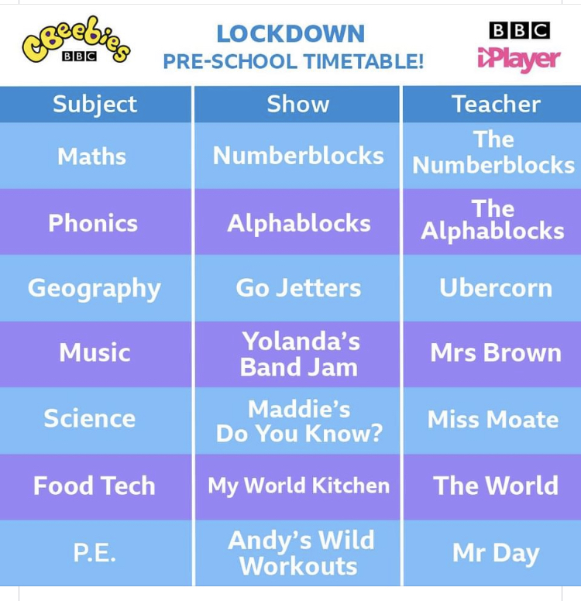
DT mini project -‘Be an Inventor’
For the afternoon lessons this week we would like you to do a mini project! This week we would like you to become an inventor! Your mini project task is to invent a totally new kind of snack. The focus of the mini project is Design Technology (DT). Rather than actually making the snack we want you to focus on ideas for new snacks and designs for the packaging.
Below are a list of activities you can complete as part of the project but feel free to include any ideas of your own and get as creative as possible! You do not have to complete all the tasks but try to do as many as possible.
- Draw a picture of your favourite snack and label it.
- Try something new to eat thinking about what it looks like, feels like, smells like and tastes like.
- Make a list of your 5 favourite flavours.
- Market research: Talk to your family members and try to find out what their favourite snacks are and why they like them so much.
- Have a Eureka moment and invent your own snack for example you might decide to make strawberry flavoured crisps or a purple carrot snack bar!
- Make a prototype of the packaging for your snack.
- Make a poster to show off your new snack.
- Can you make your own advert for your new snack?
- Can you make up a song about your snack?

