Curie |  |  |  | Date: |  | Spring Week 5
Mixed curriculum |  |  |  | Class: |  | Acorn
Day | Here is a link from our lovely PE teachers. Choose an activity and a time to suit you. Nursery & Reception PE week 4 link  Whilst there are lots of lessons for your child to engage with, please remember to provide plenty of time for your child to enjoy ‘free choice play’. It is amazing how much children learn when playing, whether they are role playing different characters, creating their own narratives with small world play or constructing a masterpiece!  Activity
Monday | https://whiterosemaths.com/homelearning/early-years/growing-6-7-8-week-3/  Comparing Height |  | https://classroom.thenational.academy/lessons/to-listen-to-and-join-in-with-an-explanation-68r62d |  | ‘Haskayne Bake Off’ mini project.  Choose your activities from the list below.
Tuesday | https://whiterosemaths.com/homelearning/early-years/growing-6-7-8-week-3/  Comparing Length |  | https://classroom.thenational.academy/lessons/to-map-and-speak-an-explanation-cmr66c |  | ‘Haskayne Bake Off’ mini project.  Choose your activities from the list below.
Wednesday | https://whiterosemaths.com/homelearning/early-years/growing-6-7-8-week-3/  Days of the Week |  | https://classroom.thenational.academy/lessons/to-step-and-speak-an-explanation-c8rk2d |  | ‘Haskayne Bake Off’ mini project.  Choose your activities from the list below.
Thursday | https://whiterosemaths.com/homelearning/early-years/growing-6-7-8-week-3/  Measuring Height |  | https://classroom.thenational.academy/lessons/to-sing-an-explanation-65hpcd |  | ‘Haskayne Bake Off’ mini project.  Choose your activities from the list below.
Friday | https://whiterosemaths.com/homelearning/early-years/growing-6-7-8-week-3/  Measuring Time |  | https://classroom.thenational.academy/lessons/to-interview-a-character-60uk4c |  | ‘Haskayne Bake Off’ mini project.  Choose your activities from the list below.
A wide selection of educational programmes can be found on ‘CBeebies i-player’. Below is possible timetable to help you choose any programmes your child may find particularly interesting.

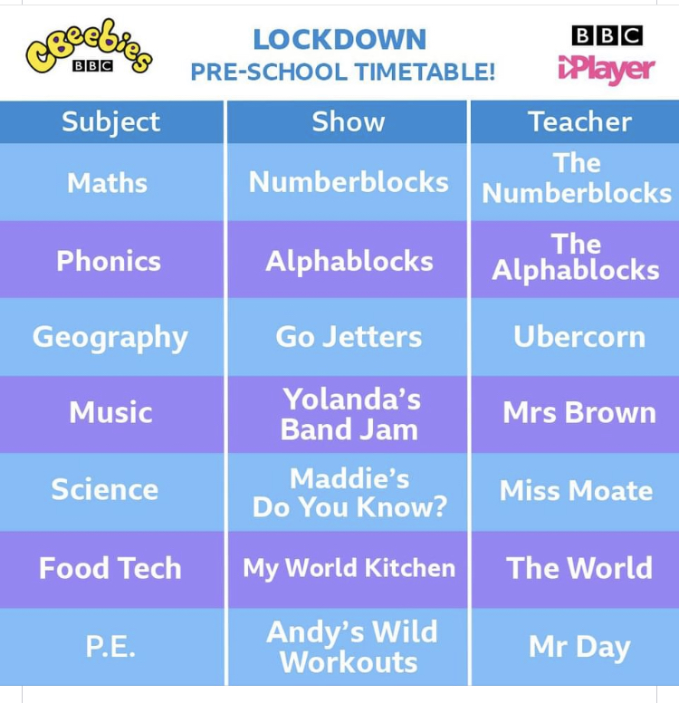
The Great Downholland-Haskayne
Bake off!
For the afternoon lessons this week we would like you to complete a new mini project! This week we would like you to use your Science knowledge and inventing skills as you become a baker! Your mini project task is to create a cake or biscuit. The focus of the mini project is to explore ingredients, follow recipes, create mixtures, tasting your end products and most importantly having fun!
In the story of Noah, God sent a rainbow as a promise that he would not destroy the earth by water. During this lock down period the rainbow has been adopted as a symbol of hope and promise from God. It is now being used as a thank you for our wonderful key workers. It might be that you decide to use a rainbow as a theme for your creation.
Below are a list of activities you can complete as part of the project but feel free to include any ideas of your own and get as creative as possible! You do not have to complete all the tasks but try to do as many as possible.
- Draw a picture of your favourite treat from the bakery.
- Try role playing bakery shops. You could use pictures of different food you might find in a bakery set different prices and invite family members to visit your bakery.
- Make a shopping list that you would take if you visited the bakery.
- Market research: Ask family members what they would like to eat if they went to the bakery.
- Decide on your treat for your ‘Bake Off Showstopper’! Do you want to make a biscuit, rice crispy cake, bread, cake or perhaps you want to decorate a shop bought treat.
- Draw a picture of your final design
- Can you write a list of ingredients?
- Get creating your ‘Bake Off’ masterpiece!
- Make sure you get photos of your final piece.
- Finally make sure you taste your hard work. What did you like best about your showstopper? What did your family think about your showstopper?

