Pasteur |  |  | Date: | Spring 1 week 6
DT |  |  | Class: | Acorn
Day | Here is a link from our lovely PE teachers. Choose an activity and a time to suit you Year 1 & 2 PE week 5 link and EYFS & KS1 Family pack week 5 link  Activity
Monday | https://whiterosemaths.com/homelearning/year-1/spring-week-5-number-place-value-within-50/  Counting to 50 by making 10s | https://classroom.thenational.academy/lessons/to-box-up-for-purpose-6ru62c  CBBC recommendation of the day  Operation Ouch – 11:35am | ‘Crafty Creator’ mini project.  Choose your activities from the link below but make sure one of them is our ‘Positive Messages Mission!’
Tuesday | https://whiterosemaths.com/homelearning/year-1/spring-week-5-number-place-value-within-50/  Numbers to 50 | https://classroom.thenational.academy/lessons/to-identify-features-of-a-persuasive-advert-read-as-a-writer-64t64c  CBBC recommendation of the day  CBBC Live Lesson- Safer Internet Day – 11:00am | ‘Crafty Creator’ mini project.  Choose your activities from the link below but make sure one of them is our ‘Positive Messages Mission!’
Wednesday | https://whiterosemaths.com/homelearning/year-1/spring-week-5-number-place-value-within-50/  Counting forwards and backwards within 50 | https://classroom.thenational.academy/lessons/to-write-a-persuasive-advert-part-1-70u30r  CBBC recommendation of the day  Art Ninja – 11:05am | ‘Crafty Creator’ mini project.  Choose your activities from the link below but make sure one of them is our ‘Positive Messages Mission!’
Thursday | https://whiterosemaths.com/homelearning/year-1/spring-week-5-number-place-value-within-50/  Tens and Ones | https://classroom.thenational.academy/lessons/to-write-a-persuasive-advert-part-2-c8t68t  CBBC recommendation of the day  Art Ninja – 11:05am | ‘Crafty Creator’ mini project.  Choose your activities from the link below but make sure one of them is our ‘Positive Messages Mission!’
Friday | https://whiterosemaths.com/homelearning/year-1/spring-week-5-number-place-value-within-50/  Represent numbers to 50 | https://classroom.thenational.academy/lessons/to-perform-a-persuasive-advert-crvk0c  CBBC recommendation of the day  Wild and Weird – 11:35am | ‘Crafty Creator’ mini project.  Choose your activities from the link below but make sure one of them is our ‘Positive Messages Mission!’
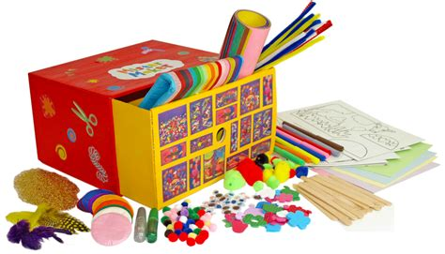
Crafty Creators!
For the last week of this half term in the afternoon lessons we would like you to really enjoy getting very creative. The link below has a range of art projects you may like to try yourself. If you have an idea of your own, feel free to create something which reflects your own interest.
https://static1.squarespace.com/static/5ea810465f8e353c3163604e/t/5ed914d3a2751d4f03619d42/1591284996917/ArtJumpStart+Full+Collection.pdf
Remember to send us photographs of anything you make so that you have your ‘time to shine’.
Positive Messages Mission!
Hello everyone,
We hope you are all doing okay. We miss you at school and can’t wait to welcome you back, hopefully very soon. We know you are all missing your friends and so we would like you to create a message in the most creative way possible for all your friends at school and home to see. For example, draw it, write it, paint it, go outside and write your message in rocks, stones or even some twigs or leaves. Your message could be something personal to your friends or a simple positive quote or word that will make someone smile.
Once you have created your message ask a grown up to take a picture of you, with your message and email it to your class teacher. We will use all your pictures of positive messages and words to create a video that we will put on the website.
We can’t wait to see your messages and pictures. We may even make a surprise appearance on the video ourselves- keep an eye out!!
Best wishes,
Mrs Hains, Mrs Gibson and Miss Grant.

