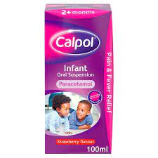
In order to try and improve our attendance we have agreed to administer non prescribed medication such as Calpol. We have bought Calpol for the school so that you don’t need to send a bottle in each time. If you require us to administer any other medication this will need to be provided and handed into the office.
To save you filling in a form each time please sign and return the slip below which we will keep in our records. If you require us to administer Calpol, please let the staff on the door know in the morning and we will send a slip home to advise the amount and time given.
If we have not received any notification from you in the morning but we feel your child my benefit from some Calpol during the day we will phone you to discuss.
Thank you
……………………………………………………………………………………………………………………………………………………..

Child:………………………………………………….……
I give permission for the school to administer Calpol to my child.
I will inform the door staff in the morning when this is needed.

Signed:…………………………………………………………

Dated:…………………………………………………………

