# Downholland Haskayne CE Primary

# Newsletter No: 11 Contact: bursar@haskayne.lancs.sch.uk

# 22nd December 2021 Phone: 0151 526 0614

# 

# School

Something

Something

**Public Service Announcement**

Parents: What we are being asked to do is not humanly possible. There is a reason we are either a working parent, a stay-at-home parent or a part-time working parent.

Working, parenting and teaching are three different jobs that cannot be done at the same time.

It’s not hard because you are doing it wrong. It’s hard because it’s too much. Do the best you can.

When you have to pick, because at some point you will, choose connection. Pick playing a game over arguing about an academic assignment. Pick teaching your child to do laundry rather than feeling frustrated that they aren’t helping. Pick laughing, and snuggling, and reminding them that they are safe.

If you are stressed, lower your expectations where you can and virtually reach out for social connection. We are in this together to stay well. That means mentally well, too.

**Emily W King Ph.D**

Change 4 Life

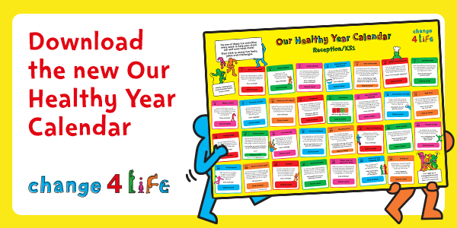

<https://campaignresources.phe.gov.uk/resources/campaigns/40-school-zone/resources/5602>

[**https://www.nhs.uk/better-health/**](https://www.nhs.uk/better-health/)

**We thought this new healthy year calendar might be useful to help your children to eat well, move more and be more mindful of their wellbeing.**

**Thank you to Mrs Moffitt for telling us about it.**

Non

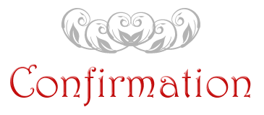

**Certificate of Achievement**

We have awarded certificates to

Well done to our “Stars of the week”

**After School Clubs**

Name……………………………………….

I give permission for my child to take part in the Epiphinay Service on Wednesday 8th Jnauary 2014

Signed:……………………………….

Dated:……………………………….

* A

**Haskayne ‘Bake-off’**

Using our science knowledge and inventing skills you will have a chance to release your inner Mary Berry

and show off your baking skills!

Have a think about your show

piece cakes or biscuits for the week commencing Monday 1st February.

If you need any resources for home learning tasks we are here to help







Have a lovely weekend,

Mrs Hains & all the staff