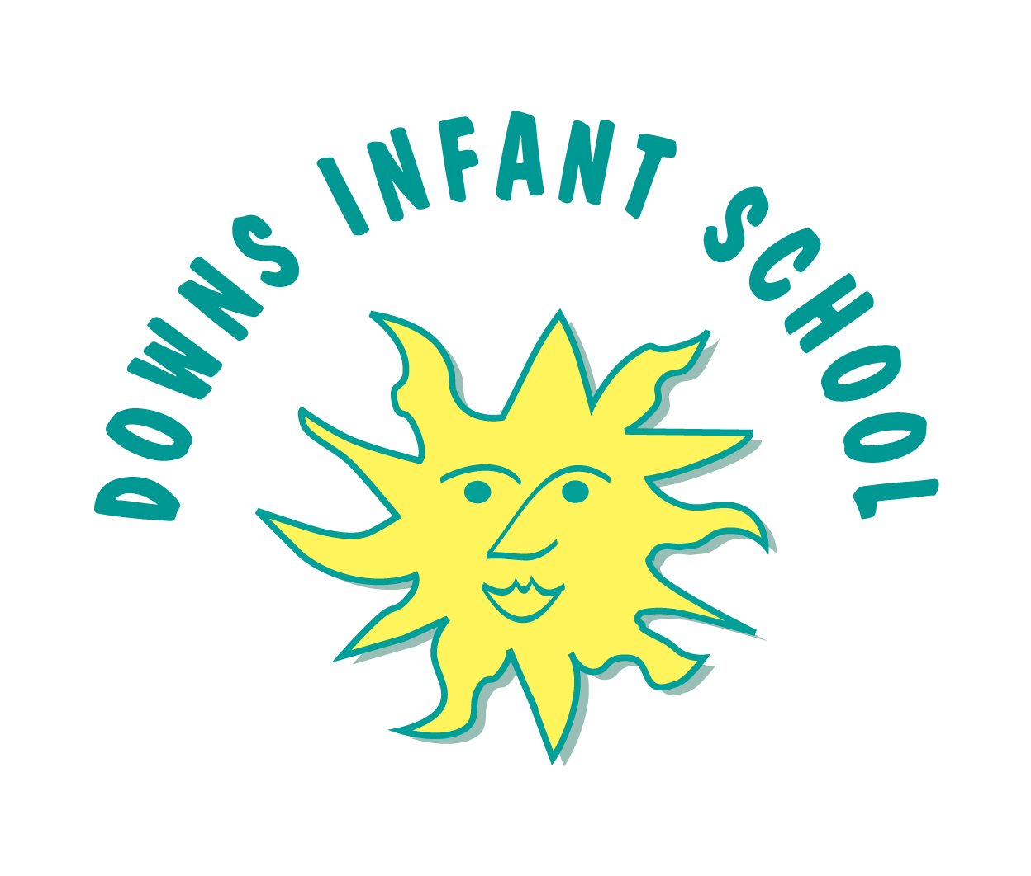Downs Infants Curriculum Statement: History

History helps pupils to understand the complexity of people's lives, the process of change, the diversity of societies and relationships between different groups, as well as their own identity and the challenges of their time.
Intent | Implementation | Impact
What will take place before teaching in the classroom? | What will this look like in the classroom? | How will this be measured?
At Downs Infant School we aim to develop the whole child. We aim that children are enabled to make the very best of their lives; having choice and opportunity in their social and economic situation, contributing to society and developing a sense of self-worth. We aim to provide a broad and balanced curriculum and to fulfil the requirements of the EYFS and the National Curriculum, which are inclusive to all children. We use our curriculum drivers to feed into and inspire our children in History. Their learning will be through coherent planning and will be cross-curricular, giving their learning relevance and a purpose. | We implement a curriculum that is progressive throughout the school. In Key stage 1 our History curriculum is based on the 2014 Primary National Curriculum in England. In Reception it is based upon the EYFS Framework. History in Reception is explored through Understanding the World: the children are given opportunities to explore, observe and find out about people, places, technology and the environment.  Our teachers in Key stage 1 use a progression map/document, medium term planning document and then the more in-depth termly planning to deliver their lessons. The progression document/map ensures the curriculum is covered and that the skills/knowledge is progressive from Reception to Year 2. In the Reception year group they follow an early years way of planning and due to the way the curriculum is mapped out over the year History may not be focused upon in a particular topic however a high quality enabling environment and it’s resources ensure that children have opportunities to explore historical skills frequently, including looking closely at similarities and differences, past and present events in their own lives and families and life cycles.  In addition the topic guides may be amended at times to reflect changing needs and circumstances, to enable flexibility in capitalising upon the educational potential of unforeseen special events, children’s interests and ‘one offs’.  Educational trips/visits are used as a way to enhance the children’s learning of History. Trips provide opportunities to explore at first hand the history they have been learning about in the classroom. | In Key Stage 1 we measure the impact of our History curriculum through a variety of ways. Firstly we pre-teach vocabulary to the children to introduce a topic, and ask AfL open ended questions, thus assessing their initial knowledge. We then discuss our children’s learning at the time when they are doing/finishing it and then discuss their learning and understanding with them individually through further questioning. Sometimes low impact quiz’s are completed at the end of the topic to further help to assess their learning. We take images of children’s practical learning and record this on Tapestry.  In Reception we regularly record evidence of learning on Tapestry and link to the elements of the ‘Understanding of the World’  At one point in the year subject leaders will have allotted time to monitor History throughout the school, carrying out lesson observations, learning walks during COOL time and interviewing a selection of pupils to assess their understanding (pupil voice) which then feeds directly back into further planning. The subject leaders then use this to inform how well the teaching, and learning has gone and what aspects might be changed for the future or what aspects we need to include in the following planning. This is fed back to staff in a summary/ round up via a staff meeting where any changes to planning or areas for CPD are identified and implimented.

