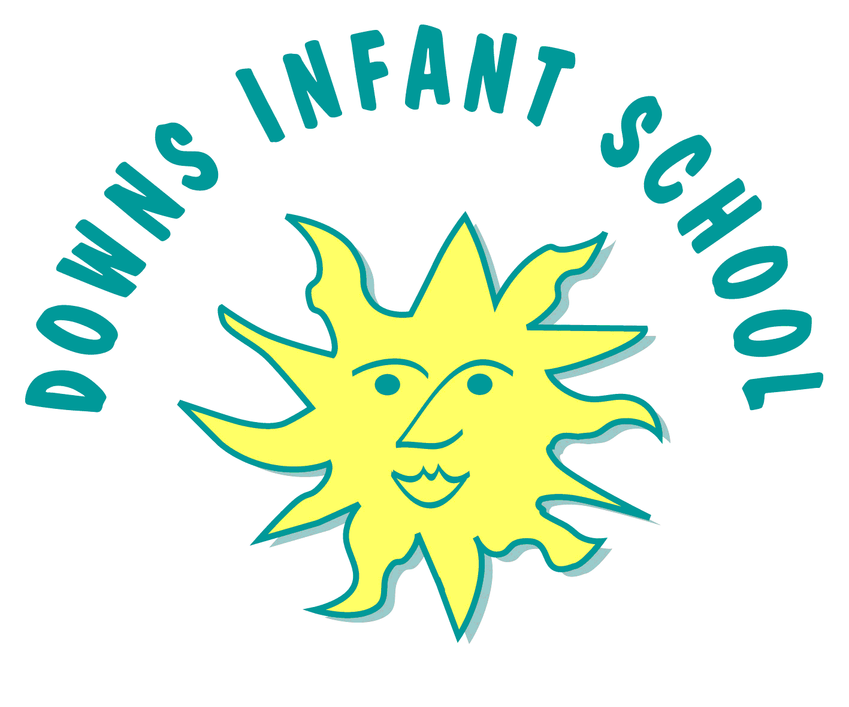
Downs Infants Curriculum Statement
English

“Reading and writing cannot be separated. Reading is breathing in; writing is breathing out.” – Pam Allyn

Intent | Implementation | Impact
What will take place before teaching in the classroom? | What will this look like in the classroom? | How will this be measured?
Our aim at Downs Infants is for all of our children to develop a love and passion for every aspect of English. We provide a language rich environment so that children are continually stumbling across opportunities; this reinforces their learning and love of English in fun and meaningful ways.  Through our range and variety of texts, authors and genre we aim to inspire children to make informed choices about what they would like to read and write about. One child’s love of a comic is another child’s fascination with a non fiction book! We have a comprehensive reading spine representing all types of diversity as well as including classics!  We recognise the importance of nurturing a culture where children take pride in their writing, can write clearly and accurately and adapt their language and style for a range of contexts.  We want to inspire children to be confident in the art of speaking and listening and to be able to use discussion to communicate and further their learning.  We believe that children need to develop a secure knowledge-base in English, which follows a clear pathway of progression as they advance through the primary curriculum.  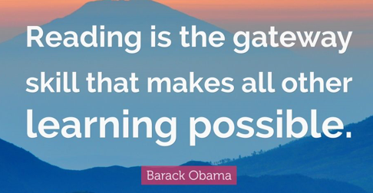 | 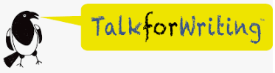  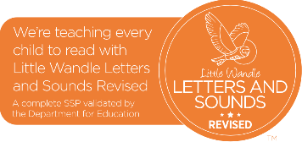  We have a rigorous and well organised English curriculum that provides many purposeful opportunities for reading, writing and spoken language. Our curriculum for Key Stage 1 closely follows the purpose and aims of the National Curriculum for English 2014.  As an infant school that has ‘Continuous Provision’ at its core, we pride ourselves on high quality interactions with children that include questioning, challenging and supporting children at their level.  All children in Reception, Year 1 and Year 2 receive four English lessons and five phonics lessons per week as well as additional handwriting and spelling sessions. The English lessons are taught using a ‘Talk for Writing’ approach, which are delivered in 3 week cycles. During each unit, children move through the phases of Imitation, Innovation and Independent application, developing the core skills necessary for writing a range of text-types. A key aspect of children’s writing is drawing on language and structure they have picked up from either reading themselves or being read to. We collect quality language that children are encouraged to magpie in their writing.  They have the opportunity to edit and publish writing, enabling them to become skilled and reflective writers. Children in Key Stage 1 learn how to write using pre cursive handwriting (see handwriting policy). Children in Reception learn how to write in line with Little Wandle handwriting patter using a non-cursive letter formation.  All children across the school have a daily 30 minute phonics lesson. In Reception, we follow Little Wandle Letters and Sounds Revised and in KS1 we follow our own phonics programme, Sunshine Phonics, based on Letters and Sounds and Jolly Phonics. In KS1 children are grouped by phonics phases to best meet the needs of all. These groups are fluid and regularly reviewed.  All children participate in guided reading sessions where specific reading skills such as vocabulary, inference, predicting, explaining, retrieval, sequencing, prosody and comprehension are taught and embedded.  In Reception we use Collins Big Cat books for Little Wandle Letters and Sounds Revised. In KS1, we use Bug Club Phonics books and children have access to both physical and electronical books via the Bug Club app. These books are also embedded in our phonics plans. We have a large team of reading volunteers from our school community who read with individual children as part of our Reading Army. Some children also take part in the Better Reading Partnership intervention.  On-going assessment leads to quick identification and intervention that is focused on supporting children in closing gaps in their phonic knowledge.  We search for enrichment opportunities, be that visiting authors or members of our community to encourage and celebrate English.  We have a library that we are proud of and we have our own ‘reading army’ (parents, relatives and friends from our school community) who support many children with their reading.  We aim for all children to have books read aloud to them. This is made up of a diet of least ‘5 a day’ throughout their time at home and school.  All these opportunities help to ensure that children benefit from access to positive role models from the local and wider community. | As a result, we have a community of enthusiastic and articulate readers and writers who enjoy showcasing their developing literacy knowledge and skills. There is a ‘buzz’ around English in the school with quality discussion around books and writing being common place. Children are confident to take risks in their English, and love to discuss and share their ideas.  We strive to ensure that our children's attainment is in line with or exceeds their potential when we consider the different starting points of all our children.  The impact of our English curriculum will ensure our pupils are academically prepared for life beyond Infant school and throughout their educational journey. Their love and passion for English inspires them to take ownership of their learning, working hard to produce high standards of written work across all areas of the curriculum.  Children are informally assessed in every English lesson and teachers adapt their lessons and questioning based on what they observe. Children are assessed half-termly using our own assessment to identify which sounds they can recognise and those that need further teaching. We also assess their ability to apply their knowledge in context.  We formally assess the children in reading every half-term to ensure they are reading the correctly banded book. This assessment is not only based on word-reading but also on comprehension (both literal and inferential).  All children receive verbal feedback on written tasks throughout the week, which supports them in making progress towards the end of year expectations.  Children are assessed formally at the end of each term; this is a detailed assessment which allows us to see what skills the children have securely acquired and where further support may be needed.  Children in Year 1 sit the Phonics Screening Check. Any child not passing the check  resits it in Year 2.

Appendix: Handwriting policy, Phonics overview, Writing overview, Phonics and Early Reading Policy

