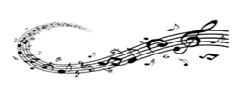
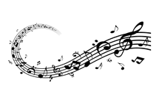
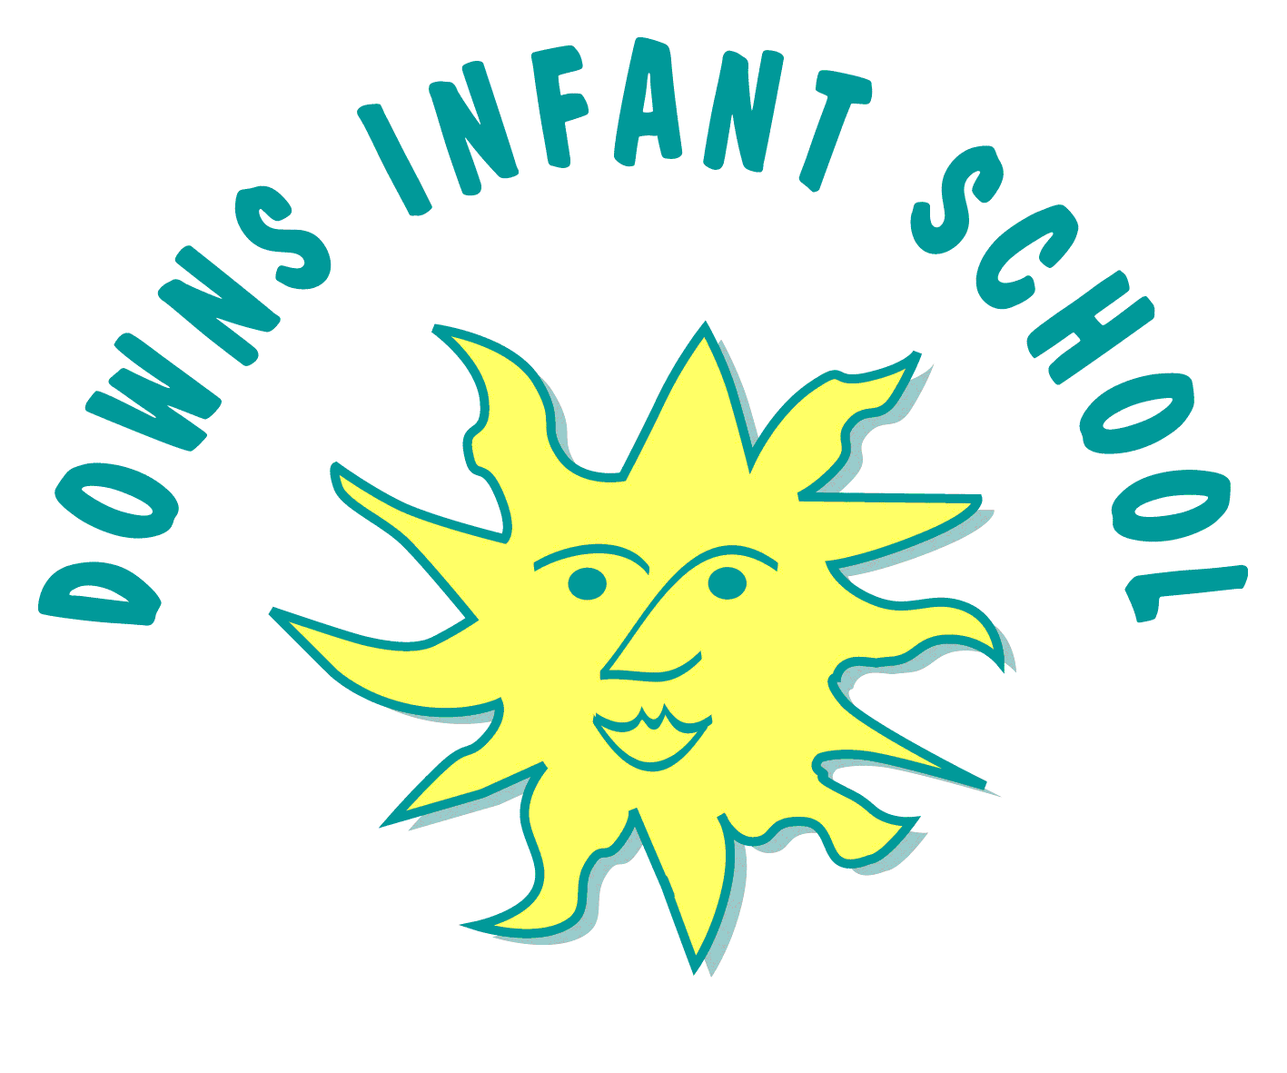
Downs Infants Music Curriculum Statement
“Music can change the world.” Ludwig van Beethoven.
“Music acts like a magic key, to which the most tightly closed heart opens.” Maria Augusta von Trapp
Intent | Implementation | Impact
What will take place before teaching in the classroom? | What will this look like in the classroom? | How will this be measured?
At Downs Infants, Music is a vital part of school life because it is enjoyable. It enables all children to develop a vast range of essential skills. Their social, physical, intellectual, emotional and spiritual development is enhanced through the use of Music, because it is so accessible and can stimulate in so many different ways, genres, styles and traditions.  Music builds confidence and self-esteem as knowledge is attained, and we can all feel a sense of creative achievement in our aesthetic development.  We are able to use Music as we interact socially, and gain a sense of community and belonging. When we celebrate, Music provides the core for our gathering together, either participating as listeners or performers.  Music has strong links with many other curriculum areas, and children can develop their ability to communicate, attain skills, confidence and a love of music both as composers and listeners.  Music can be delivered to our children in such a way that it can be accessed and interpreted by all our children who all have different experiences, knowledge and skills. Music enables all children to share, express, perform and appreciate things in their own way, supporting them in their transition between home, school and the wider world. | At Downs Infants, children experience music in their classroom, as a year group and as a whole school. Music will begin and end everyone’s week with whole school and singing assembly.  There are opportunities for everyone to listen and respond to live and recorded music during assemblies and recitals, to play instruments, to sing songs, speak chants and rhymes and explore rhythmic opportunities; and to develop as composers by creating, selecting and combining sounds.  We deliver the Charanga Musical School Scheme which provides us with week-by-week lesson support for each year group in the school. Progression is clear, and engaging and exciting whiteboard resources support every lesson. The Scheme supports all the requirements of the national curriculum. It has an integrated, practical, exploratory and child-led approach to musical learning. The interrelated dimensions of music weave through the units to encourage the development of musical skills as the learning progresses through listening and appraising, differing musical activities (including creating and exploring) and performing. The ‘Anyone can play’ Charanga scheme can be used with some of our children with SEND where appropriate.  In Year 2, there is an opportunity to learn the Recorder or the Violin with a specialist teacher.  In addition to daily singing and listening to music, we provide a range of enrichment opportunities such as visiting musicians. We have links with the junior school by having their pupils come to perform gigs and recitals for us.  We have an extra-curricular choir for Year 2 children, which sings at school and local community events, at Christmas and in the summer.  Children have regular opportunities to perform throughout the year with events such as ‘busking’ in reception, Christmas performances from all year groups and Spring show from Year 1 and a summer show from Year 2.  There is also a Year 2 Samba Band that performs with our Dancers and Chanters when we participate in the Brighton Festival Children’s Parade, as well as performing at local community events and our summer DownsFest. | It is clear that Music plays a vital and exciting part of life at Downs Infant School by the children’s developing sense of rhythm and love of Music.  Music will be used in school to support staff well being.  Children in Reception work towards the Early learning goals; ‘Exploring and using media and materials’  and ‘Being Imaginative’. Observations and assessments are recorded on Tapestry.  In KS1, music is assessed in the focus half term and teacher assessment is used at all other times. Can they:  - Use their voices expressively.  - Play tuned and un-tuned instruments.  - Listen with concentration and understanding to a range of music.  - Explore how they can create music though the use of pitch, duration, dynamics, tempo, timbre, texture, structure and appropriate notation.  Children's attainment is in line or exceeds their potential and they make at least good progress in their musical development to demonstrate progression based on their different experiences, knowledge and skills.  Music enhances their journey through life and school. For them, it really does ‘change the world’.

